Informatics Institute of Technology

In Collaboration With

The University of Westminster, UK



*The University of Westminster, Coat of Arms*

GenSum

A Generalized Text Summarization System using Optimized

Transformers

A dissertation by

Mr. Nazhim Kalam

W1761265 | 2019281

Supervised by

Mr. Torin Wirasingha

April 2023

Submitted in partial fulfilment of the requirements for the

BSc (Hons) Computer Science degree at the University of Westminster.

**DECLARATION**

I affirm that this dissertation, including its sub-components, is the product of my own original research endeavors. Furthermore, I confirm that I have not previously submitted or presented any of this content, in whole or in part, as part of any other degree or qualification program at any other university or institution. Any factual information obtained from credible external sources has been duly acknowledged through proper citation.

**Student Name**: Nazhim Kalam

**Registration Number**: w1761265 -- 2019281

**Signature: Date:** April 27, 2023



**ABSTRACT**

Abstractive text summarization systems have been integrated with various application in the world to perform text summarization and its nothing new to the field. However, with the prior research it found that in the domain of movies the need for performance improvement is required using latest approaches than the current traditional ML & DL methods, movie review summarization plays a major role in helping users to make better decisions by matching their interest with the reviews of the movie, this saves a lot of time and also improves businesses in their sales.

In 2017 researches from Google Brain introduced NLP Transformers, which is a latest approach to solve NLP problems and its increasingly been known and used nowadays over traditional ML & DL approaches like using basic LSTM, RNN approaches. The author explored ways in which to get an optimal solution using Transformer for abstractive text summarization and yet making a generalized solution which can be adapted with respect to any domain (be it hotels, movies, restaurants) and increase its performance as the system gets used over with time.

The author was able to experiment with few of the top tier transformer architectures to filter out the optimal model and integrated an automated hyperparameter searching mechanism which will find the best set of hyperparameters to train the model. **ROUGE1 of 80.8, ROUGE2 of 79.42, ROUGEL of 80.8, ROUGELSUM of 80.8** was the optimal evaluation metric result achieved from the BART model giving the best result.

**Keywords:** Natural Language Processing (NLP), Machine Learning (ML), Deep Learning (DL), Recall-Oriented Understudy for Gisting Evaluation (ROUGE), Inductive logic programming (ILP)

**Subject Descriptors:**

* Computing methodologies 🡪 Artificial intelligence 🡪 Natural language processing 🡪 Natural language generation
* Theory of computation 🡪 Theory and algorithms for application domains 🡪 Machine learning theory 🡪 Semi-supervised learning.
* Information systems 🡪 Information systems applications 🡪 Management and querying of encrypted data.
* Security and privacy 🡪 Database and storage security 🡪 Data mining.

# **PUBLICATIONS**

1. **A Review on Creating a Performance Adaptive Generalized Abstractive Text Summarization Using Optimized Transformers**

Conference: SmartNets 2023 - BDA-ML

Status: Submitted, In-Review

Venue: Asia, Colombo

Date: April 08, 2023

# **ACKNOWLEDGEMENT**

I am grateful for the supportive individuals in my life who have empowered me to exceed my previous limitations and achieve my current level of success, including the completion-of this final year research project.

I would like to express my deepest gratitude to Mr. Guhanathan Poravi, my esteemed module leader, for his consistent review and invaluable guidance that has tremendously improved my reports. His feedback has instilled in me the confidence to conduct research at any level. I am also grateful to my supervisor, Mr. Torin Wirasingha, for his contribution in refining my project idea and expanding its scope. I extend my appreciation to the evaluators of this project, who took the time to thoroughly review my work and provide valuable advice for its enhancement. Furthermore, I would like to thank all the interviewees and survey respondents, including industry and academia experts, as well as my senior and junior peers at IIT, for their invaluable input in the requirement gathering process.

I express my heartfelt appreciation to the esteemed lecturers at the Informatics Institute of Technology, as well as the supportive management, for the invaluable opportunities, unwavering support, and invaluable guidance they have provided me throughout my undergraduate degree. I would also like to acknowledge my fellow friends from university, whose continued support and positive influence have played a pivotal role in my growth as a developer/researcher. Their encouragement and camaraderie have fueled my rapid progress over the span of four years. Lastly, I extend my deepest gratitude to my parents for their unwavering support and encouragement in pursuing my dreams, and to my beloved family, friends, and significant other, whose unwavering encouragement has been a beacon of strength during challenging times.

**CONTENTS**

**PUBLICATIONS** Iii

**ACKNOWLEDGEMENT** Iv

**LIST OF TABLES** Xii

**LIST OF FIGURES** Xiv

**LIST OF ABBREVIATIONS** Xvi

**CHAPTER 01. INTRODUCTION** 1

**1.1 Chapter Overview** 1

**1.2 Problem Domain** 1

**1.2.1 Time Series Forecasting** 1

**1.2.2 Liquid Time-Constant (LTC) Networks** 1

**1.2.3 Cryptocurrencies** 2

**1.3 Problem Definition** 3

**1.3.1 Problem Statement** 3

**1.4 Research Motivation** 3

**1.5 Research Gap** 3

**1.6 Contribution To The Body Of Knowledge** 4

**1.6.1 Research Domain Contribution** 5

**1.6.1 Problem Domain Contribution** 5

**1.7 Research Challenge** 5

**1.8 Research Questions** 6

**1.9 Research Aim** 6

**1.10 Research Objectives** 7

**1.11 Chapter Summary** 9

**CHAPTER 02. LITERATURE REVIEW** 10

**2.1 Chapter Overview** 10

**2.2 Concept Map** 10

**2.3 Problem Domain** 10

**2.3.1 Time Series Forecasting** 10

**2.3.2 Cryptocurrencies (Bitcoin)** 11

**2.3.2.1 Opportunities Of Cryptocurrencies** 11

**2.3.2.2 Challenges Of Cryptocurrencies** 12

**2.3.2.3 Why Have Cryptocurrencies Taken The World By Storm?** 12

**2.3.2.4 Cryptocurrency Exchanges** 13

**2.4 Existing Work** 13

**2.4.1 Time Series Forecasting** 13

**2.4.2 Bitcoin Forecasting** 13

**2.4.2.1 Factors That Affect The Rate Of Bitcoin (BTC)** 14

**2.4.3 Open Market Forecasting** 14

**2.4.4 Bitcoin Twitter Analysis** 15

**2.5 Technological Review** 16

**2.5.1 Statistical-Based Forecasting Techniques** 17

**2.5.1.1 Autoregressive Integrated Moving Average (ARIMA)** 17

**2.5.1.2 Seasonal Autoregressive Integrated Moving Average (SARIMA)** 17

**2.5.1.3 Generalized Autoregressive Conditional Heteroskedasticity (GARCH)** 17

**2.5.1.4 Prophet** 17

**2.5.2 Deep Learning-Based Forecasting Techniques** 18

**2.5.2.1 Long Short-Term Memory (LSTM)** 18

**2.5.2.2 Gated Recurrent Unit (GRU)** 18

**2.5.2.3 Neural Basis Expansion Analysis For Interpretable Time Series (N-BEATS)** 19

**2.5.2.4 Temporal Fusion Transformer (TFT)** 19

**2.5.3 Concerns About Existing Used Techniques** 19

**2.5.3.1 Issues In Statistical Models** 19

**2.5.3.2 Issues In Deep Learning Models** 20

**2.5.4 Neural Ordinary Differential Equations (Odes)** 20

**2.5.5 Approach Proposed By A Liquid Time-Constant (LTC)** 21

**2.5.6 Neural Stochastic Differential Equations (Sdes)** 22

**2.5.7 Traditional Required Techniques** 23

**2.5.7.1 Data Preprocessing** 23

**2.5.7.2 Hyperparameter Tuning** 24

**2.5.7.3 Validation** 24

**2.5.8 NLP Techniques That Can Assist** 25

**2.5.8.1 Sentiment Analysis** 25

**2.5.8.2 Named Entity Recognition (NER)** 25

**2.5.9 Proposed Architecture** 26

**2.6 Evaluation** 26

**2.6.1 Evaluation Approaches** 26

**2.6.2 Benchmarking** 28

**2.6.2.1 System Benchmarking** 28

**2.6.2.2 Algorithm Benchmarking** 28

**2.6.3 Research Justification** 28

**2.7 Chapter Summary** 28

**CHAPTER 03. METHODOLOGY** 29

**3.1 Chapter Overview** 29

**3.2 Research Methodology** 29

**3.3 Development Methodology** 30

**3.3.1 Life Cycle Model** 30

**3.3.2 Requirement Elicitation Methodology** 30

**3.3.3 Design Methodology** 30

**3.3.4 Software Development Methodology** 30

**3.4 Project Management Methodology** 30

**3.4.1 Schedule** 31

**3.4.1.1 Gantt Chart** 31

**3.4.1.2 Deliverables** 32

**3.5 Resources** 32

**3.5.1 Software Requirements** 32

**3.5.2 Hardware Requirements** 34

**3.5.3 Technical Skills** 34

**3.5.4 Data Requirements** 34

**3.6 Risks & Mitigation** 35

**3.7 Chapter Summary** 35

**CHAPTER 04. SOFTWARE REQUIREMENTS SPECIFICATION** 36

**4.1 Chapter Overview** 36

**4.2 Rich Picture** 36

**4.3 Stakeholder Analysis** 37

**4.3.1 Stakeholder Onion Model** 37

**4.3.2 Stakeholder Viewpoints** 38

**4.4 Selection Of Requirement Elicitation Methodologies** 39

**4.5 Discussion Of Findings** 40

**4.5.1 Literature Review** 40

**4.5.2 Observations** 40

**4.5.3 Interviews** 41

**4.5.4 Survey** 42

**4.5.5 Prototyping** 47

**4.5.6 Summary Of Findings** 49

**4.6 Context Diagram** 50

**4.7 Use Case Diagram** 50

**4.8 Use Case Descriptions** 51

**4.9 Requirements** 52

**4.9.1 Functional Requirements** 52

**4.9.2 Non-Functional Requirements** 53

**4.10 Chapter Summary** 54

**CHAPTER 05. SOCIAL, LEGAL, ETHICAL & PROFESSIONAL ISSUES** 55

**5.1 Chapter Overview** 55

**5.2 SLEP Issues And Mitigation** 55

**5.3 Chapter Summary** 55

**CHAPTER 06. DESIGN** 56

**6.1 Chapter Overview** 56

**6.2 Design Goals** 56

**6.3 System Architecture Design** 57

**6.3.1 Architecture Diagram** 57

**6.3.2 Discussion Of Tiers Of The Architecture** 58

**6.4 Detailed Design** 59

**6.4.1 Choice Of Design Paradigm** 59

**6.5 Design Diagrams** 59

**6.5.1 Data Flow Diagrams** 59

**6.5.1.1 Level 01 Data Flow Diagram** 59

**6.5.1.2 Level 02 Data Flow Diagram** 60

**6.5.2 Algorithm Design** 61

**6.5.2.1 Liquid Time-Stochasticity (LTS) Algorithm** 61

**6.5.2.2 Tweet Sentiment Weighting Algorithm** 63

**6.5.3 LTS Algorithm Analysis** 63

**6.5.4 UI Design** 64

**6.5.5 System Process Activity Diagram** 64

**6.6 Chapter Summary** 64

**CHAPTER 07. IMPLEMENTATION** 65

**7.1 Chapter Overview** 65

**7.2 Technology Selection** 65

**7.2.1 Technology Stack** 65

**7.2.2 Selection Of Data** 66

**7.2.3 Selection Of Programming Language** 66

**7.2.4 Selection Of Development Framework** 67

**7.2.4.1 Deep Learning (DL) Framework** 67

**7.2.4.2 User Interface (UI) Framework** 67

**7.2.4.3 Application Programming Interface (API) Web Framework** 67

**7.2.5 Other Libraries & Tools** 67

**7.2.6 Integrated Development Environment (IDE)** 68

**7.2.7 Summary Of Chosen Tools & Technologies** 68

**7.3 Implementation Of Core Functionalities** 69

**7.3.1 Algorithm Implementation** 69

**7.3.2 Data Fetchers** 71

**7.3.3 Preprocessing** 72

**7.4 User Interface** 72

**7.5 Chapter Summary** 72

**CHAPTER 08. TESTING** 73

**8.1 Chapter Overview** 73

**8.2 Testing Objectives & Goals** 73

**8.3 Testing Criteria** 73

**8.4 Model Testing & Evaluation** 74

**8.4.1 Model Testing** 74

**8.4.2 Model Evaluation** 75

**8.5 Benchmarking** 75

**8.6 Functional Testing** 76

**8.7 Module & Integration Testing** 76

**8.8 Non-Functional Testing** 76

**8.9 Limitations Of The Testing Process** 77

**8.10 Chapter Summary** 77

**CHAPTER 09. EVALUATION** 78

**9.1 Chapter Overview** 78

**9.2 Evaluation Methodology & Approach** 78

**9.3 Evaluation Criteria** 78

**9.4 Self-Evaluation** 79

**9.5 Selection Of Evaluators** 81

**9.6 Evaluation Results & Expert Opinions** 81

**9.7 Limitations Of Evaluation** 81

**9.8 Evaluation Of Functional Requirements** 82

**9.9 Evaluation Of Non-Functional Requirements** 82

**9.10 Chapter Summary** 82

**CHAPTER 10. CONCLUSION** 84

**10.1 Chapter Overview** 84

**10.2 Achievement Of Research Aim & Objectives** 84

**10.2.1 Achievement Of The Research Aim** 84

**10.2.2 Achievement Of Objectives** 84

**10.3 Utilization Of Knowledge From The Degree** 84

**10.4 Use Of Existing Skills** 85

**10.5 Use Of New Skills** 85

**10.6 Achievement Of Learning Outcomes** 86

**10.7 Problems And Challenges Faced** 86

**10.8 Deviations** 87

**10.9 Limitations Of The Research** 87

**10.10 Future Enhancements** 87

**10.11 Achievement Of The Contribution To The Body Of Knowledge** 88

**10.11.1 Research Domain Contributions** 88

**10.11.2 Problem Domain Contributions** 88

**10.11.3 Additional Contribution** 88

**10.12 Implementation Code** 88

**10.13 Concluding Remarks** 88

**REFERENCES** I

**APPENDIX A – INTRODUCTION** XII

**A.1. Prototype Feature Diagram** XII

**A.2. Project Scope** XII

**APPENDIX B – LITERATURE REVIEW** XIV

**B.1. Analysis Of Forecasting Algorithms** XIV

**B.2. Studies Associated With These Algorithms** XVII

**APPENDIX C – SRS** XIX

**C.1. Requirement Elicitation Methodologies** XIX

**C.2. Interview Analysis** XIX

**C.3. Survey Analysis** XXI

**C.4. Use Case Descriptions** XXIII

**C.5. Functional Requirements** XXV

**APPENDIX D – DESIGN** XXVI

**D.1. LTS Algorithm Intuition** XXVI

**D.2. Tweet Sentiment Weighting Algorithm Intuition** XXX

**D.3. LTS Algorithm Complexity Analysis** XXXI

**D.4. UI Wireframes** XXXII

**APPENDIX E – IMPLEMENTATION** XXXIV

**E.1. Selection Of Programming Language** XXXIV

**E.2. Selection Of Deep Learning (DL) Framework** XXXV

**E.3. Selection Of User Interface (UI) Framework** XXXV

**E.4. Selection Of Application Programming Interface (API) Framework** XXXVI

**E.5. Fetch Data** XXXVII

**E.6. Preprocessing** XLI

**E.7. User Interface** XLIV

**APPENDIX F – TESTING** XLIX

**F.1. Functional Testing** XLIX

**F.2. Non-Functional Testing** L

**APPENDIX G – EVALUATION** LV

**G.1. Expert Evaluators** LV

**G.2. Evaluation Of Functional Requirements** LV

**G.3. Evaluation Of Non-Functional Requirements** LVII

**APPENDIX H – CONCLUSION** LIX

**H.1. Status Of Research Objectives** LIX

**H.2. Achievement Of Learning Outcomes** LXI

**APPENDIX I – CONCEPT MAP** LXIII

**APPENDIX J – EXTENDED REVIEW PAPER** LXIV

**J.1. Acceptance Notification** LXIV

**J.2. Extended Review Paper** LXV

# **LIST OF TABLES**

Table 1: research objectives 7

Table 2: Evaluation metrics for TS forecasting systems 27

Table 3: Research methodology 29

Table 4: Deliverables & dates 32

Table 5: Risk management plan 35

Table 6: Stakeholder viewpoints 38

Table 7: Requirement elicitation methodologies 39

Table 8: Literature review findings 40

Table 9: Observations findings 40

Table 10: Interview thematic analysis codes, themes & conclusions 41

Table 11: Survey analysis 42

Table 12: Prototyping findings 47

Table 13: Summary of findings 49

Table 14: Use case description UC:01; UC:02 51

Table 15: Functional requirements 52

Table 16: Non-functional requirements 53

Table 17: SLEP issues & mitigation 55

Table 18: Design goals of the proposed system 56

Table 19: Dataset sources 66

Table 20: Chosen libraries & tools 67

Table 21: Chosen IDEs 68

Table 22: Summary of chosen tools & technologies 68

Table 23: Univariate model evaluation 75

Table 24: Multivariate model evaluation 75

Table 25: Module & integration testing 76

Table 26: Evaluation criteria 78

Table 27: Self-evaluation of the author 79

Table 28: Categorization of selected evaluators 81

Table 29: Thematic analysis of expert feedback 81

Table 30: Knowledge utilized from the degree 84

Table 31: Problems and challenges faced 86

Table 32: Analysis of forecasting algorithms XIV

Table 33: Few studies associated with these algorithms XVII

Table 34: Stakeholder groups XIX

Table 35: Interview participant details XIX

Table 36: Interview thematic analysis themes, conclusions & evidence XX

Table 37: Survey thematic analysis codes, themes & conclusions XXI

Table 38: Use case description UC:03; UC:04; UC:05 XXIII

Table 39: Use case description UC:07 XXIII

Table 40: ‘MoSCoW’ technique of requirement prioritization XXV

Table 41: Complexities of BPTT and adjoint sensitivity XXXI

Table 42: Selection of data science language XXXIV

Table 43: Selection of DL framework XXXV

Table 44: Selection of UI framework XXXV

Table 45: Selection of web framework XXXVI

Table 46: Functional testing XLIX

Table 47: Non-functional testing LIII

Table 48: Selected expert evaluator details LV

Table 49: Evaluation of the implementation of functional requirements LV

Table 50: Evaluation of the implementation of non-functional requirements LVII

Table 51: Evaluation of the achievement of design goals LVIII

Table 52: Status of research objectives LIX

Table 53: Achievement of learning outcomes LXI

# **LIST OF FIGURES**

Figure 1: Global market share (Fortune Business Insights, 2021) 11

Figure 2: Latest trends (Fortune Business Insights, 2021) 12

Figure 3: Proposed architecture (*Self-Composed*) 26

Figure 4: Gantt chart (*Self-Composed*) 31

Figure 5: Rich picture diagram (*Self-Composed*) 36

Figure 6: Stakeholder onion model (*self-Composed*) 37

Figure 7: Context diagram (*Self-Composed*) 50

Figure 8: Use case diagram (*Self-Composed*) 50

Figure 9: Three-tiered architecture (*Self-Composed*) 57

Figure 10: Data flow diagram - level 01 (*Self-Composed*) 60

Figure 11: Data flow diagram - level 02 (*Self-Composed*) 60

Figure 12: System process activity diagram (*Self-Composed*) 64

Figure 13: Tech stack (*Self-Composed*) 65

Figure 14: Initialize algorithm (*Self-Composed*) 69

Figure 15: Build algorithm (*Self-Composed*) 70

Figure 16: Algorithm – sensory, stochastic and leakage variables (*Self-Composed*) 70

Figure 17: Algorithm – forward propagation (*Self-Composed*) 70

Figure 18: Algorithm – define weights and biases (*Self-Composed*) 71

Figure 19: Algorithm – Euler-Maruyama SDE solver (*Self-Composed*) 71

Figure 20: Univariate model testing (*Self-Composed*) 74

Figure 21: Multivariate model testing (*Self-Composed*) 74

Figure 22: TensorBoard loss curve (*Self-Composed*) 74

Figure 23: Prototype feature diagram (*Self-Composed*) XII

Figure 24: Algorithm intuition (*Self-Composed*) XXVI

Figure 25: Understanding what an SDE solves XXVI

Figure 26: UI wireframes – Home (*Self-Composed*) XXXII

Figure 27: UI wireframes – News (*Self-Composed*) XXXII

Figure 28: UI wireframes – Cryptocurrencies (*Self-Composed*) XXXII

Figure 29: UI wireframes – Cryptocurrency (*Self-Composed*) XXXII

Figure 30: UI wireframes – Admin login (*Self-Composed*) XXXIII

Figure 31: UI wireframes – Admin metrics (*Self-Composed*) XXXIII

Figure 32: UI wireframes – Forecast (*Self-Composed*) XXXIII

Figure 33: Fetch historical prices (*Self-Composed*) XXXVII

Figure 34: Fetch Twitter volume (*Self-Composed*) XXXVIII

Figure 35: Fetch block reward size (*Self-Composed*) XXXVIII

Figure 36: Fetch google trends (*Self-Composed*) XXXVIII

Figure 37: Scrape tweets (*Self-Composed*) XXXIX

Figure 38: Clean tweets (*Self-Composed*) XL

Figure 39: Analyze sentiments (*Self-Composed*) XLI

Figure 40: Combine and condense tweets (*Self-Composed*) XLII

Figure 41: Combine all datasets (*Self-Composed*) XLIII

Figure 42: GUI - Home (*Self-Composed*) XLIV

Figure 43: GUI - News (*Self-Composed*) XLV

Figure 44: GUI - Cryptocurrencies (*Self-Composed*) XLV

Figure 45: GUI - Cryptocurrency (*Self-Composed*) XLVI

Figure 46: GUI - Admin login (*Self-Composed*) XLVII

Figure 47: GUI - Admin metrics (*Self-Composed*) XLVII

Figure 48: GUI - Forecast (*Self-Composed*) XLVIII

Figure 49: Lighthouse home page (*Self-Composed*) LI

Figure 50: Lighthouse login page (*Self-Composed*) LI

Figure 51: Lighthouse cryptocurrencies page (*Self-Composed*) LI

Figure 52: Lighthouse cryptocurrency page (*Self-Composed*) LI

Figure 53: Lighthouse news page (*Self-Composed*) LI

Figure 54: Lighthouse metrics page (*Self-Composed*) LI

Figure 55: CodeFactor - Algorithm repository (*Self-Composed*) LII

Figure 56: CodeFactor - Application repository (*Self-Composed*) LII

Figure 57: CodeQL - Algorithm repository (*Self-Composed*) LII

Figure 58: CodeQL - Application repository (*Self-Composed*) LIII

# **LIST OF ABBREVIATIONS**

|  |  |
| --- | --- |
| **AI** | Artificial Intelligence. |
| **API** | Application Programming Interface. |
| **AD** | Automatic Differentiation. |
| **ARIMA** | Autoregressive Integrated Moving Average. |
| **BPTT** | Back-Propagation Through Time. |
| **BTC** | Bitcoin. |
| **CT-GRU/RNN** | Continuous-time Gated Recurrent Unit / Recurrent Neural Network. |
| **DL** | Deep Learning. |
| **GPU** | Graphics Processing Unit. |
| **LSTM** | Long Short-Term Memory. |
| **LTC** | Liquid Time-constant. |
| **ML** | Machine Learning. |
| **(s)MAPE** | Symmetric Mean Absolute Product Error. |
| **MASE** | Mean Absolute Scaled Error. |
| **MSE** | Mean Squared Error. |
| **MVP** | Minimal Viable Product. |
| **N-BEATS** | Neural Basis Expansion Analysis for interpretable Time Series. |
| **NER** | Named Entity Recognition. |
| **NLP** | Natural Language Processing. |
| **POC** | Proof-Of-Concept. |
| **REST** | Representational State Transfer. |
| **RMSE** | Root Mean Squared Error. |
| **RNN** | Recurrent Neural Network. |
| **SOTA** | State Of the Art. |
| **SDE**; **ODE** | Stochastic Differential Equations; Ordinary Differential Equations. |
| **SGD** | Stochastic Gradient Descent. |
| **TS** | Time Series. |
| **UI** | User Interface. |
| **VADER** | Valence Aware Dictionary for Sentiment Reasoning. |
| **XAI** | Explainable Artificial Intelligence. |

# **CHAPTER 01. INTRODUCTION**

# **1.1 Chapter Overview**

In this chapter, a series of top-tier pretrained transformer designs are optimized using automated search hyperparameter optimization in an effort to improve the performance of abstractive text summarization for movie reviews while developing a generalized solution that may be used in other domains. Along with a review of previous studies and a presentation of the anticipated project timetable, the research problem, gap, challenge, and method will be discussed in the work plan.

# **1.2 Problem Domain**

## **1.2.1 Movie User Reviews**

A growing number of websites, like Amazon and the Internet Movie Database (IMBD), a website for movie reviews, allow users to publish reviews for things they are interested in, along with the growth of Web 2.0, where user interaction is prioritized. (Khan, Gul, Zareei, et al., 2020)

Online movie reviews are evolving into an important information source for users, with the continuous increase in data on the web (M and Mehla, 2019). However, online users post a significant number of movies reviews every day, hence making it difficult for them to manually summarize the reviews and determine their interest in the film. One of the challenging problems in natural language processing is mining and summarizing movie reviews. (Khan, Gul, Uddin, et al., 2020).

Text summary assist users or business decision-makers by compiling and analyzing a significant number of online reviews. (Alsaqer and Sasi, 2017).

These days, the majority of people research a film's reviews before selecting or watching it on any platform, such Netflix or Amazon Prime, but we also come across conflicting reviews that can be either good or bad. While most reviews are detailed and require a significant amount of time to review, this develops a problem where users aren't able to make quicker decisions. Therefore, by summarizing the review makes it easier and faster for users to make decisions. This can also help streaming services like Netflix quickly discover the viewing habits or preferences of their users (Dashtipour et al., 2021)

## **1.2.2 Text Summarization**

Today, there is a lot of textual material available, including news stories and reviews. Text summarizing helps us quickly find the key elements of the full piece by minimizing the quantity of text. (Mahajan et al., 2021).

Extractive summarization and abstractive summarization are typically the two methods of text summarization. When extractive summarizing, the most important lines from the context or article are plucked out without being altered in any way. Meanwhile, abstractive summarizing aims to create the sentences on its own and creates the summary; this is superior than extractive summarization since it is more meaningful to generate our own phrases inside the context rather than to utilize selected sentences from the context without any change. (Etemad, Abidi and Chhabra, 2021).

**1.2.3 Transformers**

Transformers in NLP is a novel architecture that aims to solve sequence-to-sequence tasks while handling long range dependencies with ease. It has surpassed competing neural models like CNN (Convolutional Neural Nets) and RNN (Recurrent Neural Nets) in terms of performance to appear as the dominant architecture for natural language processing (Wolf et al., 2020).

Transformers uses self-attention mechanism to target on selected areas of the input sentence followed by the encoder and decoder architecture (Etemad, Abidi and Chhabra, 2021).

# **1.3 Problem Definition**

In the domain of movie review summarization, currently there are no researches done using the latest deep learning approaches (***such as Transformers***) to solve this problem, standard machine & deep learning algorithms such as Naïve Bayes, RNN have been used, the usage of advanced deep learning approaches can be utilized in order to enhance the quality/accuracy of the text summarization.

Deep learning models take longer to train but they provide greater accuracy since they can simultaneously automate feature extraction and classification, whereas machine learning algorithms require feature selection at first. Therefore, applying deep learning techniques will help to improve the quality of text summarization and help the user in making better decisions (Etemad, Abidi and Chhabra, 2021).

## **1.3.1 Problem statement**

No prior research has looked into applying cutting-edge deep learning methods like Transformers to produce abstractive summaries from movie reviews, which can improve text summarization. This solution aims to be generic and accessible to any sector. (Khan, Gul, Zareei, et al., 2020).

# **1.4 Research motivation**

The identified problem can also be applied to several other domains which requires to improve the quality abstractive text summarization using the advanced approaches of deep learning, not only specific movie reviews, this is why a generalized solution was thought of initially (Kouris, Alexandridis and Stafylopatis, 2019).

As mentioned in the work of (Etemad, Abidi and Chhabra, 2021), syntactic and semantic issues with text summarization were the main issues that researchers were concerned on solving. and with respect to their research by exploring multiple deep learning techniques, they concluded that Transformer based models (T5 model) outperformed in all NLP tasks, this encourages the author to go deeper into the field of transformers optimization in order to enhance the quality of text summarization and address the constraints associated with the summarizing of movie reviews.

# **1.5 Research Questions**

**R**Q1: What are the top tier transformer architectures widely used and know for NLP problems related to text summarization?

**R**Q2: How can a pretrained transformer architecture be fine-tuned to get the optimal hyper parameters and to automate it for model retraining?

**R**Q3: What kind of evaluations should we perform after fine-tuning to filter out the best transformer architecture?

**R**Q4: How can domain generalization be integrated for system?

# **1.6 Research Aim & Objectives**

## **1.6.1 Research Aim**

***The aim of this research is to design, develop and evaluate an optimal adaptive generalized transformer architecture from a range of popularly used architectures by fine-tuning via automated hyperparameter optimization, therefore obtaining the recommended architecture's optimum performance***

A fully working system that can be utilized to perform abstractive text summarization based on the user input from any domain (movie, hotel, ecommerce etc.…) will be created by this research project. The quality of the resulting text summary or performance optimization will be the **main points** of emphasis. To get the best result, the usage of data preparation, data analysis, conducting hyperparameter tuning, and evaluating the models will be investigated.

Components will be built, necessary information will be gathered and researched, and performance will be assessed. The system may be utilized for private or public purposes on both a hosted server and a local browser. The data science models' source code will be made available in a public repository for future research and use. A research paper will be published and it end of this study.

## **1.6.2 Research Objectives**

For the research to be considered successful, its goals must be fulfilled

Table 1: Research Objectives (*Self-Composed*)

|  |  |  |  |
| --- | --- | --- | --- |
| **Objective** | **Description** | **LO** | **RQ** |
| Literature Review | Complete a thorough critical review of earlier related work.  **RO1:** Make a preliminary investigation on existing abstractive text summarization using deep learning approaches.  **RO2:** Make a preliminary investigation on why transformers architecture was the chosen deep learning choice for this research.  **RO3:** Analyze the top tier transformer architectures widely used.  **RO4:** Analyzing how the models can be fine-tuned via hyperparameter optimization.  **RO5:** Analyzing the different approaches used for model evaluation.  **RO6:** Analyze how the model can be generalized for every other domain. | LO1, LO4,  LO8 | **R**Q1,**R**Q2,**R**Q3,**R**Q4 |
| Methodology Selection and SLEP Framework | This defines the outline structure for the requirement analysis and the design process followed by the social legal ethical and professional issues.  **RO1**: Analyzing the Research Methodology approaches.  **RO2**: Analyzing the Development Methodology approaches.  **RO3**: Analyzing the Project Management Methodology approaches.  **RO4**: Analyzing the Solution Methodology approaches.  **RO5**: Analyzing the Social, Legal Ethical and Professional Issues which could develop during the phase of the project. | LO2,  LO6 | **R**Q4,**R**Q2,**R**Q1 |
| Requirement Elicitation | Defining the project's needs utilizing relevant approaches and tools in order to solve the projected research gaps and obstacles based on prior related research.  **RO1:** Gathering information related to the expected metadata required for the dataset to contain for the model training.  **RO2:** Gathering the requirements of transformer architectures for fine-tuning and understand the end to end user expectations.  **RO3:** Getting insights from domain experts to build a suitable system.  **RO4:** Gathering the requirements for handling generalization. | LO1, LO3, LO5 | **R**Q4,**R**Q2,**R**Q1 |
| Design | Considering the following when developing the suggested system:  **RO1:** Design a component to preprocess the dataset for the respective model inputs.  **RO2:** Design a component to store the top tier transformer models with their respective metadata, to use throughout.  **RO3:** Design a hyperparameter tuning component that can improve accuracy of the transformer model.  **RO4**: Design high-level architecture for the system. | LO1, LO5 | **R**Q2 |
| Implementation | Setting up a mechanism capable of addressing the gaps that were intended to be covered.  **RO1**: To develop data preprocessing component.  **RO2**: To develop a component that handles and stores the top tier transformer architectures for fine-tuning.  **RO3**: To develop the automated hyperparameter search component that handles all the top tier architectures assigned.  **RO4**: To develop a component for the model evaluations for the measured hyperparameters | LO1, LO5, LO7 | **R**Q2,**R**Q3 |
| Evaluation | Testing and evaluating the developed system (including the data science models with the suitable metrices)  **RO1**: Performing unit test, integration and performance testing along with a test plan created.  **RO2**: Evaluating all the transformer architectures used for fine-tune experimentations, using recommended scores such as (ROUGE or BLEU SCORE). | LO1,  LO5 | **R**Q3 |
| Documentation | Keeping track of and documenting the study project's ongoing progress and any challenges encountered. | LO6, LO8 | - |
| Publication | Ensure that the documentation, reports, and papers are well-structured and include a critical analysis of the research.  **RO1**: To publish a research paper on the related work done.  **RO2**: To publish the testing & evaluation results of the work done.  **RO3**: To publish the code implementation repository as public to be access by future research investigations, along with the models and datasets | LO4,  LO8 | - |

# **1.7 Novelty of the Research**

## **1.7.1 Problem Novelty**

The problem novelty of this research is, the lack of attempt to increase transformer performance in order to get better textual summarizing outcomes (Khan, Gul, Zareei, et al., 2020).

## **1.7.2 Solution Novelty**

The solution novelty for this problem is performing an automated approach for hyperparameter tuning & creating a retraining mechanism with newly exposed data to enhance its performance further using the optimal transformer (Etemad, Abidi and Chhabra, 2021).

# **1.8 Research Gap**

Based on previous work done (Khan, Gul, Zareei, et al., 2020) related to abstractive text summarization on movie reviews, the literature identifies for the need of using advanced deep learning approaches to improve the performance of text summarization for this movie domain over traditional machine learning approach.

This project focuses on Empirical gap in the Movie Domain, as well as Theoretical and Performance gaps in the area of transformer optimization. Transformers plays a major role in the field of deep learning especially at problems related to Natural Language Processing, by performing hyperparameter optimization on several transformer architectures we can contribute to the enhanced quality of abstractive text summarization and create a generalized model which can be adapted with the respective domains usage and improve the performance

# **1.9 Contribution to the body of knowledge**

Improving the performance of an existing solution is very common in the field of data science, as we can explore new algorithms or fine-tuning existing algorithms to get better results. The contributions for this project can be classified as theoretical contributions and domain contributions.

The following is a summarization of the authors contribution:

* ***Abstractive Text Summarization:*** *Automated Hyperparameter optimization + Model Retraining + Transformers + Deep Learning*
* ***Movie User Review & Generalization:*** *Research domain target is for Movie reviews, in addition the author makes the system generalized to adapt to any domain area*.

## **1.9.1 Research Domain Contribution**

There are various deep learning techniques that can be used to handle abstractive text summarization, however with respect to previous researches done, (Zhang, Xu and Wang, 2019) it is found that transformers outperform most of the other deep learning approaches as of today but there was no much research on optimizing them for a much better performance.

This research will be focused on creating a generalized solution by achieving the optimized transformer architecture from a couple of the top tier existing architectures, via fine-tuning and performing hyperparameter optimization along with handling abstractive text summarization (Liu and Wang, 2021), therefore we are able to maximize the performance of the recommended architecture. The author plans out to make use of generalization where any domain when used the model will be optimizing and adapting towards their respective domain.

## **1.9.2 Problem Domain Contribution**

Neural Networks makes up the backbone of deep learning algorithms which enables them to process complex unstructured data over normal means of machine learning algorithms (Mahajan et al., 2021). It is found that, the need for using advanced deep learning approaches has not been explored in the domain of movie review summarization.

Given that transformers perform well in this field, the proposed solution for this domain will be finding the recommended architecture along with hyper-parameter optimization, to reach its best performance. An additional contribution will be that, the proposed solution will be generalized to any other domain linked with the field of NLP text summarization.

# **1.10 Research Challenge**

The main objective of this research is to achieve the generalized optimal transformer architecture for the field of NLP abstractive text summarization. Transformers were introduced in 2017 by a team at Google Brain and are the most used choice for NLP problems replacing RNN models, given that this architecture was introduced not much longer back brings to a point where there is a lack of research done in the area of transformer optimization for the purpose of abstractive text summarization. (Wolf et al., 2020).

Therefore, creating and finding the recommended transformer architecture along with the optimal parameters which also handles generalization becomes a challenge with very fewer resources to look up to.

Additionally, identifying suitable datasets for this domain (Movie Reviews Summarization) and Generalization is challenging and necessitates a substantial amount of effort in data preprocessing where it is important since we are dealing with NLP and performance optimization related domain.

# **1.11 Chapter summary**

The author outlined the research effort, explained why the research and problem were innovative, and discussed potential challenges that could develop while attempting to tackle them in this chapter. Additionally, the key goals that must be attained for the research to be deemed successful were outlined and connected to the necessary learning outcomes for the degree.

# **CHAPTER 02. LITERATURE REVIEW**

# **2.1 Chapter Overview**

In this chapter, the author presents critiques on prior relevant work about the use of abstractive text summarization in the domain of movie review summarization, along with the usage of advanced deep learning approaches such as transformers. Additionally, the author tries to create a generalized model that will handle several other domains in addition, not just to only the movie domain.

Finally, the author determines the optimal transformer design that has been improved in order to produce the greatest outcomes by obtaining the optimum set of hyperparameters by model fine-tuning, performing hybridization and adaptive model retraining with new data and hyperparameters.

# **2.2 Concept Map**

The concept map illustrates the project scope that will be addressed in this literature review, and the nodes that are highlighted correspond to the project's primary study areas. The concept map was created to ensure that all necessary literature was covered. The concept map can be found in **APPENDIX I**.

# **2.3 Problem Domain**

The simplicity of selling products or services to customers is growing along with the usage of technology and the internet. Sellers utilize customer feedback to better decide how to improve sales and so attain customer satisfaction (Boorugu, Ramesh and Madhavi, 2019). When it comes to movies, people typically find it quite challenging to quickly determine whether a movie meets their demands by reading the reviews, which may occasionally be very lengthy and time-consuming (Khan et al., 2020).

## **2.3.1 User Reviews**

A user/customer review is typically referred to be written feedback from a customer who has used a product or service. Consumers frequently use user ratings and reviews to drive their purchasing decisions. Because the review data is unstructured, it becomes more challenging for consumers to compare and understand lengthier reviews (Lackermair, Kailer and Kanmaz, 2013).

User and customer reviews are extremely important to major corporations like tourism and hospitality as they constitute the primary engine for the country's economic growth and development. where tourists from over the world may blog about their experiences and share their reviews online in numerous formats (Mukherjee et al., 2020).

**2.3.2 Corporate Advantage**

It is also known that it costs at least five times as much time and money to acquire a new customer as it does to keep an existing one, so it is important to learn how to foster customer loyalty to the brand, business, or service that is being offered. Customer satisfaction is essential to the survival of corporate industries. Understanding client expectations through their feedback or reviews helps business industries grow and fix faults (Pizam and Ellis, 1999).

On the other hand, companies like Netflix or Amazon Prime can use the movie summaries to help users and understand the watching pattern or their interest. Likewise, the movie-related industries need to allow the customers to quickly scan the summary and quickly decide whether they should be watching it or not (Khan et al., 2020).

**2.3.3 Text Summarization**

With the massive accumulation of information/data on the internet nowadays, it is extremely difficult to extract relevant information from a large number of textual documents. The goal of text summarizing is to provide a condensed yet meaningful version of a lengthy textual content (Shi et al., 2020).

We all know that text summarization has several uses in a variety of internet-based fields, including search engines that are used for querying and e-commerce sites that utilize sentiment analysis to determine client satisfaction with items (Etemad, Abidi and Chhabra, 2021).

However, in the movie industry, consumers may utilize text summarization to simplify customer reviews of movies, which are often lengthy and time-consuming to read. This enables users to make better decisions when they decide whether or not to watch a certain movie (Khan et al., 2020).

**2.3.4 Abstractive and Extractive Techniques**

Generally, text summarization is classified into two which are; abstractive text summarization and extractive text summarization, however the approach for creating a hybrid model for text summarization is possible (Alsaqer and Sasi, 2017). The abstractive text summarization technique aims to produce the sentences on its own and then uses them to provide a coherent summary. Therefore, the summary's content will vary from the original context yet still convey the same idea (Mahajan et al., 2021). Additionally, it is well recognized that a strong abstractive summary encompasses the input's key details and is linguistically fluent (Zhang et al., 2020).

The extractive text summarizing method focuses on picking out key phrases or groups of phrases from the original input content and combining them to produce a concise yet insightful text summary. It is determined which sentences should be included as parts of the summary based on the statistical and linguistic characteristics of the sentences (Gupta and Lehal, 2010). A hybrid system is one that combines various strategies to produce a single system. However, hybrid text summarizing systems do exist, for instance, using a combination of extractive and abstractive summarization can be utilized to generate a hybrid system that uses encoder-decoders (Kirmani et al., 2019; Abolghasemi, Dadkhah and Tohidi, 2022).

*Table 1: Comparison of Text Summarization Techniques*

|  |  |
| --- | --- |
| **Abstractive** | **Extractive** |
| Paraphrases content like humans do, meaning it creates its own context (Mahajan et al., 2021) | Doesn’t create its own context but uses the best possible phrases from the original document (Gupta and Lehal, 2010) |
| A vast number of datasets are available to experiment working in this domain. | Capable of visualizing sentence scores and investigating gradient-based ways to calculating the contribution of each input token to score prediction (Pai, 2014) |
| There is a probability of creating information which may be faulty or that gives a different in meaning compared to the original text. | There is a possibility that the combined sentences made from the extracted sentences will contain errors. |

**2.3.5 NLP with Deep Learning**

NLP is a method for computers to intelligently and effectively analyze, comprehend, and derive meaning from human language, as opposed to other approaches that only focus on the interactions between human language and computers. Deep learning techniques are increasingly being used in the field of AI compared to traditional machine learning approaches due to their success rates in handling difficult high computing learning tasks (Lopez and Kalita, 2017; Mahajan et al., 2021).

In today's NLP, machine learning is prominent, but for the most part it only involves numerically optimizing the weights of characteristics and representations that have been created by humans. Deep learning aims to investigate how computers can utilize data to create features and representations suitable for challenging interpretation tasks (Socher, Bengio and Manning, 2012).

**2.3.6 Transformers**

Open-source library Transformers contains modern transformer architectures that have been thoroughly developed and are integrated by a common API. Pretraining has enabled the efficient use of this capacity for a wide range of activities, and these designs have permitted the construction of higher-capacity models. Transformers are designed to be easy for practitioners, expandable for researchers, and quick and reliable in industrial deployments (Wolf et al., 2020).

It has been demonstrated that the modern generation of pre-trained language models based on transformers is rather competent at identifying syntactic signals like noun modifiers, possessive pronouns, prepositions, or co-referents, as well as semantic cues like entities and relations (Brasoveanu and Andonie, 2020).

Hugging Face Hub offers a variety of transformer designs, including BERT, GPT2, T5, PEGASUS, and many others. The figure below represents the daily average for unique downloads of the pretrained transformer model architectures between Oct 2019 to May 2020 (Wolf et al., 2020).

*Figure 3.1 – Transformer Architecture Downloads Rate (Wolf et al., 2020).*



(Etemad, Abidi and Chhabra, 2021) research compares various other researchers approaches taken in order to perform abstractive text summarization, these techniques includes the use of transformers and other neural network approaches such as CNN and LSTM RNN networks. The research comparison table below only includes the approaches of transformers used taken abstractive text summarization.

**2.3.7 Hyperparameter Tuning**

Finding the ideal collection of parameter values to train an algorithm using in order to build a model relevant to the dataset is known as hyperparameter tuning (Liu and Wang, 2021). The calculation of the performance improvement that may be obtained by changing the value of each of the considered hyperparameters from the original value to the value indicated in the target configuration set by the tuning strategy is where hyperparameters make the biggest contribution to improving algorithm performance (Joy and Selvan, 2022).

There are several hyperparameters that play a significant role in performance enhancement; however, not all of the parameters do so; just a select handful do, for example, learning rate, weight decay, number of epochs, batch size, and warmup ratio. As a result, giving critical hyperparameters a higher priority is crucial (aws.amazon.com, 2022).

Automated framework tools, such as Optuna, an open-source framework for hyperparameter optimization built on the Python programming language, does hyperparameter tweaking. The application of numerous hyperparameter optimization techniques, including Grid Search, Random Search, TPE, and CMA-ES algorithms, was made easier by this framework (Joy and Selvan, 2022).

**2.3.8 Generalization**

Generalization now plays a significant part in resolving issues in numerous fields that are linked to the same issue. The capacity of a model to generalize to new, previously unobserved data that comes from the same distribution as the model's original data is known as generalization (Neyshabur et al., 2017).

Generalization is a useful strategy for starting with the foundation and improving or specializing in one's field as more unseen domain data becomes available. Therefore, the generalized solution will be able to adapt to even unseen domain data, making this solution to solve a common problem in multiple domain (Zhou et al., 2021).

**2.3.9 Data Expansion**

The quality of a machine learning or deep learning model depends on a number of factors, one of which is the amount and quality of data fed during model training. There are several approaches to increase or expand your available data one of which is data augmentation (making use of existing data points to create new data points). Making using of new data from the users end by saving as the model is used is another way of exposing new data for model retraining (Shorten and Khoshgoftaar, 2019).

When generalized models are required to adapt to become domain specific, model retraining will be considered with new data used by the specialized domain as the application is used.

# **2.4 Existing work**

There have been several works done on abstractive text summarization for the field of movie reviews, mainly using the traditional machine learning algorithms. However, there are several limitations which created the need for recent deep learning approaches in order to improve the **system’s performance.**

## **2.4.1 Text Summarization Systems**

There were multiple studies done previously in the area of text summarization, regarding both abstractive and extractive text summarization. (Khan et al., 2020) research is related to the domain of movie reviews summarization which is the same as this project domain, where the author has developed an automatic approach to summarize lengthy movie reviews along with the feature where the users are allowed to quickly recognize the positive and negative aspects of the movie with respect to the review processed with. The text summarization approach taken by the author is **extractive approach**, where sentence score ranking plays a major role in creating the summary.

The study of (Boorugu, Ramesh and Madhavi, 2019) is towards the domain of ecommerce but yet related to text summarization for customer reviews on the products they sell, so purpose being that, allowing other customer make better purchasing decisions on products, therefore the hassle of going through all the reviews to making a purchasing decision can be reduced to save time, **abstractive approach** is considered to create the summary, which is a better choice of approach.

The research of (Mukherjee et al., 2020) is another **extractive approach** for text summarization where the author develops a solution for generating personalized aspect-based opinion summaries using a dataset which consists of a large collection of online tourist reviews. In addition, the author has gone a step further to personalize the summary's qualities by using the user's interest. However, using abstractive summarization would be a more effective strategy but also challenging when user interest customization is considered because the sentences have been created using own words rather than with any sentence ranking technique.

(Gupta et al., 2021) research is a comprehensive comparison study with benchmarking results of various pretrained transformer architectures such as BART, BERT, T5, PEGASUS etc... for abstractive text summarization which is an **abstractive approach.** This study includes the various types of datasets been used to explore each model with they evaluations as benchmarking results. The author has also concluded the best performing transformer architecture as **T5** by comparing the evaluation results of the study.

The study conducted by (Mahajan et al., 2021) is also an **abstractive approach** to text summarization with the addition of proper grammar and no repeated words used using a deep learning approach with RNN and likewise (Etemad, Abidi and Chhabra, 2021)research also relates to an experimenting study with various deep learning approaches for abstractive text summarization along with the evaluation benchmarking with a goal in search for the best deep learning approach for the problem.

## **2.4.2 Algorithmic approaches for Text Summarization**

As described in this literature review's Problem Domain section, deep learning approaches are mostly given priority to than traditional machine learning approaches as they can handle highly computational tasks. The author came across of multiple deep learning techniques used aswell as machine learning techniques used for handling abstractive text summarization.

The study of (Khan et al., 2020) starts by first focusing on feature extraction, then transforming reviews into vector spaces, and applying the Naive Bayes machine learning method for review classification utilizing an undirected weighted graph-based ranking algorithm to rank score for each review phrase in graph and then, in order to construct the extractive summary, the highest scoring sentences are selected. However, the author has limited the use of sophisticated deep learning algorithms to improve performance by solely using standard machine learning approaches to tackle the problem.

(Boorugu, Ramesh and Madhavi, 2019) research made use of seq2seq model for text summarization along with the attention mechanism for improved accuracy and the Concept net Number batch word embedding model, which is superior than Glove. Utilizing a 1D convolutional layer, a max pooling layer, an LSTM layer, and finally a fully connected layer at the very end. However, the author's use of generic deep learning algorithms to handle this problem introduces a new constraint that prevents performance from being improved using the most recent deep learning strategy for NLP-related problems, transformers.

The research of (Mukherjee et al., 2020) liked mentioned earlier is an extractive method text summarization based on integer linear programming (**ILP** [Unsupervised method]) to choose an informative subset of opinions centered on the identified aspects. Utilize ROUGE-based criteria to assess and contrast the summaries and get competitive outcomes. Since the dataset is also constrained, extractive summaries could not be particularly insightful; thus, utilizing an abstractive technique might produce superior results, despite the dataset's constrained size.

The study of (Mahajan et al., 2021) focus of the authors' study is utilizing the **encoder-decoder** model with the attention layer to produce text summaries with good syntax and no repeated words. the creation of an encoder-decoder model with gated recurrent units and training it to provide an abstract summary of a piece of writing. Although the author employed deep learning, its application in production required real-time training so that it could be updated with the most recent content over time.

## **2.4.3 Usage of Transformers**

(Gupta et al., 2021) research employed pretrained models such Pipeline BART, BART modified, T5, and PEGASUS to deal with text summarization as a part of the comparison study done. The ROUGE Scores were used as the evaluation measures. During the experiments, the author employed transformer designs; however, the **hyperparameters** used were **default** and might be tuned for a better performance. The constraints consist of concentrating on developing more reliable models that can further expand the method to produce summaries of varying length and applicable for multi-document summarization.

(Etemad, Abidi and Chhabra, 2021)The author explores with deep learning methods in the broad text summarization domain to determine which method—among a collection that includes RNN, CNN, and Transformers—performs best. The author also considers metrics for model evaluations including BLEU and ROUGE, despite using sophisticated deep learning algorithms, the author was unable to undertake **hyperparameter** tuning to improve the method and obtain a better outcome.

# **2.5 Technological review**

There are many applications for text summarization systems today, especially when researching papers. Users may choose from a variety of contexts, such as research paper materials, customer reviews, etc., much more easily by using summaries to comprehend the context and pinpoint the key concepts. Text summarization tools assist researchers in frequently writing an abstract of their findings. With this technique, text summaries may be extracted or abstracted. In contrast to extractive text summarizing, the abstractive text summarization approach creates its own context, which is a far more logical or human-like written language, and can help with problem solving (Barna and Heickal, 2022). Text summarizers may be quite helpful in highlighting the key elements of reviews by providing a summary of user reviews, which can sometimes be very extensive and descriptive.

Traditional machine learning and deep learning approaches has been widely used for text summarization for the domain of movies reviews, however advanced deep learning approaches such as Transformers has not been explored for the domain of movie reviews but yet been used in other case scenarios. Even though traditional machine learning and deep learning approaches performed well, there was a limitation to push the boundaries with new approaches. That’s where transformer optimized was considered via repeated hyperparameter tuning with exposure to new data and making this generalized to any domain.

## **2.5.1 Proposed architecture for the Generalized Text Summarization System.**

Figure 3.2 – Proposed Generalized Abstractive Summarization System Process Flow



## **2.5.2 Machine Learning Text Summarization Techniques**

(Boorugu, Ramesh and Madhavi, 2019) points out a previous research where a system was built that uses a hybrid classifier approach with machine learning algorithm combination of SVM and Naïve Bayes in sync with fuzzy logic and they also concluded that with the increase in the classifier count the accuracy can also be increased. They also made use of supervised ML algorithms such as KNN for the classification of the reviews which then combining appropriate words for identifying the features of the product.

(Khan et al., 2020) proposed system was for the movies domain using the customer reviews, the author broke down proposed methodology into segments of which is preprocessing, feature extraction, review classification and finally review summarization. The Nave Bayes (NB) classification method, which is regarded as a robust classifier and may achieve greater accuracy, was used to categorize the reviews from negative to positive using supervised ML classification technique, It is clear that an extractive summarization approach was used because the text summarization phase was completed in several stages, starting with the creation of a graph from classified reviews, followed by the ranking of graph nodes and the selection of the top rank sentences for the summary generation.

Initially, these machine learning methodologies were given a lot of significance, but as time has progressed on, new technologies and techniques have emerged that can utilize deep learning techniques like RNN, CNN, etc. to perform better.

## **2.5.3 Deep Learning Text Summarization Techniques**

Numerous studies have been conducted on deep learning methods for abstractive text summarization, such as with the usage of CNN, LSTM-CNN, Convolutional Seq2Seq, Sequence to Sequence RNN, Convolutional Sequence to Sequence, Transformers, T5, BART, BERT etc.… which were trained on a general dataset such as from Gigaword, DUC 2002, DUC 2004, CNN Daily Mail, DUC, Xsum, Newsroom such datasets, in order to get an evaluation comparison on which outperforms the rest and eventually the T5 Transformer outperformed the rest of the other techniques in the case of abstractive text summarization (Etemad, Abidi and Chhabra, 2021).

(Shi et al., 2020) has conducted a thorough analysis of latest developments in seq2seq models for the task of abstractive text summarizing. The author's analysis includes a full review of several distinct seq2seq models for abstractive summarization.

Out of which transformers are the advanced deep learning approach for text summarization which is an encoder-decoder model with attention layer which helps it to generate better results than a traditional simple RNN architecture (Mahajan et al., 2021).

## **2.5.4 Available Datasets for generalized text summarization**

There are two datasets that the author will be exploring throughout the development of this project. One of which is the Amazon movie reviews dataset from Stanford University Education, which contains data within the span period of more than 10 years including 8 million review data records (McAuley and Leskovec, 2013).

This dataset will be used to test out the solution for the problem domain which is abstractive text summarization for movies. Given that the author is able to create the solution for the domain of movies then, the author then plans to generalize the solution using another dataset named as Gigaword which is from TensorFlow datasets which was used previously for creating generalized content for text summarization (Kouris, Alexandridis and Stafylopatis, 2019).

## **2.5.5 Available Datasets for Generalized Text Summarization**

There are two datasets that the author will be exploring throughout the development of this project. One of which is the Amazon movie reviews dataset from Stanford University Education, which contains data within the span period of more than 10 years including 8 million review data records (McAuley and Leskovec, 2013).

This dataset will be used to test out the solution for the problem domain which is abstractive text summarization for movies. Given that the author is able to create the solution for the domain of movies then, the author then plans to generalize the solution using another dataset named as Gigaword which is from TensorFlow datasets which was used previously for creating generalized content for text summarization (Kouris, Alexandridis and Stafylopatis, 2019).

## **2.5.6 Preprocessing Techniques used in Text Summarization**

Text preprocessing is very important when it comes to dealing with text related data. In earlier studies, a variety of text preprocessing approaches were utilized for text summarization.

Sentence segmentation is a fundamental step in NLP applications including IR, machine translation, semantic role labeling, and summarization. It is the process of identifying boundaries within a document that divides the document's text into sentences, typically from a strong point of punctuation like (full stop, explanation mark, question mark, etc.), Tokenization and stop words removal will then be performed. Tokenization will be carried out by the tokenizer program to split the sentences into distinct words by splitting them at whitespaces such as blanks, tabs, and any strong punctuation. Stop word removal is also used to remove frequently used words in the document such as "I," "an," and "a" because these words carry little meaning and are best removed from the document (Khan et al., 2020).

Other researchers have incorporated a variety of other techniques, including noise removal, which eliminates unnecessary text from the input document, such as the header and footer, and named entity recognition (NER), which recognizes words in the input text as names of things like people, places, and things, among others (Barna and Heickal, 2022).

Datasets may also contain unwanted records, null records, or redundant records that are absolutely useless. These records or rows with null values are eliminated, unnecessary HTML tags and URL links are also filtered off from the text as a part of text preprocessing. Contraction mapping is crucial and this will be handling which are converting short word formats into longer such as “aren’t” into “are not”. Converting the entire text content into a single case most preferably to lowercase, therefore further character filtration would become very simpler (Mahajan et al., 2021).

# **2.6 Evaluation Techniques**

## **2.6.1 Evaluation Approaches**

A machine learning model's performance, as well as its advantages and disadvantages, are understood through the process of model evaluation, which employs many evaluation measures. During the early stages of research, it's critical to evaluate models to determine their efficiency.

The table below shows the available measure and the metrics that can been used to **quantitatively** evaluate the text summarization system.

Table 2: Evaluation metrics for abstractive text summarization

|  |  |  |  |
| --- | --- | --- | --- |
| **Measure** | **Description** | | **Objective Orientation** |
| **Metric: 01** | | | |
| ROUGE | ROUGE also known as Recall-Oriented Understudy for Gisting Evaluation. Measures are made by comparison between an automatically generated summary/translation against a group of reference summaries (generally human created summaries) (Lin, 2004). ROUGE measures the **recall,** (according to how frequently the terms from the summaries created by humans appeared in those computer - generated.) | | Positively oriented.  Higher, the better |
| **Equations** | | | |
| **Rouge-1** | | | |
| Refers to the system summary and reference summary's overlap of unigrams (one-word sequence)*. $$ROUGE-1= \frac{(\sum_{Reference Summary }{\sum_{unigram }{{Count}_{match}(unigram)}})}{(\sum_{Reference Summary }{\sum_{unigram }{Count(unigram)}})}$$* | | | |
| **Rouge-2** | | | |
| Refers to the bigram (two-word-sequence) overlap between the system and the reference summaries $$ROUGE-2= \frac{\sum_{s∈\{RefSummaries\}}{\sum_{bigrams i∈S}{min⁡(count\left(i,X\right),count(i,S))}}}{\sum_{s∈\{RefSummaries\}}{\sum_{bigrams i∈S}{count(i,S)}}}$$ | | | |
| **Rouge-L** | | | |
| Measures the longest matching word sequence $${ROUGE-L}_{(candidate, references)} = \max_{k}\{{ROUGE-L}_{single}(candidate, {references}_{k})\}$$ | | | |
| **Metric: 02** | | | |
| BLEU | | BLEU also known as Bilingual Evaluation Understudy is a metric used for evaluation for the quality of machine generated text by comparing it with a reference text that is supposed to be generated. (Steinberger and Jezek, 2009). BLEU measures the precision (as to how much words in the generated summaries appeared in the human generated summaries) | Positively oriented.  Higher, the better |
| **Equations** | | | |
| $$BLEU=\frac{Number of words in the summary which are in gold standard}{Total number of words in the summary}$$ | | | |

Different versions of ROUGE exist, including ROUGE-1, ROUGE-N, ROUGE-L, and ROUGE-S. For example, ROUGE-L considers the longest common sequence, whereas ROUGE-S and ROUGE-SU consider skip sequences. (Etemad, Abidi and Chhabra, 2021). Out of which ROUGE-1, ROUGE-2 and ROUGE-L is considered as the least number ways to get a proper evaluation of the model and the scores lies between 0 to 1. Higher the score, the better.

(Steinberger and Jezek, 2009) Out of both of these evaluation metrics ROUGE score demonstrates the best performance for text summarization as compared to BLEU. (Lin, 2004)claims that they introduced ROUGE, an evaluation package for summarization, and carried out thorough evaluations of the automated measures present in the ROUGE package using three years' worth of DUC data.

## **2.6.2 Benchmarking**

The table given below is the benchmarking results of training transformers with generalized datasets for abstractive text summarization. The author will be also following the same measures for the evaluation benchmarking for the prototype, so it can be comparable.

*Table 3.1 – Comparison table for abstractive text summarization using transformers (Etemad, Abidi and Chhabra, 2021).*

|  |  |  |  |  |  |  |
| --- | --- | --- | --- | --- | --- | --- |
| Researcher | Year | Type of model | Rouge 1 | Rouge 2 | Rouge L | Dataset |
| Haoyu Zhang et al. | 2019 | Transformer with BERT | 41.71 | 19.49 | 38.79 | CNN-Daily Mail |
| Andrew Hoang et al | 2019 | Transformer | 39.01  36.73  40.87 | 17.87  14.93  28.59 | 36.17  29.66  37.62 | CNN Daily Mail  Xsum  Newsroom |
| Kaiqiang Song et al. | 2019 | Transformer | 40.89  45.93 | 19.11  24.14 | 37.60  42.51 | Gigaword,  Newsroom |
| Mike Lewis et al. | 2019 | BART | 44.16  45.14 | 21.28  22.27 | 40.90  37.25 | CNN Daily Mail  Xsum |
| Itsumi Saito et al. | 2020 | RoBERTa Base | 45.80  45.42 | 22.53  22.13 | 42.48  36.92 | CNN Daily Mail  Xsum |
| Beliz Gunel et al. | 2020 | Transformer XL | 34.273 | 13.018 | 32.048 | CNN Daily Mail |
| Colin Raffel et al. | - | T5 | 43*.*52 | 21*.*55 | 40*.*69 | CNN Daily Mail |

# **2.7 Chapter summary**

The problem, technology domains, prior work, and assessment strategies were all broken down in a concept map at the beginning of this chapter. Then, these four areas were further divided into subtopics and examined based on the research and ideas presented in earlier works of literature. A critical analysis of all the literature has been conducted, contrasting the likes and dislikes of earlier research, potential future work described in the literature, and unique approaches that the author of this study proposes as potentials not before explored.

# **CHAPTER 03. METHODOLOGY**

# **3.1 Chapter overview**

The methodology of conducting research must be defined to ensure that the research journey is as streamlined as possible. In this chapter, the author defines the methodologies chosen and discusses their reasoning in depth. Furthermore, the project requirements, risks that can be faced and their mitigation plans, schedule, work breakdown plan, and associated deliverables are presented.

# **3.2 Research methodology**

Methodologies suitable for the research project have been evaluated and chosen from the predefined Saunders Research Onion Model (Saunders, Lewis and Thornhill, 2007, p102).

Table 3: Research methodology

|  |  |
| --- | --- |
| **Philosophy** | The **positivism** philosophy was chosen: although the data collected will be a collection of nominal and ordinal data, the data collected will be encoded into numbers. Additionally, it is expected to validate/invalidate the proposed research questions using necessary evaluation comparisons. |
| **Approach** | The **deductive** approach was chosen over the inductive since the final analysis and evaluation will be quantitative. |
| **Strategy** | **Archival research** and a**ction research** were chosen as the data collection strategy. Since the research topic is modern, the principal source of data collection would be research documents. Action research will also be included since the research process will likely be an iterative approach of diagnosis, planning, action & evaluation. To assist the supplementary research taking place, **survey** was chosen to obtain insights from end users. |
| **Choice** | **Multi-method** will suit the proposed research project most since qualitative analysis would complement to the primary quantitative approach. However, it will not be used as a combination. |
| **Time Horizon** | The **cross-sectional** time horizon was chosen over the longitudinal time horizon. Even though the latest available data will have to be obtained often to update the model, there will be no interlinking between the times when the data is gathered as they will be independent. |
| **Techniques and procedures** | As a form of **data collection & analysis**, as many sources as possible will be used since there are finite resources. The primary mediums will be statistics, reports, journals, articles, and observations. |

# **3.3 Development methodology**

## **3.3.1 Life cycle model**

**Prototyping** was chosen as the life cycle development methodology since heavy iterative building, development and evaluation are required.

## **3.3.2 Requirement elicitation methodology**

The author will utilize **surveys**, **interviews**, and the knowledge obtained from available **literature** to gather requirements to implement the associated software produced.

## **3.3.3 Design methodology**

**Structured System Analysis & Design Method** (SSADM) was chosen as the design methodology since it is easier to understand and maintain. These are essential factors given that the project will be developed over a considerably long period. Additionally, the selected software requirements (Python & React) do not promote Object Oriented Programming (OOP) in nature, but rather, functions and modules. It is also worth mentioning that it will have little discernible benefit in the case of a data science project.

## **3.3.4 Software development methodology**

Structured programming will accompany the chosen design methodology to facilitate development using modules and functions.

# **3.4 Project management methodology**

The author will follow a combination of PRINCE2 and Agile. The project will require many iterations and improvements since the implementation is novel and no reference exists. Alongside multiple iterations, it is best implemented by being divided into multiple chunks and focusing on each chunk at a time with a plan-based approach.

## **3.4.1 Schedule**

### **3.4.1.1 Gantt chart**

The project’s schedule is presented as a Gantt chart below.

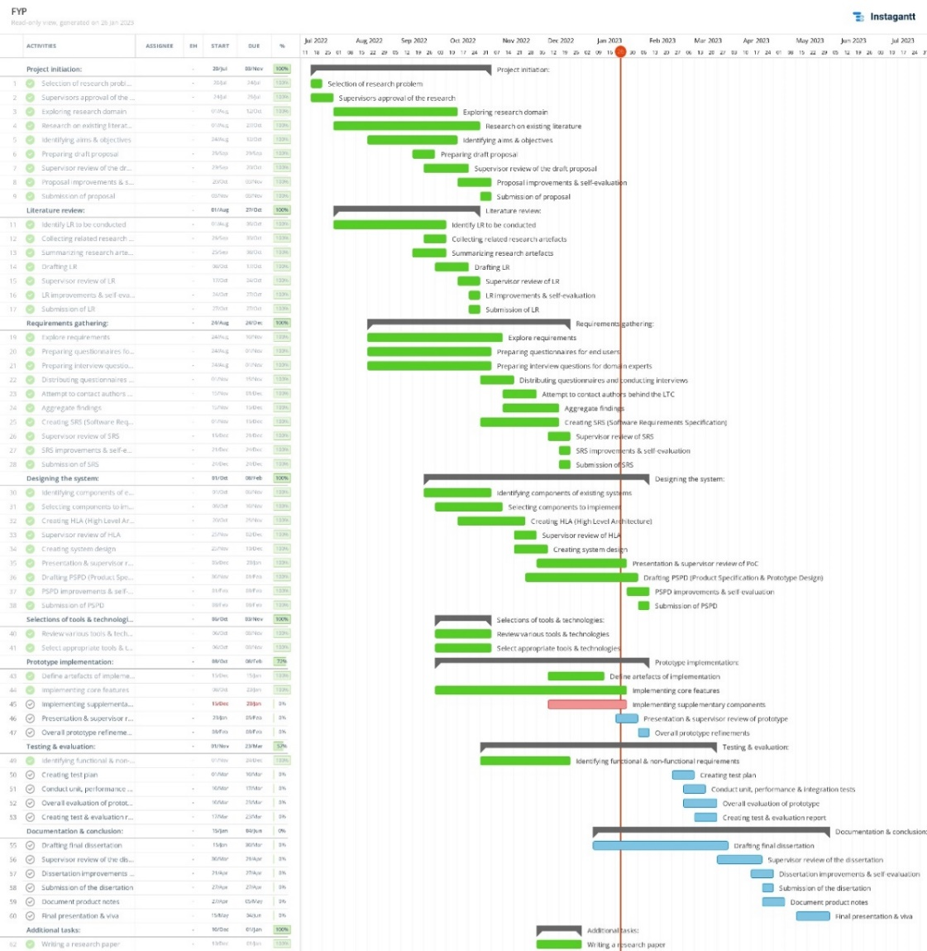

Figure 4: Gantt chart (*Self-Composed*)

*A clearer version can be found* [*Here*](https://drive.google.com/file/d/1hxyFfM2JPT-MGs1n7RSaJu0vGc9jKXvD/view?usp=sharing)

### **3.4.1.2 Deliverables**

The deliverables and respective dates are specified in the table below.

Table 4: Deliverables & dates

|  |  |
| --- | --- |
| **Deliverable** | **Date** |
| **Literature Review**. Critical analysis of related work & solutions. | 27th October 2022 |
| **Project Proposal & Ethics Forms**.The initial proposal of the research to be conducted. | 9th November 2022 |
| **Software Requirement Specification**. Defines the requirements that must be met to prototype and collect data. | 24th November 2022 |
| **Proof Of Concept & Implementation Presentation**. An initial implementation of the proposed system. | 23rd December 2022 |
| **Project Specifications Design & Prototype**. A prototype of the system with the core features and an accompanying document specifying the design followed & an overview of the implemented algorithm. | 16th February 2023 |
| **Test & Evaluation Report**. Documentation of test findings and evaluations conducted on the prototype. | 23rd March 2023 |
| **Draft Project Report**. A draft submission of the final thesis to get evaluations. | 10th April 2023 |
| **Final Thesis**. Final submission of the thesis with complete documentation of the project’s journey. | 27th April 2023 |

# **3.5 Resources**

## **3.5.1 Software requirements**

* **Operating System (Windows/macOS**/Linux**) -** Windows will be the default since it provides easy access to the required development environments and tools. macOS will be utilized to create documentation due to outstanding battery life and low power consumption.
* **Python/**R - to create the network & the respective model. Python, since it has a much simpler learning curve, provides easy integration with other mentioned software and is optimized for large-scale ML software. Meanwhile, R is more suitable for statistical data analysis (IBM Cloud Team, 2021)
* **TensorFlow/**Torch– provides libraries that facilitate DL in Python & R. TensorFlow, due to its large developer community and seamless integration with Keras for higher-level API development. Additionally, multiple visualizations will be required, which is made simple by TensorBoard (Dubovikov, 2018).
* **Flask/**Node/Golang – for seamless communication between the client and the model. Flask will be the primary choice since the ML component will use Python, it is incredibly lightweight, and there is only a requirement for a minimal REST API.
* **React**/Vue/Svelte – required to develop the client-side. A fast performant library is required to prevent lags and other performance issues. React will be the option because of the author’s familiarity and large community. (Boisdequin, 2020).
* **MongoDB** – to store the datasets and enable quick and efficient querying of the raw data.
* **VSCode/**PyCharm – environment to facilitate application development. VSCode is the primary choice since it provides a general-purpose yet lightweight development experience with multiple plugins making it more developer-friendly. PyCharm will be a secondary option if there are issues with the Python environment or a need for a dedicated python development environment.
* **Jupyter Notebook /** Google Colab– development environment for building the forecasting model. Jupyter will be the primary choice as it has less risk: it runs locally. Therefore, in case of power failures, training would not be interrupted. Colab will be the backup choice if there is a requirement for a GPU to train the model.
* **Zotero**/Mendeley – manage references and research artefacts. Zotero is chosen due to the author’s preference and is easy to use.
* **MS Office** | **Overleaf** – tools to create primary research reports. A combination of MS Office and Overleaf will facilitate the drafting of the project submission documents and the creation of professional research papers/surveys/reviews, if necessary.
* **Google Drive** / OneDrive – to backup research artefacts. Google Drive will be the primary option due to the unlimited storage availability provided by the university.
* **Figma** | **Canva** | **Draw.io –** tools to create figures and diagrams. Combining all three will streamline the design process, as each has its advantages. Figma - to design & prototype; Draw.io – to draw flow charts and other associated diagrams; Canva - to prepare attractive presentation slides.
* **GitHub**/Bitbucket**/**Gitlab – track, version & manage development code & research documents. GitHub will be the choice due to the author’s familiarity, integrations with the development environments, and email notifications that could be significant.

## **3.5.2 Hardware requirements**

* **Core i5 Processor (8th gen) /** Ryzen 5 **/** M1– for long-running intensive workloads and managing multiple development environments. The author has access to an intel processor; therefore, it will be the CPU choice. However, the other options would suffice just as much.
* **8GB Ram or above** – to manage model training, multiple development environments & multitasking. Moreover, it is required to load large datasets and multitask.
* **Disk space of approx. 20GB** – to store application code & data.

If the available hardware does not meet the required criteria, a cloud-based development environment can be used (ex: GitHub codespaces, Google Colab, Zotero web, Google Drive).

## **3.5.3 Technical skills**

* Creation of TS forecasting systems.
* Knowledge of ODEs & respective solvers.
* Implementation of a raw neural ODE and SDE.
* Ability to create optimized & scalable DL models.
* Creating a seamless deployment pipeline.
* Ability to develop optimized client-side charts & user interfaces that dynamically update.

## **3.5.4 Data requirements**

* **BTC price observations** – from a financial website (ex: [investing.com](https://investing.com/), [cmcmarkets.com](https://www.cmcmarkets.com/), [finance.yahoo.com](https://finance.yahoo.com/)).
* **BTC block reward size**, **Twitter volume** and **Google Trends** - from a website that provides the required data publicly without any authorization ([bitinfocharts.com](https://bitinfocharts.com/)).
* **BTC tweets** – from a scraper that scrapes Twitter tweets for each day.

# **3.6 Risks & mitigation**

The following table identifies possible risks that the author could face and how they could mitigate them.

Table 5: Risk management plan

|  |  |  |  |
| --- | --- | --- | --- |
| **Risk Item** | **Severity** | **Frequency** | **Mitigation Plan** |
| Lack of required knowledge | 5 | 5 | Get insights from domain experts and, if necessary, the author of the proposed algorithm. |
| Corrupted documentation | 4 | 4 | Store all necessary documentation on the cloud as well as external storage. |
| Lose access to development code | 5 | 2 | Backup code on source control and cloud storage. |
| Inability to deliver all expected deliverables | 4 | 2 | Follow a list of priorities and deliver accordingly. |
| Invalid research assumptions | 3 | 2 | Continue researching since the final output is a research contribution regardless. |

# **3.7 Chapter summary**

This chapter defined the proposed methodology followed by the author and discussed its reasoning. In detail, the author discussed the research, development, and project management methodologies followed. Finally, the project requirements, work breakdown plan, associated deliverables, and the risks that the author could face and their mitigation plans were specified.

# **CHAPTER 04. SOFTWARE REQUIREMENTS SPECIFICATION**

# **4.1 Chapter overview**

Requirement gathering is essential to ensure that the research is performed to the best possible quality and to develop software that would be helpful in the real world. In this chapter, the author focuses on identifying the requirements and the steps followed to gather these requirements. In detail, possible stakeholders, their interaction points and roles, are documented using a rich picture diagram and a stakeholder onion model. Furthermore, the requirement-gathering techniques followed and the insights obtained upon analysis are discussed to produce necessary functional and non-functional requirements, system diagrams, and prototype descriptions.

# **4.2 Rich picture**

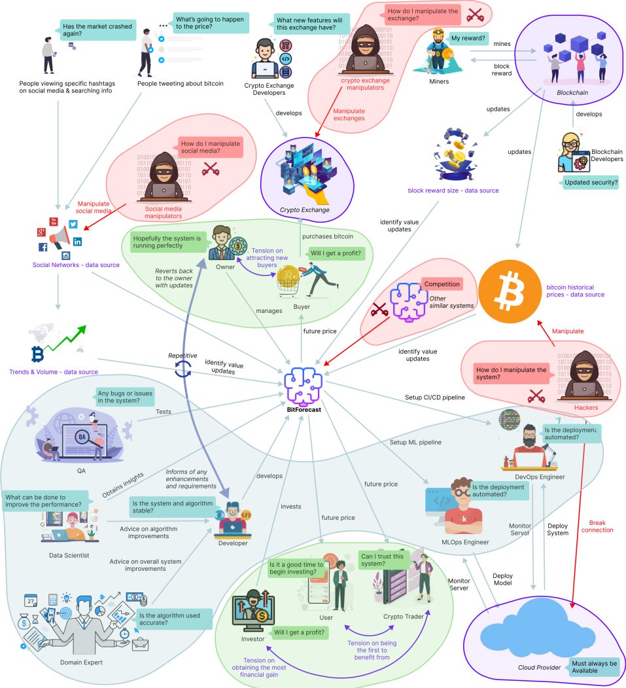

Figure 5: Rich picture diagram (*Self-Composed*)

*A clearer version can be found* [*Here*](https://drive.google.com/file/d/16Yju8CtlIUcos54x4ah7Bwv1Vy5jV_rr/view?usp=sharing)

The above diagram illustrates a helicopter view of the wider environment, how specific stakeholders would interact with the system, and how they would benefit. Furthermore, the negative impacts, stakeholders’ concerns, geographical localities, and stages of construction are identified, with knowledge the researcher could receive to improve the system.

# **4.3 Stakeholder analysis**

The following section recognizes key stakeholders associated with the system, their relationships, and their respective roles. The stakeholder onion model depicts this information, and the stakeholder viewpoints further detail it.

## **4.3.1 Stakeholder onion model**

The following diagram illustrates the key stakeholder interaction in an onion model.

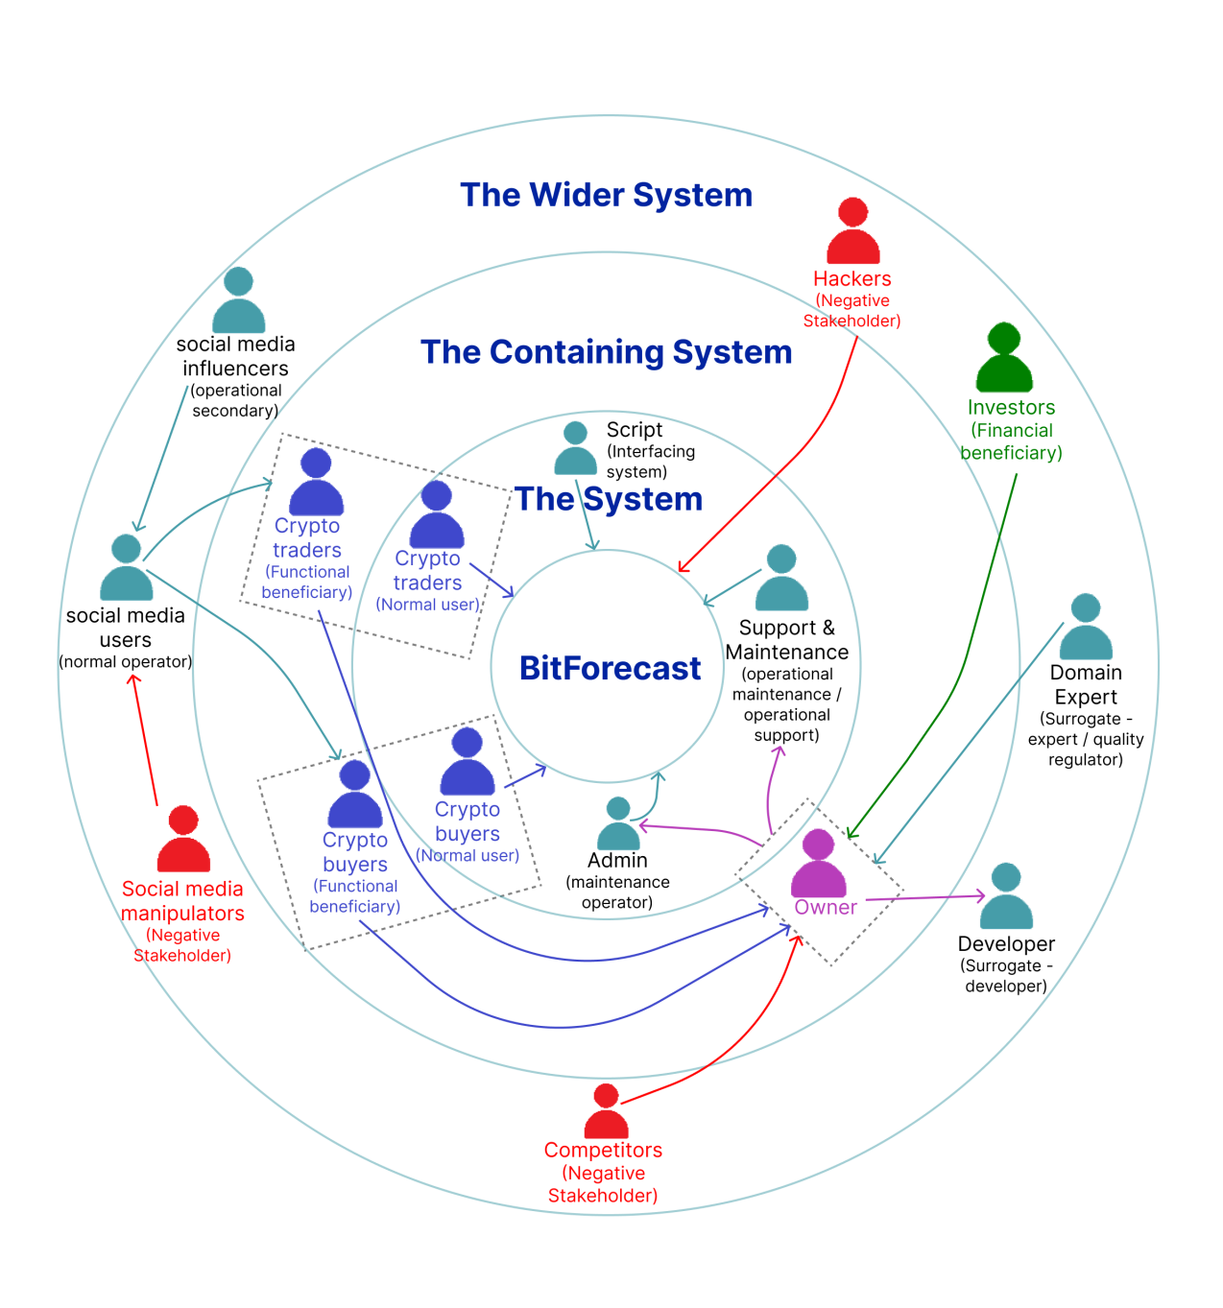

Figure 6: Stakeholder onion model (*self-Composed*)

## **4.3.2 Stakeholder viewpoints**

The following table describes the stakeholders, their role and associated actions.

Table 6: Stakeholder viewpoints

|  |  |  |
| --- | --- | --- |
| **Stakeholder** | **Role** | **Benefits/Description** |
| Support & Maintenance | Operational – support &  Operational - maintenance | Maintains the health of the system and attends to user inquiries. |
| Admin | Maintenance operator | Monitors and updates the system when necessary. |
| Script | Interfacing system | Fetches data and makes sure system is updated. |
| Owner | Owner &  Operational - administration | Manages other operators, listens to feedback, and communicates with other stakeholders. |
| Crypto trader | Functional beneficiary | More convenient for deciding whether to purchase or sell currently held assets. |
| Crypto buyer |
| Investor | Financial beneficiary | Makes profit by investing in the system, upon marketing, or user subscriptions. |
| Domain expert | Surrogate – expert &  Quality regulator | Provides advice on overall system improvements. |
| Developer (includes all roles in the rich picture) | Surrogate – developer | Develops the system. |
| Social media influencers | Operational - secondary | Influence users, drive trends, and provide thoughts. |
| Social media users | Normal operator | Get influenced to invest or sell currently held assets. |
| Competitors | Negative stakeholder | Build competing products that outperform or have better value. |
| Social media manipulators | Manipulate set trends and influencer thoughts. |
| Hackers | Disrupt the system and corrupt data. |

# **4.4 Selection of requirement elicitation methodologies**

Researchers can carry out requirement elicitation methodologies to gather requirements. The following table discusses the selected ones and their purpose.

Table 7: Requirement elicitation methodologies

|  |
| --- |
| **Method 01: Literature review** |
| An exhaustive literature review has been conducted to identify a respectable research gap in a cutting-edge research field and a domain of interest. The author studied existing systems to determine limitations and future research. A brief understanding of the implementation methods was also identified, alongside necessary best practices. |
| **Method 02: Observations** |
| Upon conducting the literature review, analysis of similar systems is an added advantage. Validating and evaluating its viability is paramount as the chosen research domain is relatively new. Existing algorithmic POCs must be studied and thoroughly assessed, as this will provide the author with the necessary insights and techniques to implement. |
| **Method 03: Interview** |
| Interviews can help gather knowledge and insights into more theoretical concepts that will be helpful behind the scenes for implementing the research component and associating with and answering the proposed research questions. The author can interview specific niche experts with knowledge of neural ODEs and SDEs to obtain said intuition, which they cannot acquire by conducting a survey. |
| **Method 04: Survey** |
| Obtaining insights and expectations from end users can be gathered by conducting a survey, specifically, the questionnaire. Upon receiving this prominent information, the author can decide whether the proposed system is helpful for the target audience and understand how the target audience intends to benefit from it. As they are large in sample size, the survey is a powerful choice for data collection. |
| **Method 05: Prototyping** |
| Prototyping will allow the developer to iterate between implementations and improvements. As the architecture is more novel, this procedure will be used abundantly as a straightforward approach to obtaining the optimal performance is unlikely and will take time. |

# **4.5 Discussion of findings**

The essential stakeholders were separated into groups, and each group was analyzed in the most suited methodology. The table breakdown of these stakeholders is available in **APPENDIX C.1**.

## **4.5.1 Literature review**

The below table discusses the key findings upon conducting an extensive literature review.

Table 8: Literature review findings

|  |  |
| --- | --- |
| **Citation** | **Discussion of findings** |
| **Research domain** | |
| Hasani et al., 2021 | Existing solutions in TS forecasting use traditional neural nets or statistics. |
| Hasani et al., 2020 | Traditional neural ODEs were underwhelming in performance compared to existing neural nets. |
| Duvenaud, 2021 | The proposed architecture by Hasani et al. (2020) uses the obsolete ODE, which lacks rapid adaptability - using an SDE instead can improve flexibility further. Therefore, combining both would produce the optimal architecture. |
| **Problem domain** | |
| Abraham et al., 2018; Valencia et al., 2019 | Based on the reviewed literature, work that included multiple exogenous features had not utilized a non-linear model. |
| Fleischer et al., 2022; Serafini et al., 2020 | Work that used a non-linear model had not included the additional features the author aims to include. As implied, a non-linear model with multiple features would produce the optimal solution. |

## **4.5.2 Observations**

The below table discusses the criteria of conducing observations and its respective findings.

Table 9: Observations findings

|  |  |
| --- | --- |
| **Criteria** | **Discussion of findings** |
| To find approaches to creating a neural SDE to implement the core research component | The author noticed that POCs of neural SDEs are available sparingly and had yet to be utilized in an ML system like the proposed solution. It is also safe to assume that building the research component could be later used as a baseline for future neural SDE implementations. |
| To find approaches taken to implement the additional component of BTC forecasting. | Although POCs of BTC forecasting systems that use LSTMs and statistical algorithms are available in abundance, what was noticed is that they all naively utilize only the closing price as a feature or the closing price with the Twitter sentiment. Considering this, the author decided to build the primary research component first so that the algorithm could be used to build ML systems and create the additional BTC forecasting system utilizing as many exogenous features as possible that can be of effect. |

## **4.5.3 Interviews**

Interviews were conducted to obtain domain expertise and any information that the author may have missed and could be significant. The author interviewed only a few candidates as the research domain is new and unknown; fortunately, they were the most knowledgeable. The author also interviewed a candidate experienced in the problem domain area. The findings were analyzed using thematic analysis and presented below. The participants’ affiliations and expertise areas are available in **APPENDIX C.2**with necessary evidence for the respective finding.

Table 10: Interview thematic analysis codes, themes & conclusions

|  |  |  |
| --- | --- | --- |
| **Code** | **Theme** | **Conclusion** |
| **Research component** | | |
| Algorithm architecture | Research Problem & Gap | The interviewees validated the research gap and the defined problem. They were also happy that the author had been conducting this research, as only a few papers were published in this domain. |
| Resource intensive | Requirements | The interviewees were concerned that ODEs and SDEs could be expensive to compute and hence could take some time, which can be an issue given that the forecasts must be produced quickly. Therefore, the author must optimize the model as much as possible to avoid user-unfriendliness. |
| Obsolete, Inflexible | Advice | The author had initially planned on only creating an implementation of the LTC architecture proposed by Hasani et al. (2020). However, the author could further improve the architecture by using SDEs instead (the base LTC uses ODEs), (which manifested into the LTS), which is the author’s current aim as it carries more significance and a potentially more outstanding contribution. |
| Visualizations, Explainability | Other suggestions | What was concluded here was that XAI is primarily present for image classification, and there needs to be more literature on the TS domain. However, XAI integration into TS modelling could be confusing and complicated due to the temporal component. Additionally, XAI for SDEs needs to be researched, which the author could look into if time permits. |
| **Problem domain** | | |
| External features  and trends | Robustness | The interview was an additional validation for the data collected in the survey. Most suggestions were to use as many extra features as possible to make the model robust. Therefore, the author will ensure that they utilize the mentioned exogenous features. |

## 

## **4.5.4 Survey**

A survey was conducted to gather requirements from the target audience to infer functionalities to implement for the supplementary product developed.

Table 11: Survey analysis

|  |  |
| --- | --- |
| **Question** | How much would a system capable of assuming tomorrow's price benefit you? |
| **Aim of question** | To identify whether the system is beneficial in the first place |
| **Findings & conclusions**    All the participants believed that the proposed system would be beneficial – where the majority had a greater belief than others. Having obtained this information, it is evident that the supplementary proposed system will be helpful. As identified, not a single participant thought that the system would not be beneficial. Notably, this validates the problem domain and gives the author the ‘green light’ to go ahead. | |
| **Question** | Who do you think would benefit from this system? |
| **Aim of question** | To identify beneficiaries and target audience |
| **Findings & conclusions**    The majority of the participants believed that the system would be beneficial for expert traders, investors as well as a new audience. However, what can be identified, is that a minute portion of participants assumed that the system would be helpful primarily for people who are already involved in the market – this is some evidence that the system must be made as simple as possible to attract a newer audience. It is also identified to help only a new audience – this is evidence that the system must not be immature. | |
| **Question** | This system will also benefit people who are not experts in cryptocurrencies |
| **Aim of question** | To identify whether non-technical crypto traders would benefit |
| **Findings & conclusions**    The responses to the above question show that the system will also apply to audiences who are not cryptocurrency experts. This question goes hand in hand with the previous question to confirm whether the system can target a newer audience of people to get into cryptocurrencies rather than just focusing on a niche audience who are experts or current investors/traders. | |
| **Question** | How do you decide whether to buy or sell assets? |
| **Aim of question** | To understand how a buyer/seller proceeds with their decision |
| **Findings & conclusions**    The responses to the above question are more of a ‘Know Your Customer’ question with no specific project-related purpose. Nevertheless, what can be identified is that most of the respondents have some knowledge of cryptocurrencies, where almost 70% are experienced in trading/investing cryptocurrencies – a great insight as nearly all the respondents have specific knowledge. Therefore, the author could use this to reach out to the respondents (whom they gathered requirements from) during the evaluation phase. | |
| **Question** | Do you think predicting a more future date (ex: a week from now) is as important as tomorrow's price? |
| **Aim of question** | To identify whether a greater future date prediction is also necessary |
| **Findings & conclusions**    The author initially considered only having a single horizon forecast, considering the limited time. However, based on the above responses, it is evident that the audience would also expect forecasts for multi horizons. Therefore, the author will additionally aim to implement the ability of multi-horizon forecasting. | |
| **Question** | Social media trends can impact the price |
| **Aim of question** | To identify whether the community believes that social media trends impact the price |
| **Findings & conclusions**    The majority of the respondents believe that social trends impact the price. Therefore, it is necessary to consider as many trends as possible. Considering the project's limited time and scope, the author has decided to use Twitter volume and Google Trends; however, Reddit, Facebook, and others would also provide insights and could be considered future work. | |
| **Question** | If a highly influential person tweets about Bitcoin, do you expect the price to tip to the side in favor of their tweets meaning? |
| **Aim of question** | To identify whether including Twitter sentiment is beneficial and to confirm the problem domain contribution. |
| **Findings & conclusions**    All participants believe that the current thoughts on social media affect the price in one way or another. Most participants further thought that the tweeter's influence adds additional significance. Considering this and the previous question, it is apparent that the mentioned social factors contribute to price changes, which validates the problem domain contribution. Additionally, based on the responses, the requirement to give more weightage to specific tweeter's sentiments (based on their influence) is apparent. | |
| **Question** | Would it be helpful to obtain a range of prices rather than a point price? (Ex: 10,000 - 15,000 instead of 12,500) |
| **Aim of question** | To identify whether including uncertainty estimates is beneficial |
| **Findings & conclusions**    The author initially decided on only providing a point forecast for the system, as this research aims to develop a novel architecture for TS forecasting. However, based on the responses and while conducting prototyping, it became evident that a single-point prediction is likely to be less valuable than a range of prices. A point prediction is implausible to be accurate, which makes the requirement of uncertainty estimates more vital. | |
| **Question** | What functionalities would you expect to have in a bitcoin forecasting system? |
| **Aim of question** | To identify any additional requirements |
| **Findings & conclusions**  To analyze opened ended questions, the author can perform thematic analysis. The analysis, including the theme and related codes, is available in **APPENDIX C.3**.  Based on the analysis conducted, it is evident that the participants would appreciate some Explainability. Including XAI is an addition that the author could look into if time permits. The participants also mentioned that the system would be better performant and robust if it utilized as many exogenous factors while making it as simple as possible. Based on these findings, the author will aim to include as much Explainability as possible and make it mandatory to use the mentioned exogenous features. | |
| **Question** | Any extra feedback you would like to provide? |
| **Aim of question** | No specific reason – is mainly used to obtain any additional feedback |
| **Findings & conclusions**  The respondents submitted a few motivational sentences to inspire and motivate the author to perform their best. | |

## **4.5.5 Prototyping**

Upon iterative prototyping, challenges that the developer did not expect to arise emerged. Challenges ranged from finding a suitable dataset to implementing the algorithm itself. The below table discusses the criteria for conducing prototyping and its respective findings.

Table 12: Prototyping findings

|  |  |
| --- | --- |
| **Criteria** | **Discussion of findings** |
| To explore the feasibility of creating the primary research component. | Building the algorithm was intimidating, as no proper reference exists. The author realized that, alongside traditional DL theories, implementing the algorithm required more profound knowledge and understanding of SDEs and differential solvers. As such a direct implementation was not possible. The author therefore implemented the LTC architecture first proposed by Hasani et al (2020) and then built upon it to develop the LTS algorithm. |
| To explore the feasibility of creating the BTC forecasting application. | The author had depended on the Twitter API to get tweet sentiment of specific days; however, this was impossible as Twitter had updated the API only to provide tweets of the past seven days. Fortunately, there were public datasets available up to a certain point in time; therefore, they had to use a third-party library to scrape tweets of dates ahead of that point in time. Moreover, upon experimentation, they gained an epiphany that solely the point price prediction would be useless; instead, a range of uncertainty estimations that provide a range of values would be more helpful. Furthermore, any explainable insights from the networks can be valuable to provide intuition into the forecast generation. |

(The rest of this page is intentionally left blank)

## **4.5.6 Summary of findings**

The below table summarizes the findings of all the techniques performed to gather the requirements for the MVP.

Table 13: Summary of findings

|  |  |  |  |  |  |  |
| --- | --- | --- | --- | --- | --- | --- |
| **ID** | **Finding** | **Literature Review** | **Observations** | **Survey** | **Interview** | **Prototyping** |
| **Research domain** | | | | | | |
| 1 | Validate research domain and gap. | ✓ | ✓ |  | ✓ |  |
| 2 | The novelty of the research hypothesis (an architecture inspired by the LTC). | ✓ | ✓ |  | ✓ |  |
| 3 | Neural ODEs are an advancement for TS forecasting. | ✓ |  |  | ✓ |  |
| 4 | Try to integrate latent SDEs into an LTC architecture for a novel algorithm implementation instead of using the same obsolete latent ODE. |  |  |  | ✓ | ✓ |
| **Problem domain** | | | | | | |
| 5 | The system will be of use to experts and new audiences. |  |  | ✓ |  |  |
| 6 | Social trends can be a source of impact. | ✓ |  | ✓ |  | ✓ |
| 7 | Well-known influencers’ opinions cause a more drastic impact. | ✓ |  | ✓ |  |  |
| 8 | A system combining all exogenous features in a non-linear model has yet to be explored. | ✓ |  |  |  |  |
| 9 | Including a range of prices than a point price is an added advantage and can produce more credibility. |  |  | ✓ |  | ✓ |
| 10 | Implementing an Explainability component will drastically make the system more credible. |  |  | ✓ |  | ✓ |
| 11 | A system capable of changing its hyperparameters would make it worthwhile for experts. |  |  | ✓ |  |  |

# **4.6 Context diagram**

The following diagram depicts the system’s boundaries and interactions. Determining them before the development will provide the author insight into how the information should flow.

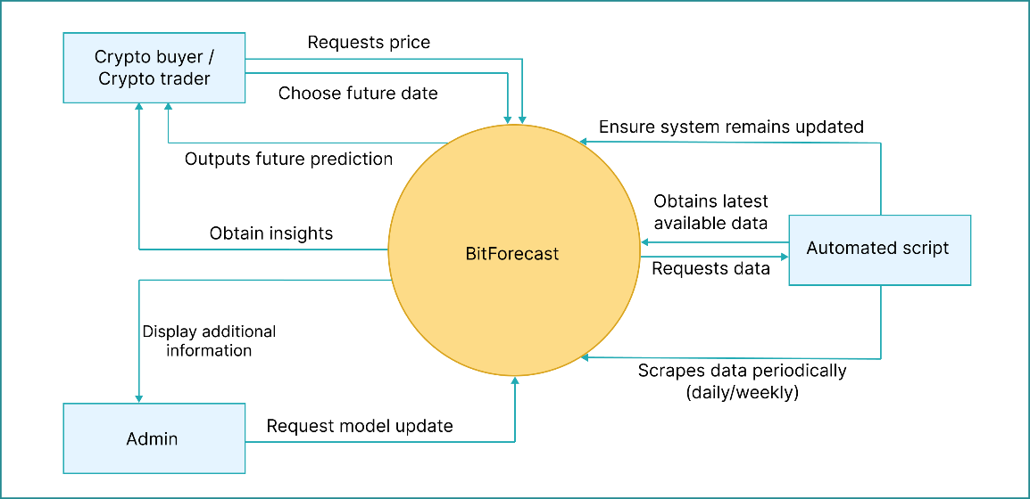

Figure 7: Context diagram (*Self-Composed*)

# **4.7 Use case diagram**

The below diagram demonstrates the “sea level” use cases of the proposed system, describing the functionalities at a high level the system will provide end users with.

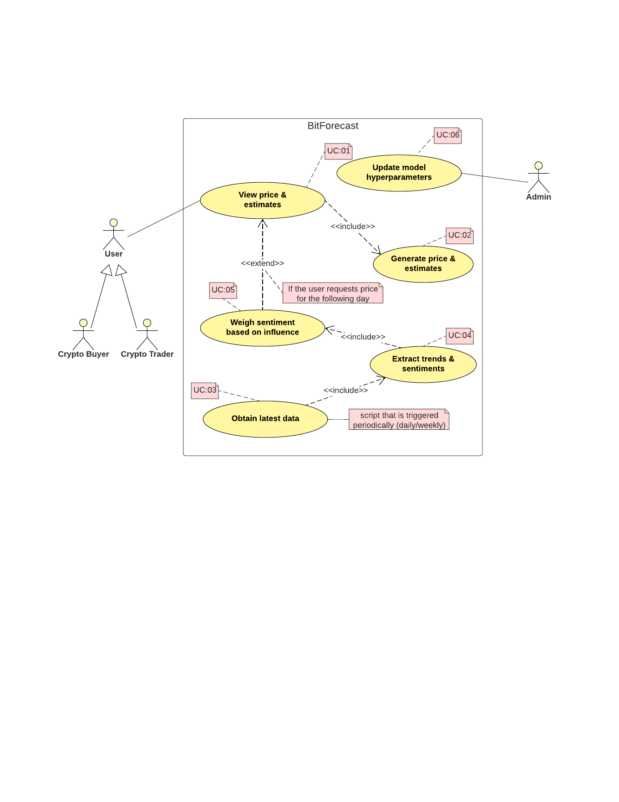

Figure 8: Use case diagram (*Self-Composed*)

# **4.8 Use case descriptions**

The core use case description is presented below; any sub-descriptions are available in **APPENDIX C.4**.

Table 14: Use case description UC:01; UC:02

|  |  |
| --- | --- |
| Use case | Display price & estimates |
| Id | UC:01; UC:02 |
| Description | Display future prices and their respective uncertainty estimations based on the user’s choice of date, alongside any Explainability insights. |
| Actor | User |
| Supporting actor (if any) | None |
| Stakeholders | Crypto buyer, crypto trader |
| Pre-conditions | All the data must be scraped and preprocessed, and the forecast should have been generated. |
| Main flow | 1. User requests tomorrow’s price. 2. The system recognizes the need to utilize available exogenous features. 3. The system ensures data available is up-to-date (must be in this case, as the script will run periodically automatically). If not:    1. Obtains the latest available data.    2. Performs sentiment analysis and self-retrains. 4. The system generates price and upper and lower estimations. 5. Display output to the user along with any insights. |
| Alternative flows | 1. The user requests the price for a date ahead of tomorrow. 2. The system recognizes the inability to utilize other features. 3. The system generates price and upper and lower estimations. 4. Display output to the user along with any insights. |
| Exceptional flows | 1. The system could not generate a prediction – display a user-friendly error message. |
| Post-conditions | The user is displayed with a forecast and necessary insights. |

# **4.9 Requirements**

## **4.9.1 Functional requirements**

The functional requirements were determined based on priority using the ‘MoSCoW’ technique, which is detailed in **APPENDIX C.5**.

Table 15: Functional requirements

|  |  |  |  |
| --- | --- | --- | --- |
| **ID** | **Description** | **Priority** | **Use Case** |
| **Research level** | | | |
| FR1 | A robust and scalable implementation of the novel algorithm must follow recommended standards. | M | **-** |
| FR2 | The developed algorithm must be able to be used as existing layers and algorithms (ex: LSTM, CNN). | M | - |
| **System level** | | | |
| FR3 | Users must be able to choose a future date. | M | UC:01 |
| FR4 | Users must be able to view the point prediction price. | M | UC:03 |
| FR5 | The system must generate the point prediction price based on the user’s choice of date. | M | UC:02 |
| FR6 | The script must obtain the latest data available periodically. | M | UC:04 |
| FR7 | The script must extract trends and sentiments from obtained data. | M | UC:05 |
| FR8 | Users should be able to view a range of prices along with the single-point price. | S | UC:03 |
| FR9 | The system should generate higher and lower bound uncertainty estimations. | S | UC:02 |
| FR10 | The GUI should plot the forecast with the current prices in a single graph to show the growth/decline. | S | UC:03 |
| FR11 | The script could weight sentiment based on any influential personnel’s tweet. | C | UC:06 |
| FR12 | The system could display some insights to the user, such as a highly influential tweet that made it predict the price. | C | UC:03 |
| FR13 | Admins could authenticate and update the model with different parameters. | C | N/A |
| FR14 | Admins could get additional information about a prediction, such as the evaluation metric and accuracy. | C | N/A |
| FR15 | The system will not produce forecasts for other cryptocurrencies. | W | N/A |
| FR16 | The system will not produce real-time forecasts (ex: hourly). | W | N/A |

## **4.9.2 Non-functional requirements**

The author prioritized the non-functional requirements based on the following two levels:

* Important – best to have them.
* Desirable – better to have them.

Table 16: Non-functional requirements

|  |  |  |  |
| --- | --- | --- | --- |
| **ID** | **Requirement** | **Description** | **Priority** |
| NFR1 | Performance | The system must take little time to generate a forecast, given that a couple of extra features are in use. | Important |
| NFR2 | Performance | The system must not unnecessarily keep updating its data. | Important |
| NFR3 | Usability | The user interface must be simple and effective and provide user-friendly errors if any occur. | Important |
| NFR4 | Maintainability | The author must document the codebase well in case of future reference, mainly the algorithm development repository. | Important |
| NFR5 | Quality | The output must be of good quality so that it provides vital insights. | Desirable |
| NFR6 | Scalability | The system must be deployed to a cloud with no scaling issues and good resources for efficient and optimal performance, especially as there could be multiple concurrent active user requests. | Desirable |
| NFR7 | Security | The system must be resilient to attackers, specifically to prevent data manipulation. | Desirable |
| NFR8 | Compatibility | To ensure compatibility, the developer must test the system on most browsers and mobile phones. | Desirable |
| NFR9 | Availability | In critical failures, the primary operator must be available and solve issues as soon as possible. | Desirable |

# **4.10 Chapter summary**

In this chapter, the author defined necessary stakeholders interacting with the system and described how the interaction would occur, visualizing this using a rich picture diagram and Saunder’s Onion model. Additionally, requirement elicitation techniques, their reasoning, and their respective findings were discussed and presented. Finally, the author specified the use cases, associated descriptions, and system requirements.

# **CHAPTER 05. SOCIAL, LEGAL, ETHICAL & PROFESSIONAL ISSUES**

# **5.1 Chapter overview**

This chapter outlines any social, legal, ethical or professional issues that arose during the journey of this project and the actions that were taken to mitigate them.

# **5.2 SLEP issues and mitigation**

The below table breaks down any identified SLEP issues and how they were mitigated.

Table 17: SLEP issues & mitigation

|  |  |
| --- | --- |
| **Social** | **Legal** |
| Names of the interviewees are not included in the dissertation.  Personal details were not collected by the conducted survey, and the respondents were kept anonymous.  Information obtained are not saved elsewhere. | The datasets used are all available freely for the public and no names were recorded for the case of Twitter tweets.  Utilized tools and technologies are open source or are provided to students free of charge.  The codebase is available in GitHub with the open-source MIT license. |
| **Ethical** | **Professional** |
| Participants were clearly informed on what would the data be used for.  The work presented in this report is genuine and not reproduced elsewhere. Any ideas taken are clearly cited and given credit. | Professional standards were followed as much as possible.  Responses and evaluations received are not tampered with and the limitations are clearly stated. |

# **5.3 Chapter summary**

The chapter detailed the social, legal, ethical and professional issues the author faced while conducting this research and the steps they took to solve them.

# **CHAPTER 06. DESIGN**

# **6.1 Chapter overview**

Prior to implementation, detailed designing is required to ensure that implementation is as seamless as possible. In this chapter, the author focuses on selecting suitable architectural structures for implementation, considering the gathered requirements. Specifically, high-level, low-level, and associated design diagrams are presented alongside necessary UI wireframes. Moreover, the LTS architecture and a novel tweet sentiment weighting formula are also presented.

# **6.2 Design goals**

The design goals that should be achieved by the system are specified in the table below.

Table 18: Design goals of the proposed system

|  |  |  |
| --- | --- | --- |
| **ID** | **Goal** | **Justification** |
| DG1 | Performance | A typical flow in TS forecasting requires retraining the model whenever a prediction is made, as the data the model had been trained on could be outdated. However, as multiple features are being used in the proposed system, this can severely hinder performance. The author can avoid this by storing past data and only fetching needed data when necessary; as a further step, the data can be fetched periodically. |
| DG2 | Usability | Based on the analysis obtained during the requirement-gathering phase, there were mixed thoughts on whether the application would benefit people who are not experts in cryptocurrencies. Therefore, this requirement is mandatory as it is crucial to create a system that is as user-friendly as possible to be used by users across all levels of expertise. |
| DG3 | Quality | The output must be of the highest possible quality. Also, as identified in the gathered requirements, the system must display a range of prices to provide more conviction. |
| DG4 | Maintainability | As implied by the author, the research must yield two products for the project to be successful. The goal of maintainability is solely for the research product proposed. The architecture of the algorithm must be optimal and independent to be able to be used as a reference for future research. |

# **6.3 System architecture design**

## **6.3.1 Architecture diagram**

The system’s high-level architecture design is depicted below. The author chose a three-tiered architecture because of the distinct separation of concerns of the presentation, logic, and data layers.

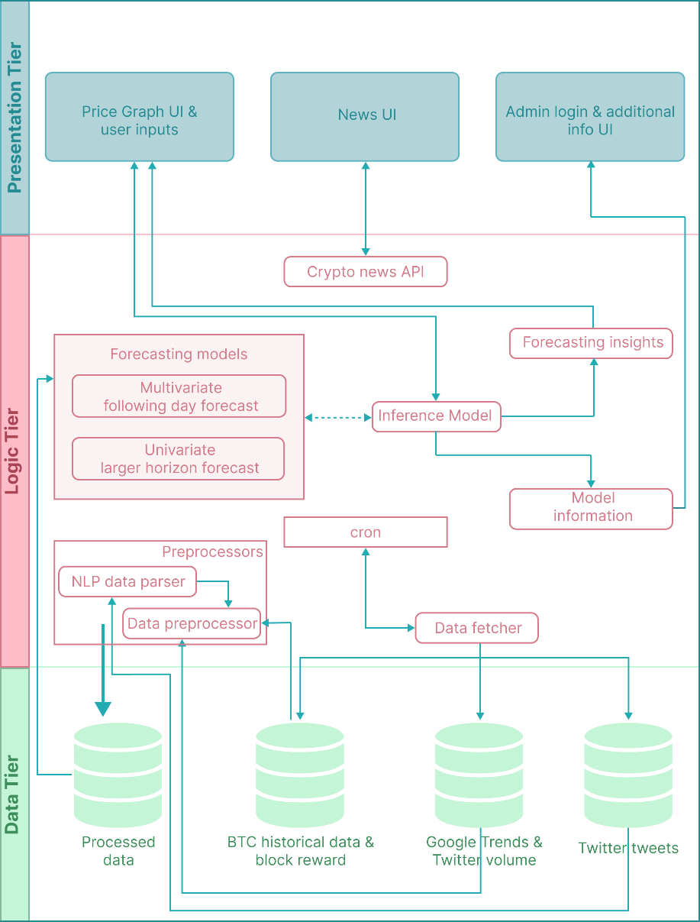

Figure 9: Three-tiered architecture (*Self-Composed*)

## **6.3.2 Discussion of tiers of the architecture**

**Data Tier**

All data in this layer are fetched from an API and stored in individual collections in MongoDB to ensure updated data is available whenever necessary.

* BTC historical data & block reward – historical data of BTC closing prices of the past several years and the associated block reward obtained for mining BTC.
* Google Trends - historical data of the number of searches made each day that are BTC-related.
* Twitter volume – historical data of the number of tweets posted each day that are BTC-related.
* Twitter tweets - historical data of the tweets posted that are BTC-related.

**Logic Tier**

The logic tier consists of the base logic performed on the data in the data tier to provide an output in the presentation tier.

* Preprocessors – consist of code required to process the raw data fetched from the API’s so that the forecasting model can use it.
  + Data preprocessor – required for general preprocessing steps such as normalization and cleaning.
  + NLP data parser – required to perform sentiment analysis on the tweet data and give more weightage to a specific tweeter’s sentiment.
* Data fetcher & cron – the automated scheduler that the script will run periodically to ensure that the data and model are up-to-date.
* Forecasting models – models that will be used to provide forecasts.
  + Multivariate following-day forecast – utilized for the following-day forecasts.
  + Univariate greater horizon forecast – utilized for forecasts requested days ahead of the following day.
* Model information – extra information of the model that the admin could view (ex: accuracy, no. of epochs).
* Forecasting insights – additional information presented to the user to demonstrate forecasting-related Explainability.
* Crypto news API – an additional third-party API to provide users with daily cryptocurrency news.

**Presentation Tier**

The point of interaction where the user interacts with the system.

* Price graph UI & user inputs – main UI of the MVP that is presented to the user. It would display the current pricing graph, provide the user options to choose a future date, and generate a new chart with the inference.
* News UI – a minor sub-feature that will display news about the cryptocurrency world.
* Admin login & additional info UI – a ‘could have’ feature that will provide an authorized user to obtain information about the current model in use and, further, provide the ability to retrain the model by adjusting hyperparameters in use.

# **6.4 Detailed design**

## **6.4.1 Choice of design paradigm**

As identified in previous chapters, the choice of design paradigm is SSADM. To re-elaborate, as this research is primarily focused on developing a novel architecture with a novel algorithm, extensive experimentation is paramount. Furthermore, the selected programming languages do not promote OOP; instead, they encourage using function-based modules and components.

# **6.5 Design diagrams**

## **6.5.1 Data flow diagrams**

The data flow diagrams are depicted using level 0, level 1, and level 2, where level 0 is the **context diagram** presented in the SRS chapter.

### **6.5.1.1 Level 01 data flow diagram**

The level 01 diagram is an extensive breakdown of the core components proposed in the context diagram.

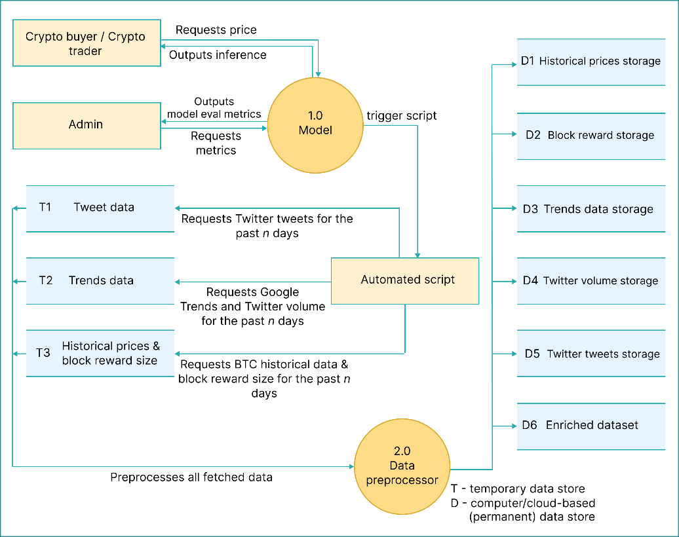

Figure 10: Data flow diagram - level 01 (*Self-Composed*)

### **6.5.1.2 Level 02 data flow diagram**

The level 02 diagram is a more extensive breakdown of the core data preprocessor component proposed in level 01.

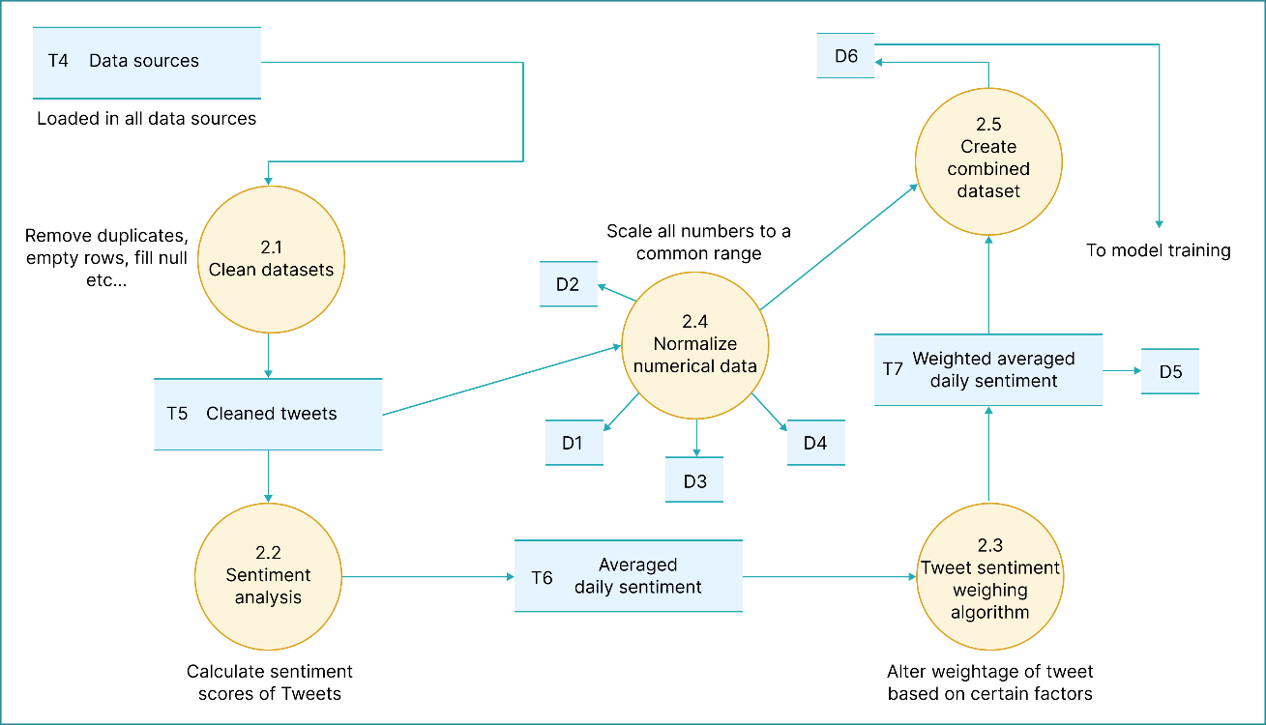

Figure 11: Data flow diagram - level 02 (*Self-Composed*)

## **6.5.2 Algorithm design**

**Research domain**

Upon gathering requirements to implement the research component, the author realized they could further enhance the existing LTC architecture by integrating flexible latent SDEs instead of the current ODEs. The author will therefore attempt to design and evaluate a novel algorithmic implementation inspired by the original LTC proposed by Hasani et al. (2020), which can be considered their primary contribution to the body of knowledge (the LTS is the result of this modification). A simple illustration is available in **APPENDIX D.1** to gather intuition alongside an in-depth derivation and explanation of the proposed formula.

**Problem domain**

Upon analyzing requirements and reading literature on the supplementary forecasting application being implemented, the author noticed that there was no clear technique to weight tweet sentiments based on the tweeter’s influence. The author therefore will propose another novel algorithm to weight these sentiments - this can be considered as a secondary contribution.

### **6.5.2.1 Liquid Time-stochasticity (LTS) algorithm**

Upon studying the architecture proposed by Hasani et al. (2020), the author could utilize a linear system of SDEs to declare the flow to manifest a novel algorithm with more flexibility for instantaneous adaptation of tiny changes. Moreover, this is an excellent enhancement as the additional component being developed belongs to the open market, which can have small instant price changes. The below formula is what the author proposes:

$$\boxed{\frac{dx(t)}{dt}=-\left[\frac{1}{τ}+f\left(x\left(t\right), I\left(t\right), t,θ\right)-oB \right]x\left(t\right)+f\left(x\left(t\right),I\left(t\right),t,θ\right)A }$$

Where;

|  |  |  |  |
| --- | --- | --- | --- |
| $$τ$$ | *Time-constant* | $$f$$ | *Neural network* |
| $$x\left(t\right)$$ | *Hidden state* | $$θ,A$$ | *Parameters* |
| $$I\left(t\right)$$ | *Input* | $$B$$ | *Noise (Brownian motion)* |
| *t* | *Time* | $$o$$ | *Intensity of noise (parameter)* |

**Algorithm forward propagation by SDE solvers**

Hasani et al. (2020) determined that their LTC architecture that uses a linear system of ODEs was ‘stiff equations’. They also found that regular Runge-Kutta was not suitable for solving LTCs; therefore, they designed a custom ODE solver by combining both implicit and explicit Euler methods.

As this system uses SDEs, SDE solvers must be used. As Hasani et al. (2020) determined, the architecture is a system of stiff equations. Therefore, as Press et al. (2007) decided, researchers must use an implicit solver to ensure stability. Additionally, researchers can combine an explicit solver to achieve further stability. Therefore, the author will use an SDE solver, which is implicit, and if time permits, create a further enhanced custom SDE solver by fusing an explicit solver within.

Based on the author's research, the SDE equivalent for ODE Euler methods is the Euler-Maruyama method; this is the recommended solver as it can handle all forms of noise (Li et al., 2020). Combining the explicit Euler-Maruyama solver within to create a custom solver is something researchers should explore in the future.

**How to train the network?**

Training these networks has a trade-off between accuracy and memory. Chen et al. (2019) promoted the use of the adjoint sensitivity method to perform reverse-mode AD, which is more memory efficient. Hasani et al. (2020) mentioned that this method introduced more numerical errors and opted to use the traditional BPTT approach, which is more accurate but consumes more memory. Although there exists a technique of adjoints specifically for SDEs, they cannot be used, as determined by Tzen and Raginsky (2019), and hence requires a custom-built backpropagation rule.

For this research, the author will opt for the approach by Hasani et al. (2020) to give more precision and as the author is time constrained to implement a custom backpropagation algorithm. Researchers must investigate reverse-mode AD in the future as it is the recommended approach when memory efficiency is more important. It is also worth noting that using the BPTT approach carries added benefits, such as being able to be used as an RNN layer alongside the popular optimization algorithms that are very familiar (ex: Adam, SGD) (Hasani et al., 2020).

### **6.5.2.2 Tweet sentiment weighting algorithm**

Based on the requirements received from end-users, it is evident that the impact of tweets depend on how influential the tweeter is. Performing this algorithm would change the weight of the sentiments of the tweets based on how influential the tweeter is and the engagement of the tweet itself. The author considered the “total followers” and “total listed” metrics of the tweeter, and the number of retweets and likes of the specific tweet; the other metrics are not directly correlated and as such were not considered at this point in time. The formula is presented below:

$${influencer}_{sum}={α\log_{10}\left({followers}_{count}+1\right)+ }β\log_{10}{(lists_{count}+1)}$$

$${tweet}_{sum}={γ\log_{10}\left(retweets_{count}+1\right)+ }δ\log_{10}{(like_{count}+1)}$$

$$\boxed{weighted_{score}=\frac{tweet_{sum}+influencer_{sum}}{tweet_{sum}+influencer_{sum}+1}*compound_{score} }$$

Where;

|  |  |  |  |
| --- | --- | --- | --- |
| $$α$$ | *Weight of number of followers*  ***Set as 0.5*** | $$γ$$ | *Weight of number of retweets*  ***Set as 0.1*** |
| $$β$$ | *Weight of number of lists*  ***Set as 0.3*** | $$Δ$$ | *Weight of number of likes*  ***Set as 0.1*** |

The derivation of this formula can be found in **APPENDIX D.2**.

## **6.5.3 LTS algorithm analysis**

The notable difference between the proposed architecture and traditional neural ODEs proposed by Chen et al. (2019) is the traditional BPTT approach instead of the recommended adjoint sensitivity. The analysis of the complexities of these approaches is demonstrated in **APPENDIX D.3**.

The traditional BPTT approach yields more accurate results, with the trade-off of consuming more memory, whilst reverse-mode AD acts the opposite (BPTT has **high** backward accuracy, but **O(L)** time and memory complexities compared to **O(LlogL)** time complexity and **O(1)** memory complexity in reverse-mode AD). Therefore, to obtain the best result possible, the author chose the approach of the traditional BPTT.

## **6.5.4 UI design**

The author had decided to implement a web application for the supplementary application being built due to convenience. The low-fidelity wireframes designed to be of use are available in **APPENDIX D.4**.

## **6.5.5 System process activity diagram**

A summarized system flow activity diagram that end-users will follow is presented below.

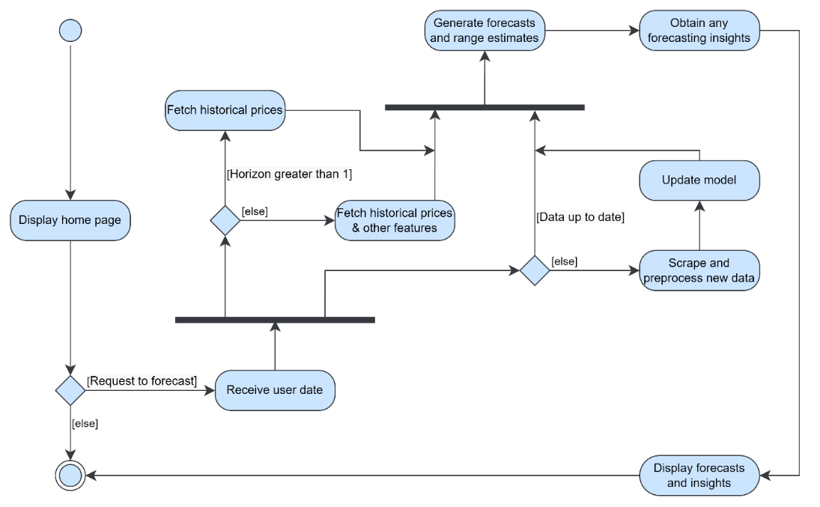

Figure 12: System process activity diagram (*Self-Composed*)

# **6.6 Chapter summary**

This chapter presented the design of the LTS algorithm architecture, the necessary intuition behind it, and the reasons for taking specific directions over others. Moreover, a novel tweet sentiment weighting algorithm is also presented. Additionally, the chapter illustrated the system’s design, architecture, data and system flow diagrams, and wireframes that would demonstrate them in the end application.

# **CHAPTER 07. IMPLEMENTATION**

# **7.1 Chapter overview**

Upon designing necessary diagrams, the next step is to convert the idea into reality. In this chapter, the author describes the core implementation of the system and the necessary decisions taken to approach that implementation. Moreover, the chosen tools, languages, and technologies are presented with their reasoning for being chosen over others.

# **7.2 Technology selection**

## **7.2.1 Technology stack**

The chosen technologies and tools to implement the system are depicted in the diagram below.

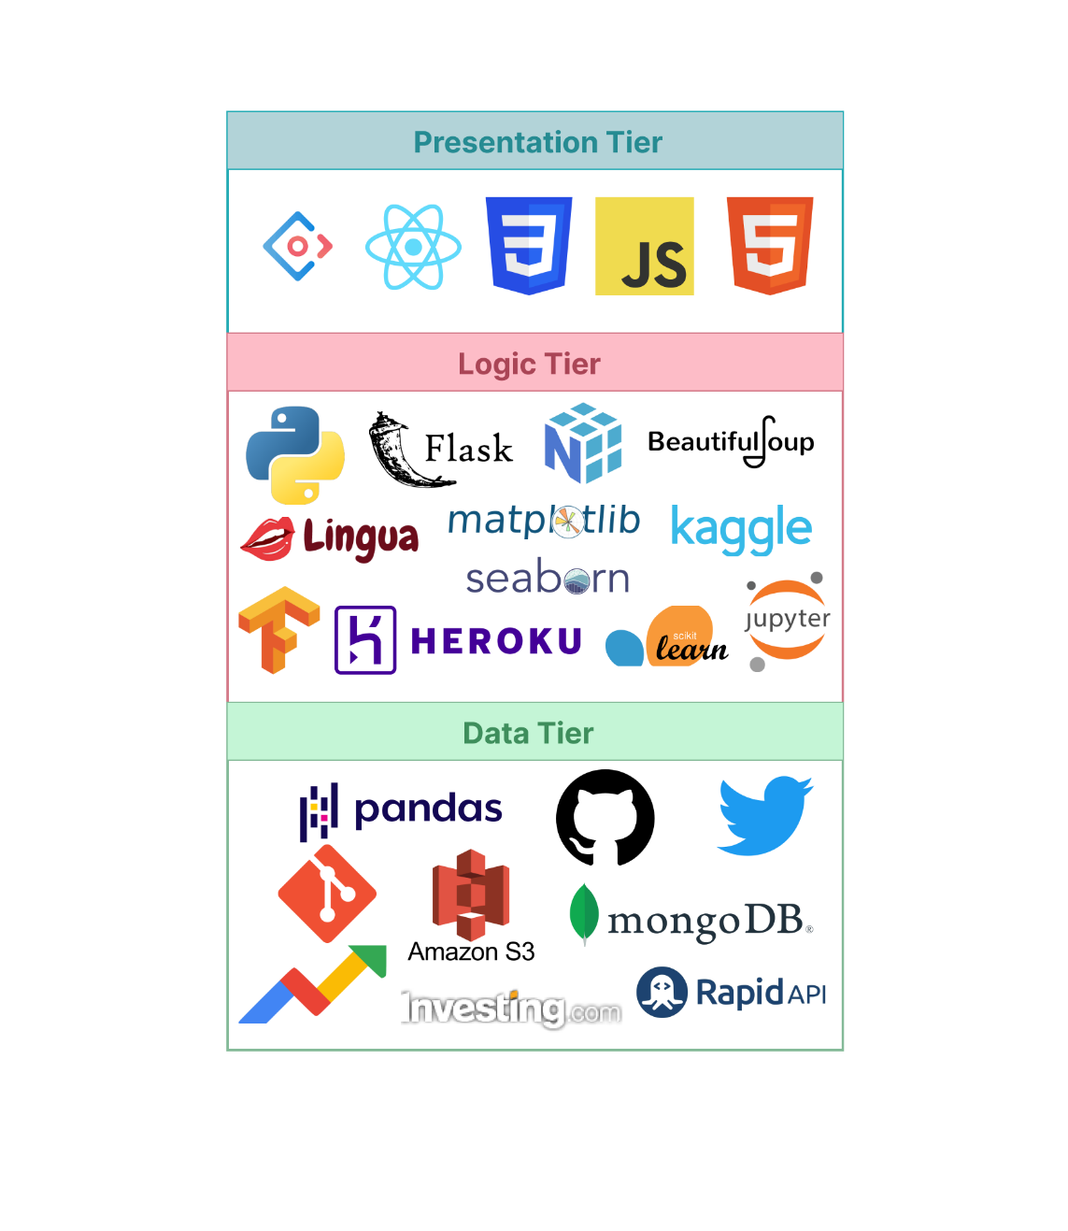

Figure 13: Tech stack (*Self-Composed*)

## **7.2.2 Selection of data**

Table 19: Dataset sources

|  |  |
| --- | --- |
| **Dataset** | **Source** |
| BTC historical data | From a third-party investing.com API. |
| BTC block reward size, BTC Twitter volume, BTC Google Trends | From a public dashboard that provides multiple different information about a specific cryptocurrency. |
| BTC tweets | Tweets from 2014-2019 were downloaded from Kaggle – the remaining dates were extracted from a Twitter tweet scraper. |

The multivariate single-horizon forecasting model combined the above data, while the univariate multi-horizon forecasting model solely used the historical data. Gathering the data was long and arduous as it was not as simple as downloading available datasets, and specific APIs being rate-limited. Dedicated python scripts were written to extract the data, store it into a MongoDB database, and to streamline updating data. The author will publicize these scripts and the data to facilitate future research.

## **7.2.3 Selection of programming language**

Programming languages were analyzed before development. Specifically for three main aspects: the client, the data science component, and the API communicating between the model and the client. Based on the analysis conducted in **APPENDIX E.1**, the author decided to use **Python**, as it was more relevant.

To develop the user interface, not much competition is present to analyze. **JavaScript** is the stand-alone leader and is the author’s choice, as it is dynamic and can handle user interactions seamlessly. Although recent technology has presented the usage of C# for frontend development, high latency issues and lack of community knowledge are a downfall.

APIs are required to set up the communication between the model and the user interface. Multiple technologies are available for API development. The author chose **Python** as their core data science component is also built using Python; therefore, utilizing the same language would reduce the time taken to learn new languages for insignificant reasons.

## **7.2.4 Selection of development framework**

### **7.2.4.1 Deep Learning (DL) framework**

The author chose Python for developing the core data science component. As the core algorithm and model will be DL-based, DL frameworks must be meticulously analyzed to select the most relevant framework. The two most popular frameworks, TensorFlow and PyTorch, were analyzed in **APPENDIX E.2**, where the author opted to use **TensorFlow**, as it provides low-level details.

### **7.2.4.2 User Interface (UI) framework**

As JavaScript was chosen for developing the UI, respective JavaScript frontend frameworks and libraries must be analyzed. There is an ocean of JavaScript libraries - the top four were selected for evaluation: Angular, Vue, Svelte, and React. The author decided to use **React**; the evaluation can be found in **APPENDIX E.3**, as there is no requirement for large-scale app development.

### **7.2.4.3 Application Programming Interface (API) web framework**

As python was chosen for the API development, respective Python web frameworks must be analyzed to select the more relevant one. Analysis was conducted between Django and Flask, as they are the two most popular frameworks. **APPENDIX E.4** demonstrates the comparison where the author decided to use **Flask**, as it is used for only exposing the models.

## **7.2.5 Other libraries & tools**

Other libraries and tools that would facilitate implementation are stated in the table below.

Table 20: Chosen libraries & tools

|  |  |
| --- | --- |
| **Library** | **Justification** |
| NumPy | Facilitates mathematical functions and calculations that are immensely required when building the algorithm. |
| Pandas | To create dataframes to perform analysis, cleaning, transformations, filtration, etc., on the datasets. |
| Scikit-learn | To create data splits and feature scaling. |
| Lingua | To detect the language of the tweets. As this project is limited to using only English tweets, they must first be identified. |
| Matplotlib + Seaborn | For analysis, visualizations, and dashboarding. |
| Beautiful Soup | For scraping the block reward size and the Twitter volume from the public dashboard. |
| VADER | Perform sentiment analysis on the tweets. |
| Redux | For API requests from the client. |
| Ant design | Makes creating appealing user interfaces hassle-free. |
| MongoDB | To store the datasets and retrieve/update whenever necessary. |
| AWS S3 | Store the models in use. |
| Heroku | To host the Flask API. |

## **7.2.6 Integrated Development Environment (IDE)**

IDEs are required to streamline implementation; the chosen IDEs are stated in the table below.

Table 21: Chosen IDEs

|  |  |
| --- | --- |
| **IDE** | **Justification** |
| Kaggle | Consists of 32GB of RAM; therefore, all datasets can be loaded and processed at once without needing to process sections of data at a time. Additionally, it provides easy integration with existing Kaggle datasets and user-uploaded datasets. |
| Jupyter | For local trials, testing, and model training. |
| VSCode | Lightweight and extremely powerful. It consists of multiple shortcuts, extensions, and snippets that can significantly boost development productivity. |

## **7.2.7 Summary of chosen tools & technologies**

The table below summarizes the tools and technologies the author chose to aid in implementation.

Table 22: Summary of chosen tools & technologies

|  |  |
| --- | --- |
| **Component** | **Tools** |
| Programming languages | Python, JavaScript |
| Development framework | Flask, TensorFlow |
| UI development framework | React |
| Libraries | Ant design, NumPy, Pandas, Scikit-learn, Beautiful Soup, Lingua, Matplotlib, Seaborn, VADER sentiment analyzer, Redux, Ant design, MongoDB, Heroku |
| IDEs; Version control | Kaggle, Jupyter notebooks, VSCode; Git + GitHub |

# **7.3 Implementation of core functionalities**

The novel algorithm, the scripts to fetch the required data, and the preprocessing performed can be considered the core functionalities of the project.

## **7.3.1 Algorithm implementation**

The author initially implemented the LTC architecture since there is no modern reference utilizing recommended best practices and approaches. The author then built on this architecture, replacing the underlying ODEs with SDEs.

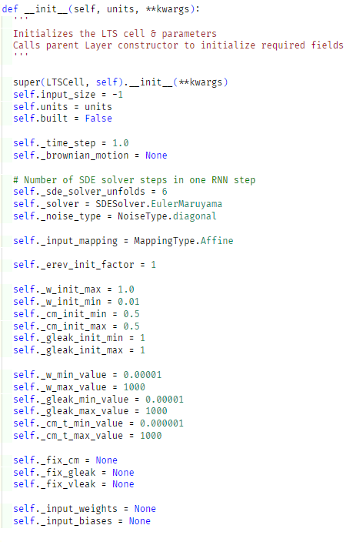

Figure 14: Initialize algorithm (*Self-Composed*)

The above code snippet initializes the algorithm cell with the necessary variable maximum and minimum values. In the above method, the built model can perform input-independent initializations. By inheriting from the base Keras Layer class, the ability to be used in the higher level of the model’s layer definition is obtained (as existing LSTM and RNN cells).

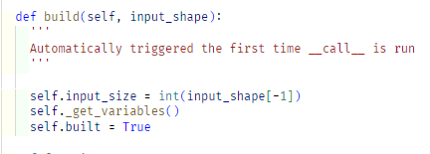

Figure 15: Build algorithm (*Self-Composed*)

The above snippet defines what occurs upon initialization; in other words, it “builds” the algorithm cell. A helper function is utilized here that defines the variables (sigma, mu, weights, and leakage conductance variables (Hasani et al., 2020)). The input shape is available within the above function; therefore, the model can initialize the variables used here. The below snippet demonstrates how some of these variables are initialized.

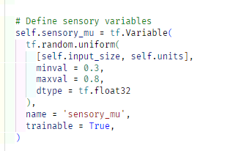 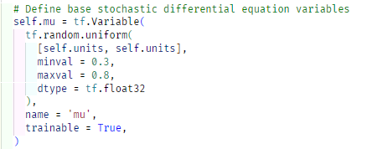

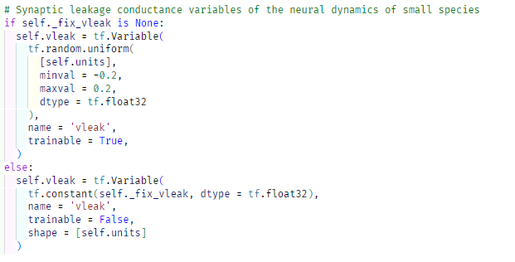

Figure 16: Algorithm – sensory, stochastic and leakage variables (*Self-Composed*)

The final step is the forward computation process that will occur on each epoch, in other words, the forward propagation process.

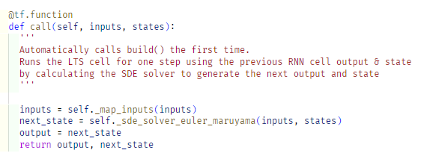

Figure 17: Algorithm – forward propagation (*Self-Composed*)

The above function is run automatically on each epoch. Initially, a helper function defines the weights and biases of the network, as demonstrated below.

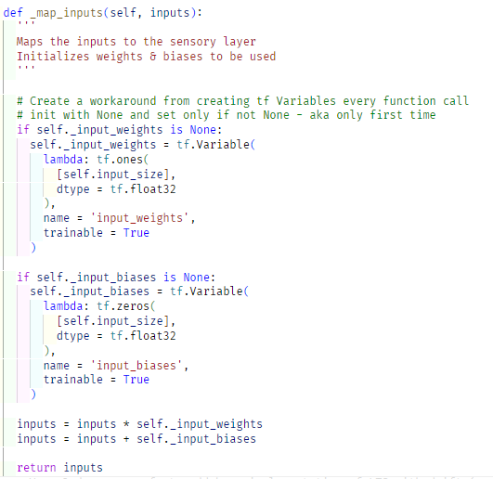

Figure 18: Algorithm – define weights and biases (*Self-Composed*)

As determined in chapter 6, the optimal way of performing the forward computation of SDEs is to use the Euler-Maruyama method. The below code snippet is an implementation of the Euler-Maruyama SDE solver used by the author utilizing Brownian motion as the noise, as demonstrated by Duvenaud (2021).

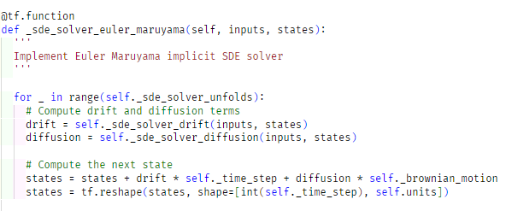

Figure 19: Algorithm – Euler-Maruyama SDE solver (*Self-Composed*)

## **7.3.2 Data fetchers**

The scripts that are used to extract the data. The scripts are placed under **APPENDIX E.5**.

## **7.3.3 Preprocessing**

Preprocessing steps are required to prepare the data fetched from the data fetchers before being used by the model. The preprocessing scripts are placed under **APPENDIX E.6**.

# **7.4 User interface**

Screenshots of the final GUI are placed under **APPENDIX E.7**.

# **7.5 Chapter summary**

This chapter focused on defining the technologies and tools that facilitate the software development that would demonstrate the research. Additionally, the implementation of the core features is shown with accompanying code snippets.

# **CHAPTER 08. TESTING**

# **8.1 Chapter overview**

Once implementation is satisfactory, testing is essential to ensure that the system’s functionalities act as expected. In this chapter, detailed testing is performed on the system and the model in use. Testing methodologies utilized include functional, non-functional, integration, and model testing, to evaluate the system as much as possible.

# **8.2 Testing objectives & goals**

The ultimate goal in conducting testing is to ensure that the system performs as expected. To meet this goal successfully, a couple of testing objectives must be met:

* Ensure that the model’s performance is as performant as it can be.
* Ensure that the functionalities implemented align with the MoSCoW’s technique of “Must have” and “Should have”.
* Identify any bug fixes / improvements that must/can be applied to the application.
* Identify if the important non-functional requirements are met.
* Conduct baseline-benchmarking so that the system can be benchmarked against in the future.

# **8.3 Testing criteria**

Prior to conducting testing, a criterion was defined that would test the system in two methods.

* Functional testing – focused on determining how well the system performs and meets the functional requirements.
* Structural testing – focused on evaluating the achievements of the non-functional requirements and design goals.

# **8.4 Model testing & evaluation**

## **8.4.1 Model testing**

Two ensemble models were implemented: univariate and multivariate. Both models were tested in a similar fashion by setting a “pseudo-future” from a specific timeframe.

*A pseudo-future is a “fake” future where we know what the actual value is at that point in time.*

The below graphs illustrate the change in the closing price with the actual and the predicted prices.

|  |  |
| --- | --- |
| Figure 20: Univariate model testing (*Self-Composed*) | Figure 21: Multivariate model testing (*Self-Composed*) |

The three predicted lines are from the implemented ensemble. 30 different models were created and trained on, and in turn 30 different predictions were proposed. The “predicted point BTC price” comes from the model with the median prediction and the upper-bound and lower-bound comes from the models with the highest and lowest price predictions respectively.

Prior to implementing the final ensemble, a single model was trained to determine whether the architecture is optimal. The below graph illustrates the loss curve recorded in TensorBoard; what can be noticed is that the model has overfit, which is inevitable as there are limited data samples.

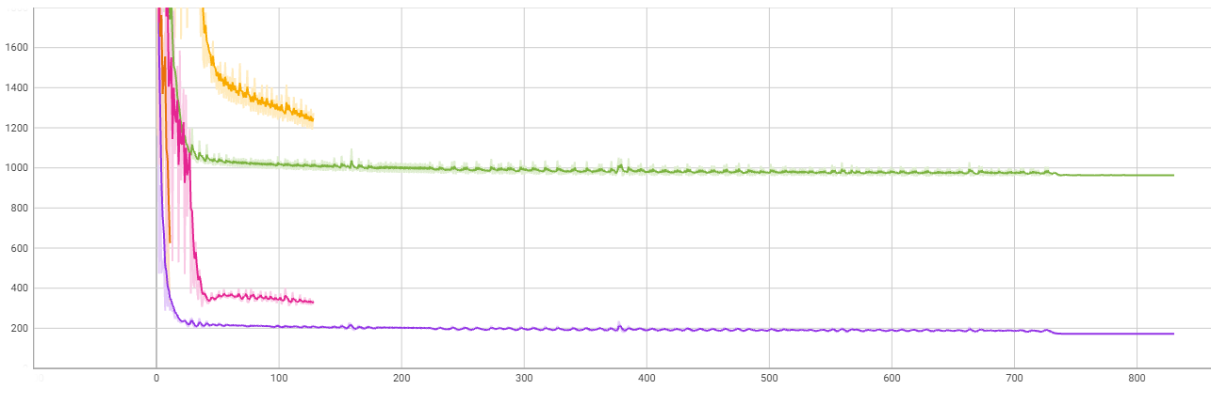

Figure 22: TensorBoard loss curve (*Self-Composed*)

## **8.4.2 Model evaluation**

The models were evaluated by calculating the evaluation metrics that were recommended having read through the literature and the author’s experience in evaluating ML models; these metrics were presented under the **Evaluation** section in **Chapter 2**.

The standard prediction and test set evaluation technique was applied to both models comparing the ensemble with the naïve forecast.

Table 23: Univariate model evaluation

|  |  |  |  |  |  |
| --- | --- | --- | --- | --- | --- |
|  | **MAE** | **MSE** | **RMSE** | **MAPE** | **MASE** |
| **Naïve forecast** | 951 | 2021966 | 1421 | 2.56% | 1.00 |
| **Ensemble** | 950 | 2013928 | 1419 | 2.56% | 0.99 |

Table 24: Multivariate model evaluation

|  |  |  |  |  |  |
| --- | --- | --- | --- | --- | --- |
|  | **MAE** | **MSE** | **RMSE** | **MAPE** | **MASE** |
| **Naïve forecast** | 858 | 1631648 | 1277 | 2.41% | 1.00 |
| **Ensemble** | 932 | 1826788 | 1351 | 2.67% | 1.00 |

Based on the above evaluation, the multivariate model performance is better than univariate. This is likely due to it being more robust as the dataset utilized was enriched with multiple exogenous features.

It can also be observed that the Naïve forecast is better in performance in multivariate while the opposite is the case for univariate. This is likely due to the increased complexity of the ensemble architecture compared to the Naïve model, which can add more noise especially since a more diverse dataset is used.

# **8.5 Benchmarking**

Extensive benchmarking was not possible as the algorithm is novel, and no system exists that utilizes all the features as in the implemented application. However, as demonstrated above, the Naïve model – that is notoriously difficult to beat in open systems - was benchmarked against to establish a baseline that could be used as a benchmark in future.

# **8.6 Functional testing**

Functional testing was performed by evaluating whether the system aligns with the functional requirements specified in **Chapter 4**. **APPENDIX F.1** shows the breakdown of the functional testing that was carried out.

# **8.7 Module & integration testing**

As demonstrated in the high-level architecture diagram presented in **Chapter 6**, the system’s logic was modularized. Each module was tested to ensure that they perform as expected.

Table 25: Module & integration testing

|  |  |  |  |  |
| --- | --- | --- | --- | --- |
| **Module** | **Input** | **Expected result** | **Actual result** | **Status** |
| Data fetcher | Triggered periodically | Fetch & update datasets. | Datasets scraped and stored into database. | Passed |
| NLP data parser | Latest scraped data. | Perform sentiment analysis on tweets. | Sentiment analysis is performed and the scores are weighted and saved in the database. | Passed |
| Data preprocessor | Latest obtained & parsed data. | Combine all datasets, clean, process and remove unneeded columns. | Datasets are cleaned and combined into a single dataset which is also then stored in the database. | Passed |
| Model information | Type of model. | Return the current evaluation metrics of the specific model. | Returns the current evaluation metrics of the specified model. | Passed |

# **8.8 Non-functional testing**

Non-functional requirements were tested by determining how well does the system align with the non-functional requirements mentioned in **Chapter 4** and the design goals stated in **Chapter 5**. **APPENDIX F.2** shows the breakdown of the non-functional testing that was carried out.

# **8.9 Limitations of the testing process**

The system was tested completely, however, the algorithm itself could not be tested. Analyzing the LTS’s complexities was possible and presented in **Chapter 6**; however, the mathematical expressions that are calculated behind the scenes could not be tested effectively. Nevertheless, simple debugging such as printing the calculated values on the terminal and comparing it against a calculator was performed; however, this does not qualify as a complete testing of the algorithm. It is worth noting however that the formula itself was accepted by the research community (*the formula was proposed in the author’s extended review paper as a rectification to the identified limitations*).

# **8.10 Chapter summary**

This chapter initially presented the objectives of conducing testing and the criterion on which it was performed. Testing was carried out on the core research component by evaluating the models in use, and the system was evaluated by functional, non-functional and integration testing. Finally, any limitations of this procedure were specified.

# **CHAPTER 09. EVALUATION**

# **9.1 Chapter overview**

Upon implementation, evaluation is required to ensure that the system has met the requirements gathered in **Chapter 4**. This chapter discusses the project’s evaluation - in detail, it presents the self-evaluation conducted by the author and feedback obtained from domain and technical experts.

# **9.2 Evaluation methodology & approach**

As the primary focus of this research is to design and implement the LTS algorithm, rigorous qualitative analysis from niche experts is required to ensure its robustness. Additionally, as the implemented system uses a model that presents a numerical output, quantitative analysis is required to determine its performance – which was presented in **Chapter 8**. In this chapter, thematic analysis conducted on the feedback obtained by the above-mentioned qualitative analysis will be presented.

# **9.3 Evaluation criteria**

Before evaluation, clear criteria must be defined to ensure that all aspects of the research are assessed. The table below breaks down the criteria the author defined prior to conducting evaluation.

Table 26: Evaluation criteria

|  |  |  |
| --- | --- | --- |
| **CR ID** | **Criterion** | **Purpose** |
| CR1 | Choice of research domain | To validate the significance of the chosen domain, topic and research gap. |
| CR2 | Research contribution | To determine the significance of the observed findings and contributions to the body of knowledge. |
| CR3 | Research novelty | To assess the novelty of the proposed solution. |
| CR4 | Research difficulty | To assess the technical difficulty of the research. |
| CR5 | Research quality | To confirm that sufficient literature has been reviewed and the research is well documented with adequate reasoning behind each technique. |
| CR6 | Development approach | To ensure that the approach taken meets industry standards and is best in class. |
| CR7 | Usability | To confirm that the system is user-friendly and convenient. |
| CR8 | Limitations & improvements | To identify any limitations and future research possibilities. |

# **9.4 Self-evaluation**

The table below presents self-evaluation that was performed by the author according to the above-mentioned criteria.

Table 27: Self-evaluation of the author

|  |  |
| --- | --- |
| **CR ID** | **Author’s self-evaluation** |
| CR1 | The chosen domain is novel and has hardly any experts with the technical knowledge, hence, it has limited research available. However, the domain has extremely high potential on being a stepping stone for more capable DL algorithms due to its ability to adapt its evaluation strategies and not being static. |
| CR2 | The author considers the contributions made as highly impactful given the short time duration. Contributions range from a novel algorithm within the research domain to a novel algorithm within the problem domain. Furthermore, the research was left open for further enhancements and work to motivate upcoming/seasoned researchers to at the very least be curious about the domain of neural ODEs/SDEs & LTCs. |
| CR3 | Prior to the completion of this research, TS algorithms all utilized traditional neural networks (LSTMs, RNNs, GRUs etc.), and had been stagnant owing to the restrictions mentioned in previous chapters. Therefore, the ultimate goal of the LTS designed by the author was to break these limitations and set higher milestones. |
| CR4 | Compared to other DL domains where ample research and literature is available to aid the researcher with their project, the chosen domain has possibly not even ten complete papers to read and understand the domain in detail. A lack of research lead to difficulty as there was no clear path to follow. |
| CR5 | Almost all the information available – ranging from research papers to recorded video conferences - on neural ODEs/SDEs & LTCs was gathered by the author and presented in this document to ensure that the quality is of the highest possible standard. |
| CR6 | Development was performed in stages: the algorithm implementation followed by the system implementation.   * To ensure that the LTS works and acts the same as other existing DL algorithms, it was built following recommended practices by TensorFlow, allowing it to be used the same way as other Keras layers. * The system was built following industry standards and techniques to ensure that it is as robust as possible and to align with recommended best practices.   Cutting-edge tools and technologies sought after by companies and employers were utilized in implementation.  Even though the system is the work of a single person, it was developed with the mindset of there being multiple contributors. Hence, it exhibits clear documentation, commit messages, workflows etc. within the GitHub repositories. |
| CR7 | The system was developed considering that the end-users have no technical knowledge by making it as user-friendly as possible. |
| CR8 | Upon completion of the system, the author identified a couple of enhancements and improvements that could be the subject of future work. |

# **9.5 Selection of evaluators**

The selection of the evaluators was done based on grouping, that is required to obtain feedback for all aspects of the project. The table below shows the grouping breakdown.

Table 28: Categorization of selected evaluators

|  |  |
| --- | --- |
| **CAT ID** | **Category** |
| CAT1 | Experts with knowledge in neural ODEs, SDEs and LTCs or traditional DL/ML. |
| CAT2 | Experts with knowledge on blockchain and cryptocurrencies. |
| CAT3 | End users of the application, including crypto buyers and traders. |

# **9.6 Evaluation results & expert opinions**

Thematic analysis was conducted to analyze the opinions and feedback received by the above-mentioned experts. The table below discusses the findings that emerged.

Table 29: Thematic analysis of expert feedback

|  |  |  |  |
| --- | --- | --- | --- |
| **CR ID** | **CAT ID** | **Theme** | **Summary of opinions** |
|  |  |  |  |
|  |  |  |  |
|  |  |  |  |
|  |  |  |  |

# **9.7 Limitations of evaluation**

Due to there being very limited experts in the research domain, only a few experts’ opinions were obtained. During the requirement gathering phase, this was made evident as the author had reached out to many ML/DL domain experts to gather more insights on the research concept, however only a few were able to provide such information. Hence, only the experts specified in **APPENDIX G.1** had the necessary knowledge and expertise to provide constructive feedback. Nevertheless, traditional ML/DL experts were also selected to obtain feedback as it still would be beneficial.

# **9.8 Evaluation of functional requirements**

The completion breakdown of the functional requirements is presented in **APPENDIX G.2**.

# **9.9 Evaluation of non-functional requirements**

The completion breakdown of the non-functional requirements and achievement of the design goals are presented in **APPENDIX G.3**.

# **9.10 Chapter summary**

This chapter focused on the evaluation of the implemented system. Prior to conducting evaluations, criteria were set, to ensure that all aspects of the system are looked into. The author performed self-evaluation, and obtained necessary feedback from evaluators which were then analyzed by thematic analysis. Finally, the evaluation of the functional and non-functional requirements was presented along with the achievement of the proposed design goals.

# **CHAPTER 10. CONCLUSION**

# **10.1 Chapter overview**

This chapter concludes the author’s research journey by marking its final remarks. In detail, it defines the author’s contributions, achievement of the stated objectives, any deviations taken from the proposed scope, challenges encountered, and future research possibilities and limitations. Furthermore, new skills the author obtained during the progression of the research as well as how their existing skills were utilized, are documented.

# **10.2 Achievement of research aim & objectives**

## **10.2.1 Achievement of the research aim**

The aim of this research is to design, develop & evaluate a novel architecture - utilizing the LTS algorithm - for *TS* forecasting, which could be the stepping stone for breaking TS limitations and further expanded to apply in other domains as well.

The aim was successfully attained by designing and developing the proposed LTS architecture in a way such that it was capable to be used as other existing layers. This algorithm was then utilized in a BTC forecasting application to evaluate its performance and to determine whether it broke limitations in TS forecasting algorithms.

## **10.2.2 Achievement of objectives**

The final status of each objective that was stated in chapter one has been marked with the objective itself in **APPENDIX H.1**.

# **10.3 Utilization of knowledge from the degree**

A tremendous amount of knowledge was required to bring the proposed research to fruition. Fortunately, a solid foundation had been laid by modules the author had completed during the course of the degree – of them, the most beneficial ones are highlighted in the table below.

Table 30: Knowledge utilized from the degree

|  |  |
| --- | --- |
| **Modules** | **Knowledge utilized** |
| Mathematics for Computing | In-depth mathematical knowledge was required to build the algorithmic formula. This module laid the foundation to get started with learning more advanced mathematical concepts. |
| Object Oriented Programming | This module provided experience in creating full-stack applications that can be considered as useful in the real world. Building a backend and integrating an API with a client was an important skill that was required in the creation of the MVP. |
| Software Development Group Project | The motivation to undergo a challenging project was obtained through this module. From pitching an idea to presenting the final product in competitions, this module laid the groundwork for future research, design, development, and evaluation. |
| Algorithms: Theory Design and Implementation | The knowledge obtained from this module was paramount when analyzing the performance and complexities of the developed algorithm. |

# **10.4 Use of existing skills**

* **Full-stack development** – the author has a few years of experience in full-stack development having done their internship at 99x working on web and mobile applications. Additionally, the author has worked for over two years at Niftron as a full-stack developer.
* **ML/DL** – the author has done a few freelancing projects that included ML & DL. Extra knowledge was gained by following courses on Coursera and YouTube.
* **Calculus** – the author had foundational calculus knowledge having completed their A levels in mathematics.

# **10.5 Use of new skills**

* **ML deployment** – creating an ML notebook can be considered as only 50% of the work in the deployment pipeline. The author had to learn a few techniques to create APIs that would serve the created models.
* **Data scraping & mining** – the datasets were not readily available and had to be fetched, scraped, cleaned, and condensed. The author had to learn and get a lot of practice on these techniques to ensure seamless updating of the used datasets.
* **Advanced calculus** – the author had to get familiar with college-level calculus to implement the LTS. MIT OpenCourseWare was used heavily to understand and learn these techniques.

# **10.6 Achievement of learning outcomes**

The achievement of the learning outcomes is presented in **APPENDIX H.2**.

# **10.7 Problems and challenges faced**

Challenges are inevitable in any research; the below table describes them and their mitigation.

Table 31: Problems and challenges faced

|  |  |
| --- | --- |
| **Problem**/**Challenge** | **Mitigation** |
| **Research domain** | |
| There are hardly any experts in neural ODEs, SDEs and LTCs. | Although there are few experts in this domain, and in turn, only a few evaluators, the ones interviewed were pretty much best in class and gave valuable insights. |
| Steep mathematics learning curve. | Designing the final formula was done almost blindly by reading through centuries-old documentations where the initial mathematical and scientific concepts were proposed. |
| Unclear direction to follow due to the lack of documentation of SDEs. | The author read through the few available literature and had to understand it as clearly as possible. The author published a paper with the proposed formula as soon as possible to determine whether it was correct and to go forward with implementation. |
| **Problem domain** | |
| Twitter API rate-limitations provided access to tweets for only the past 7 days. | The author developed a dedicated scraper to fetch the data. Only 500 tweets were collected for each day to avoid rate limitations and as this was not the primary focus of the research. |
| Datasets did not satisfy the author’s requirements. | The author developed scrapers to scrape a public dashboard that provided the required data free-of-charge. |

# **10.8 Deviations**

The author aimed to fully automate the ML pipeline of updating the model with the latest available data; however, was only capable of partially automating it. Scraping the datasets regularly was automated, however, triggering a model deployment can only be performed locally as automating this procedure requires dedicated cloud servers which are expensive.

The features in scope proposed in the project proposal are stated in **APPENDIX A.2**. Based on the proposed scope, no deviations have been taken in the category of “in-scope”. Unfortunately, due to time constraints, none of the “desirables” category had been implemented.

# **10.9 Limitations of the research**

* The application does not forecast in real time, rather gives a forecast only for specific days.
* Only 500 tweets were scraped for each day and considered to obtain the sentiment values.
* Tweets with only a tag of “bitcoin” were scraped (other tags such as “btc” could be used).
* The model must be manually trained and deployed as only the updating of data has been automated.

# **10.10 Future enhancements**

* Identify and determine how other features impact the price (Reddit, Facebook, Fiat coins).
* The LTS uses the Euler-Maruyama SDE solver which does handle all forms of noise. Nevertheless, other SDE solvers must be evaluated to determine if there would be a better performing option.
* The LTS can make use of a hybrid SDE solver that combines the implicit and explicit Euler-Maruyama solvers than the utilized implicit Euler-Maruyama.
* LTS with reverse mode AD must be evaluated instead of the proposed BPTT approach, to determine memory and time efficiency.
* Benchmark the LTS in the M4 competition to determine whether it is a SOTA TS forecasting algorithm.
* Enhance the Twitter sentiment weighting formula to consider more factors.
* Test the weighting formula to determine whether the score calculated aligns with sentiment analysis guidelines.

# **10.11 Achievement of the contribution to the body of knowledge**

Upon completion of this project, the author managed to achieve contributions to the research domain of DL and TS forecasting and the problem domain of BTC.

## **10.11.1 Research domain contributions**

* SDE-based liquid neural network – a novel implementation of the LTC with adaptability to instantaneous changes that surpasses limitations of TS forecasting algorithms.
* TensorFlow V2 implementation of the LTC & LTS algorithms.

## **10.11.2 Problem domain contributions**

* A novel algorithm to weight Twitter sentiments based on influencer metrics.
* A robust implementation of a BTC forecasting model that considers multiple exogenous features that affects the historical price.
* Surpassed the naïve forecast performance in open systems.

## **10.11.3 Additional contribution**

* Data extraction and preprocessing scripts for Twitter tweets, Twitter volume, block reward size, Google Trends and BTC historical prices.

# **10.12 Implementation code**

The code written and associated research work conducted is in GitHub for convenience, in the below links:

* Algorithm trials and testing repository – <http://bit.ly/3HYOqBB>.
* Application implementation repository - <http://bit.ly/3HXDtQu>.
* Research documentation chapters and diagrams repository - <http://bit.ly/3jxjf6V>.

# **10.13 Concluding remarks**

This marks the end of researching, designing and developing a novel algorithmic solution to solve a notorious problem in time series forecasting that hindered its performance compared to other DL domains for quite some time. Its application was demonstrated in a BTC forecasting application exhibiting promising performance that can be improved upon to apply it in other domains as well.

# **REFERENCES**

Abraham, J., Higdon, D., Nelson, J. and Ibarra, J. (2018). Cryptocurrency Price Prediction Using Tweet Volumes and Sentiment Analysis. *SMU Data Science Review*: Vol. 1: No. 3, Article 1. Available at: <https://scholar.smu.edu/datasciencereview/vol1/iss3/1>

Ackerman, D. (2021). “Liquid” machine-learning system adapts to changing conditions. *MIT News | Massachusetts Institute of Technology*. Available from <https://news.mit.edu/2021/machine-learning-adapts-0128> [Accessed 17 October 2022].

Ahmed, NK., Atiya, AF., Gayar, NE. and El-Shishiny, H. An Empirical Comparison of Machine Learning Models for Time Series Forecasting. *Econometric Reviews*. 2010;29(5-6):594–621.

Alonso-Monsalve, S. et al. (2020). Convolution on neural networks for high-frequency trend prediction of cryptocurrency exchange rates using technical indicators. *Expert Systems with Applications*, 149, 113250. Available from <https://doi.org/10.1016/j.eswa.2020.113250> [Accessed 22 October 2022].

Anumasa, S. and Srijith, P.K. (2022). Latent Time Neural Ordinary Differential Equations. *Proceedings of the AAAI Conference on Artificial Intelligence*, 36 (6), 6010–6018. Available from <https://doi.org/10.1609/aaai.v36i6.20547> [Accessed 17 October 2022].

Avdeychik, V., & Capozzi, J. (2018). SEC’s Division of Investment Management Voices Concerns Over Registered Funds Investing in Cryptocurrencies and Cryptocurrency Related Products. *Journal of Investment Compliance*, 19(2), 8–12.

Baldimtsi, F., Kiayias, A., & Samari, K. (2017). Watermarking Public-Key Cryptographic Functionalities and Implementations. In Nguyen, P. Q., & Zhou, J. (Eds.). *Information Security*, 173–191. Berlin: Springer.

Bhardwaj, S.P. et al. (2014). An Empirical Investigation of Arima and Garch Models in Agricultural Price Forecasting. *Economic Affairs*, 59 (3), 415. Available from <https://doi.org/10.5958/0976-4666.2014.00009.6> [Accessed 17 October 2022].

BI4ALL (2021). Supervised Machine Learning in Time Series Forecasting. *BI4ALL – Turning Data into Insights*. Available from <https://www.bi4all.pt/en/news/en-blog/supervised-machine-learning-in-time-series-forecasting/> [Accessed 12 October 2022].

Boisdequin, H. (2020). React vs Vue vs Angular vs Svelte. *DEV Community 👩‍💻👨‍💻*. Available from <https://dev.to/hb/react-vs-vue-vs-angular-vs-svelte-1fdm> [Accessed 18 October 2022].

Boom, V.D. (2021). Want to Buy Crypto? Here’s What to Look for In a Crypto Exchange. *Time, 11 June*. Available from <https://time.com/nextadvisor/investing/cryptocurrency/what-are-cryptocurrency-exchanges> [Accessed 23 October 2022].

Bouktif, S. et al. (2018). Optimal Deep Learning LSTM Model for Electric Load Forecasting using Feature Selection and Genetic Algorithm: Comparison with Machine Learning Approaches †. *Energies*, 11 (7), 1636. Available from <https://doi.org/10.3390/en11071636> [Accessed 28 December 2022].

Bouri, E., Gupta, R., Lau, C. K. M., Roubaud, D., & Wang, S. (2018). Bitcoin and global financial stress: A copula-based approach to dependence and causality in the quantiles. *The Quarterly Review of Economics and Finance*, 69, 297–307.

Buhalis, D. et al. (2019). Technological disruptions in services: lessons from tourism and hospitality. *Journal of Service Management*, 30 (4), 484–506. Available from <https://doi.org/10.1108/JOSM-12-2018-0398> [Accessed 22 October 2022].

Chaman L. Jain. Answers to your forecasting questions. *Journal of Business Forecasting*, 36, Spring 2017.

Chen, R.T.Q. et al. (2019). Neural Ordinary Differential Equations. Available from <https://doi.org/10.48550/arXiv.1806.07366> [Accessed 25 September 2022].

Cho, K. et al. (2014). Learning Phrase Representations using RNN Encoder-Decoder for Statistical Machine Translation. Available from <https://doi.org/10.48550/ARXIV.1406.1078> [Accessed 9 April 2023].

Critien, J.V., Gatt, A. and Ellul, J. (2022). Bitcoin price change and trend prediction through twitter sentiment and data volume. *Financial Innovation*, 8 (1), 45. Available from <https://doi.org/10.1186/s40854-022-00352-7> [Accessed 16 October 2022].

Dubovikov, K. (2018). PyTorch vs TensorFlow — spotting the difference. *Medium*. Available from <https://towardsdatascience.com/pytorch-vs-tensorflow-spotting-the-difference-25c75777377b> [Accessed 18 October 2022].

Duvenaud, D (2021). Directions in ML: Latent Stochastic Differential Equations: An Unexplored Model Class. *YouTube*. Available from <https://www.youtube.com/watch?v=6iEjF08xgBg>. [Accessed on 30 Sep. 2022].

Engle, R.F. (1982). Autoregressive Conditional Heteroscedasticity with Estimates of the Variance of United Kingdom Inflation. *Econometrica*, 50 (4), 987. Available from <https://doi.org/10.2307/1912773> [Accessed 28 December 2022].

Fischer, T. and Krauss, C. (2018). Deep learning with long short-term memory networks for financial market predictions. *European Journal of Operational Research*, 270 (2), 654–669. Available from <https://doi.org/10.1016/j.ejor.2017.11.054> [Accessed 14 February 2023].

Fleischer, J.P. et al. (2022). Time Series Analysis of Cryptocurrency Prices Using Long Short-Term Memory. *Algorithms*, 15 (7), 230. Available from <https://doi.org/10.3390/a15070230> [Accessed 26 September 2022].

Fortune Business Insights (2021). Cryptocurrency Market Size, Growth & Trends | Forecast [2028]. *Fortune Business Insights*. Available from <https://www.fortunebusinessinsights.com/industry-reports/cryptocurrency-market-100149> [Accessed 23 October 2022].

Funahashi, K. and Nakamura, Y. (1993). Approximation of dynamical systems by continuous time recurrent neural networks. *Neural Networks*, 6 (6), 801–806. Available from <https://doi.org/10.1016/S0893-6080(05)80125-X> [Accessed 14 October 2022].

G. E. Box, G. M. Jenkins, G. C. Reinsel, and G. M. Ljung, Time series analysis: forecasting and control (John Wiley & Sons, 2015).

Gilliland, M. (2014). A naive forecast is not necessarily bad. *The Business Forecasting Deal*. Available from <https://blogs.sas.com/content/forecasting/2014/04/30/a-naive-forecast-is-not-necessarily-bad/> [Accessed 15 October 2022].

Hasani, R. et al. (2020). Liquid Time-constant Networks. Available from <https://doi.org/10.48550/arXiv.2006.04439> [Accessed 25 September 2022].

Hasani, R. et al. (2021). Liquid Neural Networks. *YouTube*. Available from <https://www.youtube.com/watch?v=IlliqYiRhMU&t=350s>. [Accessed on 30 Sep. 2022].

Hochreiter, S. and Schmidhuber, J. (1997). Long Short-Term Memory. *Neural Computation*, 9 (8), 1735–1780. Available from <https://doi.org/10.1162/neco.1997.9.8.1735> [Accessed 25 September 2022].

Hutto, C., & Gilbert, E. (2014). VADER: A Parsimonious Rule-Based Model for Sentiment Analysis of social media Text. *Proceedings of the International AAAI Conference on Web and social media*, 8(1), 216-225

Hyndman, R. J., & Koehler, A. B. (2006). Another look at measures of forecast accuracy. *International Journal of Forecasting*, 22(4), 679–688

Hyndman, R.J., & Athanasopoulos, G. (2021). *Forecasting: principles and practice*, 3rd edition, OTexts: Melbourne, Australia. Available from <https://otexts.com/fpp3/>. [Accessed on 30 Sep. 2022].

IBM Cloud Team (2021). Python vs. R: What’s the Difference? *IBM*. Available from <https://www.ibm.com/cloud/blog/python-vs-r> [Accessed 18 October 2022].

InterviewBit (2021). Flask Vs Django: Which Python Framework to Choose? *InterviewBit*. Available from <https://www.interviewbit.com/blog/flask-vs-django/> [Accessed 12 December 2022].

Kerr, J. (2018). How Can Legislators Protect Sport from the Integrity Threat Posed by Cryptocurrencies? *The International Sports Law Journal*, 18(1), 79–97.

Kervanci, I. sibel and Akay, F. (2020). Review on Bitcoin Price Prediction Using Machine Learning and Statistical Methods. *Sakarya University Journal of Computer and Information Sciences*. Available from <https://doi.org/10.35377/saucis.03.03.774276> [Accessed 25 September 2022].

Kfir, I. (2020). Cryptocurrencies, national security, crime and terrorism. *Comparative Strategy*, 39 (2), 113–127. Available from <https://doi.org/10.1080/01495933.2020.1718983> [Accessed 22 October 2022].

Kim, M. et al. (2019). A Hybrid Neural Network Model for Power Demand Forecasting. *Energies*, 12 (5), 931. Available from <https://doi.org/10.3390/en12050931> [Accessed 16 October 2022].

Kim, Y.B. et al. (2016). Predicting Fluctuations in Cryptocurrency Transactions Based on User Comments and Replies. *PLOS ONE*, 11 (8), e0161197. Available from <https://doi.org/10.1371/journal.pone.0161197> [Accessed 16 October 2022].

Kuan, L. et al. (2017). Short-term electricity load forecasting method based on multilayered self-normalizing GRU network. *2017 IEEE Conference on Energy Internet and Energy System Integration* (EI2). November 2017. Beijing: IEEE, 1–5. Available from <https://doi.org/10.1109/EI2.2017.8245330> [Accessed 17 October 2022].

Kurama, V. (2022). PyTorch vs. TensorFlow: 2022 Deep Learning Comparison | Built In. *Built In*. Available from <https://builtin.com/data-science/pytorch-vs-tensorflow> [Accessed 12 December 2022].

Lapicque, L. 1907. Recherches quantitatives sur l’excitation electrique des nerfs traitee comme une polarization. *Journal de Physiologie et de Pathologie Generalej* 9: 620–635.

Lara-Benítez, P., Carranza-García, M. and Riquelme, J.C. (2021). An Experimental Review on Deep Learning Architectures for Time Series Forecasting. *International Journal of Neural Systems*, 31 (03), 2130001. Available from <https://doi.org/10.1142/S0129065721300011> [Accessed 16 October 2022].

Li, A.W. and Bastos, G.S. (2020). Stock Market Forecasting Using Deep Learning and Technical Analysis: A Systematic Review. *IEEE Access*, 8, 185232–185242. Available from <https://doi.org/10.1109/ACCESS.2020.3030226> [Accessed 16 October 2022].

Li, S. et al. (2019). Enhancing the Locality and Breaking the Memory Bottleneck of Transformer on Time Series Forecasting. Available from <https://doi.org/10.48550/ARXIV.1907.00235> [Accessed 17 October 2022].

Li, X. et al. (2020). Scalable Gradients for Stochastic Differential Equations. Available from <http://arxiv.org/abs/2001.01328> [Accessed 18 January 2023].

Lim, B. and Zohren, S. (2020). Time Series Forecasting With Deep Learning: A Survey. Available from <https://doi.org/10.1098/rsta.2020.0209> [Accessed 21 October 2022].

Lim, B. et al. (2019). Temporal Fusion Transformers for Interpretable Multi-horizon Time Series Forecasting. Available from <https://doi.org/10.48550/ARXIV.1912.09363> [Accessed 17 October 2022].

Maiti, M., Vyklyuk, Y. and Vuković, D. (2020). Cryptocurrencies chaotic co‐movement forecasting with neural networks. *Internet Technology Letters*, 3 (3). Available from <https://doi.org/10.1002/itl2.157> [Accessed 16 October 2022].

Makridakis, S., Spiliotis, E. and Assimakopoulos, V. (2018a). Statistical and Machine Learning forecasting methods: Concerns and ways forward. *PLOS ONE*, 13 (3), e0194889. Available from <https://doi.org/10.1371/journal.pone.0194889> [Accessed 25 September 2022].

Makridakis, S., Spiliotis, E. and Assimakopoulos, V. (2018b). The M4 Competition: Results, findings, conclusion and way forward. *International Journal of Forecasting*, 34 (4), 802–808. Available from <https://doi.org/10.1016/j.ijforecast.2018.06.001> [Accessed 25 September 2022].

Miller, P. (2016). Chapter 1—The Cryptocurrency Enigma. In Sammons, J. (Ed.), *Digital Forensics*, 1–25. Syngress. <https://doi.org/10.1016/B978-0-12-804526-8.00001-0>

Mozer, M.C., Kazakov, D. and Lindsey, R.V. (2017). Discrete Event, Continuous Time RNNs. Available from <https://doi.org/10.48550/ARXIV.1710.04110> [Accessed 14 October 2022].

Mudassir, M. et al. (2020). Time-series forecasting of Bitcoin prices using high-dimensional features: a machine learning approach. *Neural Computing and Applications*. Available from <https://doi.org/10.1007/s00521-020-05129-6> [Accessed 3 December 2022].

Nica, O., Piotrowska, K., & Schenk-Hoppé, K. R. (2017). Cryptocurrencies: Economic Benefits and Risks. SSRN Scholarly Paper ID 3059856.

Oreshkin, B.N. et al. (2020). N-BEATS: Neural basis expansion analysis for interpretable time series forecasting. Available from <http://arxiv.org/abs/1905.10437> [Accessed 26 September 2022].

Pan, C. et al. (2019). Very Short-Term Solar Generation Forecasting Based on LSTM with Temporal Attention Mechanism. *2019 IEEE 5th International Conference on Computer and Communications (ICCC)*. December 2019. Chengdu, China: IEEE, 267–271. Available from <https://doi.org/10.1109/ICCC47050.2019.9064298> [Accessed 14 February 2023].

Pant, D.R. et al. (2018). Recurrent Neural Network Based Bitcoin Price Prediction by Twitter Sentiment Analysis. 2018 IEEE 3rd International Conference on Computing, *Communication and Security (ICCCS)*. October 2018. Kathmandu: IEEE, 128–132. Available from <https://doi.org/10.1109/CCCS.2018.8586824> [Accessed 16 October 2022].

Patadiya, J. (2021). Angular vs React | Angular vs Vue | React vs Vue - Know the Difference. *Radixweb*. Available from <https://radixweb.com/blog/angular-vs-react-vs-vue> [Accessed 12 December 2022].

Peluchetti, S. and Favaro, S. (2019). Infinitely deep neural networks as diffusion processes. Available from <https://doi.org/10.48550/ARXIV.1905.11065> [Accessed 2 December 2022].

Picasso, A. et al. (2019). Technical analysis and sentiment embeddings for market trend prediction. *Expert Systems with Applications*, 135, 60–70. Available from <https://doi.org/10.1016/j.eswa.2019.06.014> [Accessed 16 October 2022].

Poulopoulos, D. (2021). Is “Liquid” ML the answer to autonomous driving? *Medium*. Available from <https://towardsdatascience.com/is-liquid-ml-the-answer-to-autonomous-driving-bf2e899a9065> [Accessed 25 September 2022].

Pournader, M. et al. (2020). Blockchain applications in supply chains, transport and logistics: a systematic review of the literature. *International Journal of Production Research*, 58 (7), 2063–2081. Available from <https://doi.org/10.1080/00207543.2019.1650976> [Accessed 22 October 2022].

Press, W.H. (ed.). (2007). *Numerical recipes: the art of scientific computing*, 3rd ed. Cambridge, UK; New York: Cambridge University Press.

Rahouti, M., Xiong, K. and Ghani, N. (2018). Bitcoin Concepts, Threats, and Machine-Learning Security Solutions. *IEEE Access*, 6, 67189–67205. Available from <https://doi.org/10.1109/ACCESS.2018.2874539> [Accessed 25 September 2022].

Rejeb, A., Rejeb, K. and G. Keogh, J. (2021). Cryptocurrencies in Modern Finance: A Literature Review. *ETIKONOMI*, 20 (1), 93–118. Available from <https://doi.org/10.15408/etk.v20i1.16911> [Accessed 22 October 2022].

Rizwan, M., Narejo, S. and Javed, M. (2019). Bitcoin price prediction using Deep Learning Algorithm. *2019 13th International Conference on Mathematics, Actuarial Science, Computer Science and Statistics (MACS)*. December 2019. Karachi, Pakistan: IEEE, 1–7. Available from <https://doi.org/10.1109/MACS48846.2019.9024772> [Accessed 26 September 2022].

Rosenthal, S. et al. (2014). SemEval-2014 Task 9: Sentiment Analysis in Twitter. Proceedings of the 8th International Workshop on Semantic Evaluation (SemEval 2014). 2014. *Dublin, Ireland: Association for Computational Linguistics*, 73–80. Available from <https://doi.org/10.3115/v1/S14-2009> [Accessed 16 October 2022].

Roy, S., Nanjiba, S. and Chakrabarty, A. (2018). Bitcoin Price Forecasting Using Time Series Analysis. *2018 21st International Conference of Computer and Information Technology (ICCIT)*. December 2018. Dhaka, Bangladesh: IEEE, 1–5. Available from <https://doi.org/10.1109/ICCITECHN.2018.8631923> [Accessed 25 September 2022].

Rubanova, Y., Chen, R.T.Q. and Duvenaud, D. (2019). Latent ODEs for Irregularly-Sampled Time Series. Available from <https://doi.org/10.48550/ARXIV.1907.03907> [Accessed 18 October 2022].

S. Nakamoto, (2020). *Bitcoin: A peer-to-peer electronic cash system*. Available from <https://bitcoin.org/bitcoin.pdf> [Accessed 25 September 2022].

Sagheer, A. and Kotb, M. (2019). Time series forecasting of petroleum production using deep LSTM recurrent networks. *Neurocomputing*, 323, 203–213. Available from <https://doi.org/10.1016/j.neucom.2018.09.082> [Accessed 17 October 2022].

Sarkodie, S.A., Ahmed, M.Y. and Owusu, P.A. (2022). COVID-19 pandemic improves market signals of cryptocurrencies–evidence from Bitcoin, Bitcoin Cash, Ethereum, and Litecoin. *Finance Research Letters*, 44, 102049. Available from <https://doi.org/10.1016/j.frl.2021.102049> [Accessed 16 October 2022].

Saunders, M.N.K., Lewis, P. and Thornhill, A. (2007). *Research methods for business students*, 4th ed. Harlow, England; New York: Financial Times/Prentice Hall.

Scharding, T. (2019). National Currency, World Currency, Cryptocurrency: A Fichtean Approach to the Ethics of Bitcoin. *Business and Society Review*, 124(2), 219–238.

Serafini, G. et al. (2020). Sentiment-Driven Price Prediction of the Bitcoin based on Statistical and Deep Learning Approaches. *2020 International Joint Conference on Neural Networks (IJCNN)*. July 2020. Glasgow, United Kingdom: IEEE, 1–8. Available from <https://doi.org/10.1109/IJCNN48605.2020.9206704> [Accessed 16 October 2022].

Shen, D., Urquhart, A. and Wang, P. (2019). Does twitter predict Bitcoin? *Economics Letters*, 174, 118–122. Available from <https://doi.org/10.1016/j.econlet.2018.11.007> [Accessed 16 October 2022].

Shrivastava, S. (2020). Cross Validation in Time Series. *Medium*. Available from <https://medium.com/@soumyachess1496/cross-validation-in-time-series-566ae4981ce4> [Accessed 12 October 2022].

Siami-Namini, S., Tavakoli, N. and Siami Namin, A. (2018). A Comparison of ARIMA and LSTM in Forecasting Time Series. *2018 17th IEEE International Conference on Machine Learning and Applications (ICMLA)*. December 2018. Orlando, FL: IEEE, 1394–1401. Available from <https://doi.org/10.1109/ICMLA.2018.00227> [Accessed 17 October 2022].

Smyl, S. (2020). A hybrid method of exponential smoothing and recurrent neural networks for time series forecasting. *International Journal of Forecasting*, 36 (1), 75–85. Available from <https://doi.org/10.1016/j.ijforecast.2019.03.017> [Accessed 25 September 2022].

Taylor, S.J. and Letham, B. (2017). Forecasting at scale. *PeerJ Preprints*. Available from <https://doi.org/10.7287/peerj.preprints.3190v2> [Accessed 17 October 2022].

Tzen, B. and Raginsky, M. (2019). Neural Stochastic Differential Equations: Deep Latent Gaussian Models in the Diffusion Limit. Available from <http://arxiv.org/abs/1905.09883> [Accessed 2 December 2022].

Ugurlu, U., Oksuz, I. and Tas, O. (2018). Electricity Price Forecasting Using Recurrent Neural Networks. *Energies*, 11 (5), 1255. Available from <https://doi.org/10.3390/en11051255> [Accessed 14 February 2023].

Valencia, F., Gómez-Espinosa, A. and Valdés-Aguirre, B. (2019). Price Movement Prediction of Cryptocurrencies Using Sentiment Analysis and Machine Learning. *Entropy*, 21 (6), 589. Available from <https://doi.org/10.3390/e21060589> [Accessed 16 October 2022].

Valipour, M. (2015). Long-term runoff study using SARIMA and ARIMA models in the United States: Runoff forecasting using SARIMA. *Meteorological Applications*, 22 (3), 592–598. Available from <https://doi.org/10.1002/met.1491> [Accessed 16 October 2022].

Wang, Y. et al. (2019). Making sense of blockchain technology: How will it transform supply chains? *International Journal of Production Economics*, 211, 221–236. Available from <https://doi.org/10.1016/j.ijpe.2019.02.002> [Accessed 22 October 2022].

Wang, Y., Liao, W. and Chang, Y. (2018). Gated Recurrent Unit Network-Based Short-Term Photovoltaic Forecasting. *Energies*, 11 (8), 2163. Available from <https://doi.org/10.3390/en11082163> [Accessed 28 December 2022].

Wilson, C. (2019). Cryptocurrencies: The Future of Finance? In: Yu, F.-L.T. and Kwan, D.S. (eds.). *Contemporary Issues in International Political Economy*. Singapore: Springer Singapore, 359–394. Available from <https://doi.org/10.1007/978-981-13-6462-4_16> [Accessed 22 October 2022].

Wolf, T. et al. (2020). Transformers: State-of-the-Art Natural Language Processing. *Proceedings of the 2020 Conference on Empirical Methods in Natural Language Processing: System Demonstrations*. October 2020. Online: Association for Computational Linguistics, 38–45. Available from <https://doi.org/10.18653/v1/2020.emnlp-demos.6> [Accessed 19 October 2022].

Yenidogan, I. et al. (2018). Bitcoin Forecasting Using ARIMA and PROPHET. *2018 3rd International Conference on Computer Science and Engineering (UBMK)*. September 2018. Sarajevo: IEEE, 621–624. Available from <https://doi.org/10.1109/UBMK.2018.8566476> [Accessed 16 October 2022].

Zhang, R. et al. (2022). Comparison of ARIMA and LSTM for prediction of hemorrhagic fever at different time scales in China. *PLOS ONE*, 17 (1), e0262009. Available from <https://doi.org/10.1371/journal.pone.0262009> [Accessed 17 October 2022].

# **APPENDIX A – INTRODUCTION**

# **A.1. Prototype feature diagram**

The diagram below depicts the prototype feature diagram proposed in the proposal document.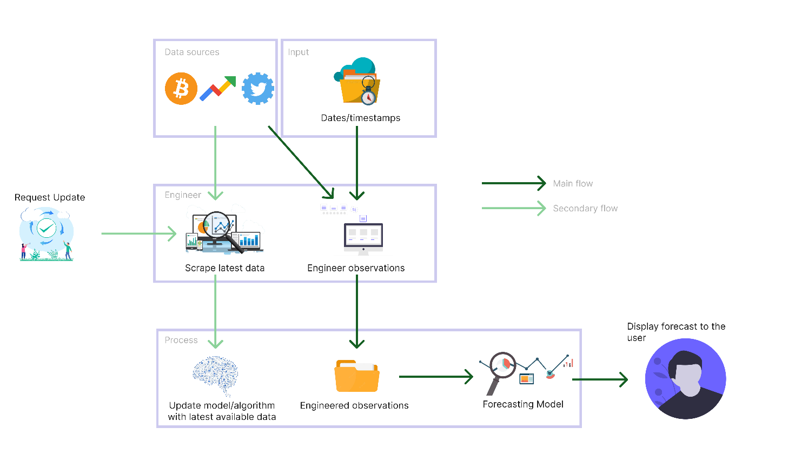

Figure 23: Prototype feature diagram (*Self-Composed*)

# **A.2. Project scope**

**In scope**

* Implementing a novel LTC architecture capable of being used as currently existing solutions and the corresponding creation of a system.
* Periodic updates of the model with the latest available data.
* Evaluate and compare the implemented system against existing solutions.
* Ability to display a range of predictions for the chosen horizon.
* By combining them with the BTC historical data, consider Twitter sentiment, volume, and the ‘block reward size’ as external factors.

**Out scope**

* Application of the algorithm implemented in other domains to justify whether it could be an advancement in those domains.
* Forecast multiple different cryptocurrencies.
* Use of live, on-demand data instead of daily data & incremental learning.

**Desirables**

* Benchmark implementation against the M4 competition to further justify the future of TS forecasting algorithms.
* Evaluate other neural ODEs (CT-RNN, CT-GRU, Latent ODE) and SDEs (Latent SDE).
* Explainable AI for neural SDEs and neural ODEs.

# **APPENDIX B – LITERATURE REVIEW**

# **B.1. Analysis of forecasting algorithms**

Table 32: Analysis of forecasting algorithms

|  |  |  |  |
| --- | --- | --- | --- |
| **Ref.** | **Brief** | **Improvements/Contribution** | **Limitations/Future work** |
| **Statistical-based forecasting algorithms** | | | |
| Box et al., 2015 | **ARIMA**. A statistical analysis model for understanding the dataset or predicting future trends. This model depends on past values to predict the future and uses lagged moving averages to smoothen the data. | Improved performance for TS forecasting data that correlate with values ahead of time. | Does not handle well with nonlinear data and long-term forecasting. Furthermore, it performs best on univariate analysis and cannot capture data volatility. |
| Engle, 1982 | **GARCH**. A modeling technique that specializes in predicting volatility in data. | Captures volatility in datasets and boasts significant performance improvements in the family of statistical forecasting algorithms. | Needs to improve interpretability and adaptability. |
| Taylor and Letham, 2017 | **Prophet**. A modular regression model with interpretable parameters. These parameters can be adjusted according to the problem by domain experts, similar to ARIMA. | Solves forecasting at scale, where scale refers to three types. 1) A large number of people forecasting. 2) A large variety of problems. 3) A large number of forecasts being created. | It uses simple and weak assumptions and produces much poorer performance than ARIMA. And it does not model relationships between the past and future. |
| **DL-based forecasting algorithms** | | | |
| Hochreiter and Schmidhuber, 1997 | **LSTM**. An algorithm that learns to bridge minimal time lags by enforcing constant error flows. It learns much faster, creates more successful runs, and can solve complex tasks that have not been solved before. | Improved performance for short-sequence predictions. Overcame error back-flow problems present in conventional BPTT, where they tended to blow up or vanish. | Prediction capacity limits long sequence performance, where the MSE and RMSE rise unacceptably. Therefore, there are better solutions for predictions of the distant future. They are also prone to overfitting. |
| Cho et al., 2014 | **GRU**. Similar architecture to that of LSTMs but combine the “forget” and “input” gates to create two gates, “reset” and “update”, instead of the three found in LSTMs. | Solve the vanishing gradient problem in RNNs as LSTMs, but also consume less memory and run faster. | Suitable for problems with smaller datasets and tend to be less accurate for datasets with larger sequences. |
| Oreshkin et al., 2020 | **N-BEATS**. An architecture that solves the univariate time series point forecasting problem. It carries some benefits, some of which are being understandable, easily applicable to multiple other fields, and being fast to train. | Outperformed the M4 competition winner of the previous year and improved the statistical benchmark forecast. | Tailored specifically for univariate TS analysis, therefore, would perform poorly on multivariate analysis. Additionally, Meta-learning is speculated to be a reason for the performance and must be investigated. |
| Lim et al., 2019 | **TFT**. An attention-based architecture that solves multi-horizon forecasting with interpretability of the used inputs. | Demonstrate significant performance improvements over set benchmarks for a variety of datasets. | Training and inference times are expensive and require moderately extensive resources. Hardware optimizations can reduce these. |
| Hasani et al., 2020 | **LTC**. A novel formulation of the NODE architecture. Boasts superior expressivity that is capable of adapting to unforeseen changes. | Surpassed traditional DL and statistical models and overcame the underwhelming performance of other neural ODE architectures. | It cannot model uncertainty and is computationally intensive. |

# **B.2. Studies associated with these algorithms**

Table 33: Few studies associated with these algorithms

|  |  |  |  |
| --- | --- | --- | --- |
| **Ref.** | **Technology** | **Outperforms** | **Findings** |
| **Statistical-based forecasting algorithms** | | | |
| Zhang et al., 2022 | ARIMA | LSTM | ARIMA outperformed the LSTM model for monthly and weekly forecasts, while LSTM performed better for daily forecasts. Additionally, they mentioned that there is no clear superior. |
| Yenidogan et al., 2018 | Prophet | ARIMA | Prophet is strong to outliers and missing data. It is also optimized for business forecasts with trends and seasonality within and nonlinear data growths, which ARIMA cannot handle. |
| **DL-based forecasting algorithms** | | | |
| Kuan et al., 2017 | GRU | LSTM, traditional GRU | Scaled exponential linear units were proposed to deal with vanishing gradients. These architectures significantly outperformed LSTM and traditional GRU models. |
| Ugurlu, Oksuz and Tas, 2018 | GRU | MLP, LSTM | Performed much better than LSTM and trained faster as it is simply a simpler form of LSTM. |
| Wang, Liao and Chang, 2018 | GRU | LSTM, ARIMA | K-Means clustering and Pearson coefficient were used to cluster groups and extract the most important features, respectively, which were then used to train the model. |
| Sagheer and Kotb, 2019 | LSTM | ARIMA, GRU | Genetic algorithms were used to create an optimized LSTM architecture. |
| Bouktif et al., 2018 | LSTM | MLP, Linear regression | The most optimal time lags and number of layers for an LSTM was found using genetic algorithms. |
| Fischer and Krauss, 2018 | LSTM | MLP, Logistic regression | Peeked into the internals of the LSTM to find common stock patterns in noisy data. |
| Pan et al., 2019 | LSTM | MLP, traditional LSTM | Utilized a novel attention-based LSTM architecture to improve the performance of traditional LSTMs. |
| Oreshkin et al., 2020 | N-BEATS | Competition winner | Surpassed the previous winner of the M4 competition with a significant difference in performance. Concluded that hybrid models are only **sometimes** the best-performing. |
| Hasani et al., 2020 | LTC | LSTM, GRU, CT-RNN, CT-GRU | A more stable implementation of the neural ODE can be built by using a linear system of ODEs to declare the network’s flow. |

# **APPENDIX C – SRS**

# **C.1. Requirement elicitation methodologies**

Table 34: Stakeholder groups

|  |  |  |  |
| --- | --- | --- | --- |
| **Group** | **Stakeholders** | **Reason** | **Instrument** |
| G1 | Domain experts (neural ODE/SDE and blockchain/crypto) | Gather any insights and knowledge specifically in the research domain to answer research questions and anything the author may have missed. | Interview |
| G2 | End users (trader & buyer) | Gather requirements for the supplementary application implementation. | Survey |
| G3 | Competitors | Analyze any existing systems and literature in the research and problem domain. | LR/Observations |
| G4 | Developers | Ensure completion and feasibility of the project. | Prototyping |

# **C.2. Interview analysis**

Table 35: Interview participant details

|  |  |  |
| --- | --- | --- |
| **ID** | **Affiliation** | **Expertise related to the research** |
| P1 | Google Brain visiting researcher and Associate Professor at University of Toronto. | Neural ODEs and SDEs. |
| P2 | Research scientist at Deepmind. | Neural ODEs and SDEs. |
| P3 | Research scientist at Meta AI. | Probabilistic DL and differential equations. |
| P4 | PhD candidate at University of Nottingham. | XAI |
| P5 | Chief Product Officer at Niftron. | Blockchain and cryptocurrencies. |

Table 36: Interview thematic analysis themes, conclusions & evidence

|  |  |  |
| --- | --- | --- |
| **Theme** | **Conclusion** | **Evidence** |
| **Research component** | | |
| Research Problem & Gap | The interviewees validated the research gap and the defined problem. They were also happy that the author had been conducting this research, as few papers were published in this domain. | “Yes, there are many TS forecasting algorithms; however, many are obsolete.”  “Yes, the chosen field of architectures can be considered an advancement.”  “As per my knowledge, I have not seen a system using the basic LTC architecture itself, so this new architecture will be novel.” |
| Requirements | The interviewees were concerned that ODEs and SDEs could be expensive to compute and hence could take some time, which can be an issue given that the forecasts must be produced quickly. Therefore, the author must optimize the model as much as possible to avoid user-unfriendliness. | “They are expensive to compute.”  “It can be resource-intensive.” |
| Advice | The author had initially planned on only creating an implementation of the LTC architecture proposed by Hasani et al. (2020). However, the author could further improve the architecture by using SDEs instead (the base LTC uses ODEs), which could manifest into a novel algorithm, which is the author’s current aim as it carries more significance and a potentially more outstanding contribution. | “I think latent ODEs are obsolete.”  “You should look into latent SDEs instead.”  “Latent SDEs are more flexible, you could try applying LTC architectures to those more flexible models instead.” |
| Other suggestions | What was concluded here was that XAI is primarily present for image classification, and there needs to be more literature on the TS domain. However, XAI integration into TS modelling could be confusing and complicated due to the temporal component. Additionally, XAI for SDEs needs to be researched, which the author could look into if time permits. | “Yea, in the domain of TS I have not seen many explainable AI research conducted.”  “Explainable AI is flourishing in image classification but I have not seen it in TS.”  “Integrating explainable AI might not be straightforward as other domains.” |
| **Problem domain** | | |
| Robustness | The interview was an additional validation for the data collected in the survey. Most suggestions were to use as many extra features as possible to make the model robust. Therefore, the author will ensure that they utilize the mentioned exogenous features. | “It is best if you try to include as many features as possible.”  “It is not practical to forecast with only historical prices.” |

# **C.3. Survey analysis**

Table 37: Survey thematic analysis codes, themes & conclusions

|  |  |  |  |
| --- | --- | --- | --- |
| **Code** | | **Theme** | |
| Exogenous factors | | Robustness | |
| Explainability, Insights | | Reliability | |
| Simplicity, Convenience | | User-friendly | |
| Tuning | | Editability | |
| On-demand | | Future consideration | |
| **Theme** | **Conclusion** | | **Evidence** |
| Robustness | Participants believed that prediction needed more than just including historical prices and that social media Trends and other factors (ex: sentiment) are required to make the system as robust and performant as possible. | | “Use previous trends in the past.”  “Consider all possible external factors.” |
| Reliability | Almost all respondents requested that the system provide an Explainability component so that the insights obtained can be reliable as the inference becomes as transparent as possible. | | “Insights about the forecast will be beneficial.”  “Provide as much Explainability to make the prediction as credible as possible.”  “The rate of success of the prediction would be useful.” |
| User-friendly | A couple of participants requested that the system provide some cryptocurrency news to make it convenient and make the inference procedure as straightforward as possible, so there is no hindrance. | | “Show some news about the current cryptocurrency world in the platform, so it’s convenient for the users.”  “Make the steps from choosing a date to forecasting as simple as possible.” |
| Editability | An ML-knowledgeable participant mentioned that it would be an ideal scenario if the system could tune the hyperparameters of the model in use, which could be an excellent enhancement to the system as the model anyways retrains periodically. | | “Coming from machine learning point of view, I think it’ll be a good idea if there’s a functionality to change the hyperparameters used.” |
| Future considerations | A couple of participants mentioned some additional features the author believes they will not be able to cover, given the time allotted. | | “Predict the market for any given time duration.”  “Ability to identify a pump and dump scenario compared to an actual increase in the price of stock/crypto.” |

# **C.4. Use case descriptions**

Table 38: Use case description UC:03; UC:04; UC:05

|  |  |
| --- | --- |
| Use case | Manage exogenous features |
| Id | UC:03; UC:04, UC:05 |
| Description | Manage and process new data without the need for manual interaction. |
| Actor | None |
| Supporting actor (if any) | None |
| Stakeholders (if any) | None |
| Pre-conditions | The latest available data must be scraped and available. |
| Main flow | 1. A cron job triggered fetches the latest historical prices, tweets, Twitter volume, trends, and block reward size data. 2. Twitter volume, Google trends, and block reward size are scaled and cleaned. 3. Tweets undergo sentiment analysis to determine current speculation. 4. The sentiment is further weighted based on the tweeter’s importance. 5. Features are combined with historical closing prices to create an enriched dataset and retrain the model. |
| Alternative flows | None |
| Exceptional flows | 1. The script could not fetch recent data – retry a few days later or alert Admin for manual overhaul. |
| Post-conditions | A new enriched dataset with the features is generated. |

Table 39: Use case description UC:07

|  |  |
| --- | --- |
| Use case | Update model hyperparameters |
| Id | UC:07 |
| Description | Manually change the hyperparameters used by the model. |
| Actor | Admin |
| Supporting actor (if any) | None |
| Stakeholders (if any) | None |
| Pre-conditions | All the data must be scraped and preprocessed (as the model would ideally need to be retrained upon hyperparameter tuning). |
| Main flow | 1. Admin authorizes themselves. 2. Admin can change the hyperparameters in use to a set of predefined values. 3. The system ensures data available is up-to-date (must be in this case, as the script will run periodically automatically). If not:    1. Obtains the latest available data.    2. Performs sentiment analysis and self-retrains. 4. The system retrains itself with the data and new hyperparameters. |
| Alternative flows | None |
| Exceptional flows | None |
| Post-conditions | The model is updated with the chosen hyperparameters. |

# **C.5. Functional requirements**

Table 40: ‘MoSCoW’ technique of requirement prioritization

|  |  |
| --- | --- |
| **Priority level** | **Description** |
| M (Must have) | The author must implement requirements with this priority for the project to succeed. |
| S (Should have) | Requirements that would be of value but are not necessary. |
| C (could have) | Features that are optional and have no significant impact. It is desirable to implement them if time permits. |
| W (Will not have) | Requirements that will not be a part of the implementation at this point. |

# **APPENDIX D – DESIGN**

# **D.1. LTS algorithm intuition**

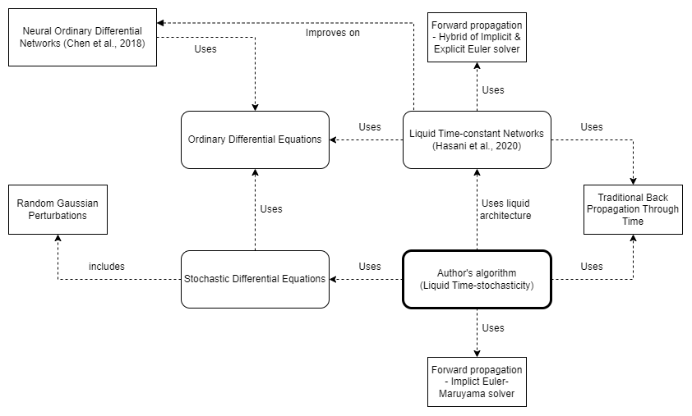

Figure 24: Algorithm intuition (*Self-Composed*)

**What exactly an SDE solves compared to an ODE?**

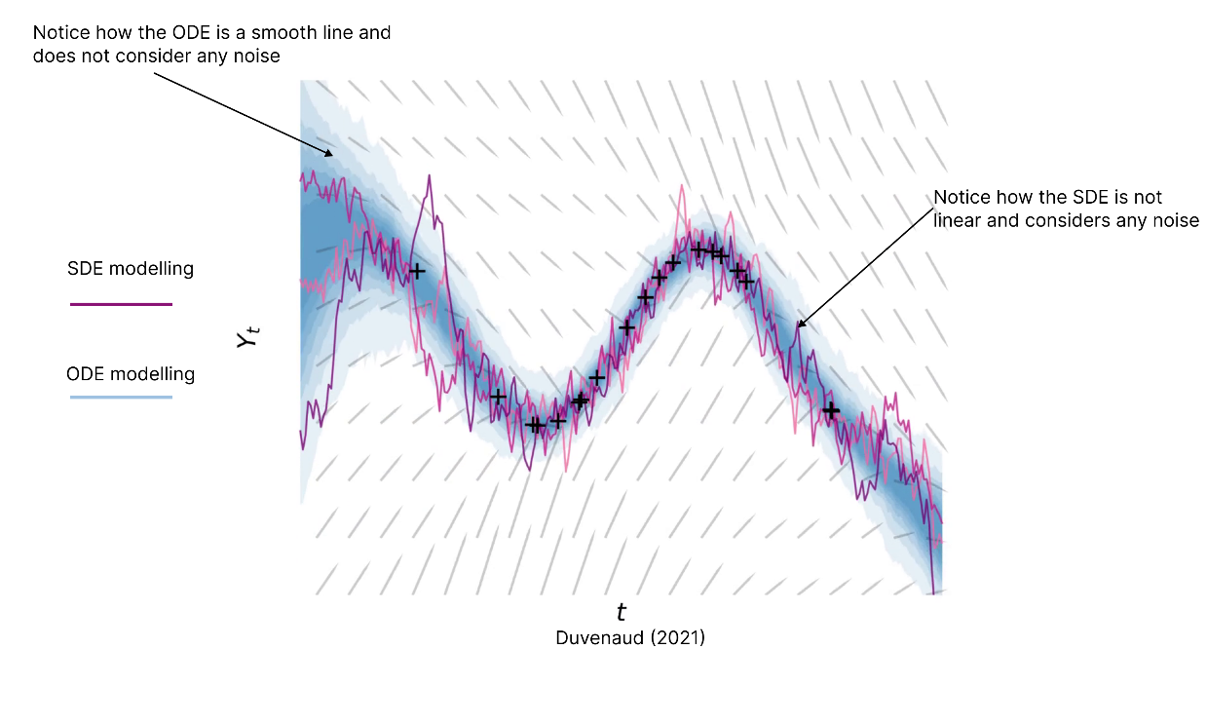

Figure 25: Understanding what an SDE solves

Considering this, SDEs would more accurately model domains that have high volatility/noise.

**Existing LTC architecture**

$$\frac{dx(t)}{dt}= -\left[\frac{1}{τ}+ f(x\left(t\right), I\left(t\right), t, θ)\right]x(t)+f(x\left(t\right), I\left(t\right), t, θ)A$$

|  |  |
| --- | --- |
| $$τ$$ | *Time-constant* |
| $$x\left(t\right)$$ | *Hidden state* |
| $$I\left(t\right)$$ | *Input* |
| *t* | *Time* |
| $$f$$ | *Neural network* |
| $$θ,A$$ | *Parameters* |

The above formulation was proposed byHasani et al. (2020), where a system of linear ODEs is used to declare the flow of the hidden state; the ODEs are of the following form.

$$\frac{dx(t)}{dt}= \frac{-x(t)}{τ}+S(t)$$

*Where S(t) represents the following nonlinearity*

$$S\left(t\right)=f(x\left(t\right), I\left(t\right), t, θ)(A-x\left(t\right))$$

The equation manifests by plugging the above equation into the system of linear ODEs.

**Formulation**

***Step 01 – transitioning from an ODE to an SDE***

In simple terms, an SDE is an ODE with additional noise added at each step, which the model can use to model uncertainty.

$$Assume an ODE is: \frac{dx}{dt}= f\left(x\right);which obtains the expected slope of x\left(t\right)$$

The above ODE can be used to calculate the ‘expected’ slope, whereas the ‘realized’ slope differs from the ‘expected’ due to random noise, also called random Gaussian perturbations or Gaussian white noise. With that in consideration, the following can be derived:

$$An SDE is: \frac{dx}{dt}= f\left(x\right)+ E_{t+dt};where E_{t+dt} is \sim N\left(0, 1\right)$$

$$Where N\left(0, 1\right) is a Gaussian 0,1 random variable$$

However, noise can be of varying intensities (some could be high, some could be low). Considering this varying intensity, the SDE can be further expressed as follows:

$$\frac{dx}{dt}= f\left(x\right)+ {g\left(x\right)* E}_{t+dt};where g\left(x\right) is the intensity$$

As implied, the missing factor in the existing architecture that consists of ODEs is the absent stochastic transition dynamics (i.e., a noise for each timestep – which is vital to model the tiny unobserved interactions). The above equation considers the small unobserved interactions and uncertainties that could occur; this is further important in the context of TS data, as the initial state of data is unlikely to be certain.

***Step 02 – adding neural networks into SDE dynamics***

Based on the findings of Duvenaud (2021), the noise mentioned in the previous step can be considered as Brownian motion: a generalized form of the Gaussian noise. Researchers can produce the following by plugging Brownian motion into the equation determined in the previous step.

$$dx= f\left(x\left(t\right)\right)dt+o\left(x\left(t\right)\right)dB\left(t\right)$$

A neural network can be integrated into the above equation to solve the system, resulting in the following equation:

$$dx= f_{θ}\left(x(t)\right)dt+o_{θ}\left(x\left(t\right)\right)dB\left(t\right)$$

$$where f is usually a tiny neural network and θ are its parameters$$

***Step 03 – Integrating the above equation into the LTC architecture***

Moving back to the main problem at hand, the author can now construct a new formula by using the equation determined in the previous step.

$$\frac{dx(t)}{dt}= \frac{-x(t)}{τ}+S(t)$$

The above equation is a linear system of ODEs initially proposed by Lapicque (1907) - the author could add the uncertainty noise to the equation to produce the following:

$$\frac{dx\left(t\right)}{dt}= \frac{-x\left(t\right)}{τ}+S\left(t\right)+o\left(x\left(t\right)\right)B$$

The above equation now defines a stochastic process instead of deterministic evolution. Therefore, researchers can model any tiny unobserved interactions.

Finally, the following could be derived by applying this to the LTC formula:

$$\frac{dx\left(t\right)}{dt}= \frac{-x\left(t\right)}{τ}+S\left(t\right)+o\left(x\left(t\right)\right)B$$

$$Replace S\left(t\right) with the nonlinearity proposed,$$

$$\frac{dx\left(t\right)}{dt}= \frac{-x\left(t\right)}{τ}+f(x\left(t\right), I\left(t\right), t, θ)(A-x\left(t\right))+o\left(x\left(t\right)\right)B$$

$$Expand out the equation,$$

$$\frac{dx\left(t\right)}{dt}= \frac{-x\left(t\right)}{τ} - f\left(x\left(t\right), I\left(t\right), t, θ\right)x\left(t\right)+o\left(x\left(t\right)\right)B+ f\left(x\left(t\right), I\left(t\right), t, θ\right)A$$

$$Lastly, refactor the equation into the format of the original LTC$$

$$\boxed{\frac{dx(t)}{dt}=-\left[\frac{1}{τ}+f\left(x\left(t\right), I\left(t\right), t,θ\right)-oB \right]x\left(t\right)+f\left(x\left(t\right),I\left(t\right),t,θ\right)A }$$

# **D.2. Tweet sentiment weighting algorithm intuition**

The proposed formula is a linear combination of the metrics considered by the author.

Initially, the metrics are specified and defined as follows:

$${followers}_{count}, lists_{count}, retweets_{count}, like_{count}$$

Alpha, beta, gamma and delta are different weighting factors applied to each metric. This is determined by observing how much of an impact each metric makes. Applying these weighting factors will produce the following:

$$α{followers}_{count}, βlists_{count}, γretweets_{count}, δlike_{count}$$

The author wanted to provide more weightage to the tweeter themselves rather than the specific tweet, as the impact of a tweet is more correlated with the tweeter rather than its likes and retweets. As such, the author proposes the arbitrary values of **0.5**, **0.3**, **0.1** and **0.1** for alpha, beta, gamma and delta respectively.

To avoid a specific metric from dominating the score (if the number of followers is in the millions and number of retweets is in the thousands, the number of followers would dominate the score), a logarithm can be applied. Applying a logarithm can normalize and balance all the metrics into a similar scale to avoid any bias, as such accurately reflect each metric’s true impact on the score. Furthermore, the author will add the value “1” to each metric prior to obtaining the logarithmic value. Performing this will prevent mathematical errors that would arise for the case of a metric having the value of 0. The terms can now be written as follows:

$α\log_{10}\left({followers}_{count}+1\right),$ $β\log_{10}{(lists_{count}+1)},{γ\log_{10}\left(retweets_{count}+1\right), }δ\log_{10}{(like_{count}+1)}$

As the formula is a linear combination of these metrics, they are summed up to provide a tweet sum and an influencer sum.

${influencer}_{sum}= α\log_{10}\left({followers}_{count}+1\right)+$ $β\log_{10}\left(lists_{count}+1\right)$

$$tweet_{sum}={γ\log_{10}\left(retweets_{count}+1\right)+}δ\log_{10}{(like_{count}+1)}$$

The obtained sums do not fall within any range and must be normalized to ensure that the final score will not exceed 1. Normalization can be applied as follows:

$${influencer}_{score}=\frac{tweet_{sum}+influencer_{sum}}{tweet_{sum}+influencer_{sum}+1}$$

Finally, this influencer score can be applied to the vanilla compound score to obtain a weighted compound score.

$$\boxed{weighted_{score}={influencer}_{score}*compound_{score} }$$

# **D.3. LTS algorithm complexity analysis**

Table 41: Complexities of BPTT and adjoint sensitivity

**Note:** *L* = number of steps

|  |  |  |
| --- | --- | --- |
|  | **BPTT** | **Adjoint sensitivity** |
| Time | O(L) | **O(LlogL)** |
| Memory | O(L) | **O(1)** |
| Forward accuracy | High | High |
| Backward accuracy | **High** | Low |

# **D.4. UI wireframes**

|  |  |
| --- | --- |
| Figure 26: UI wireframes – Home (*Self-Composed*) | Figure 27: UI wireframes – News (*Self-Composed*) |
| Figure 28: UI wireframes – Cryptocurrencies (*Self-Composed*) | Figure 29: UI wireframes – Cryptocurrency (*Self-Composed*) |

|  |  |
| --- | --- |
| Figure 30: UI wireframes – Admin login (*Self-Composed*) | Figure 31: UI wireframes – Admin metrics (*Self-Composed*) |
| Figure 32: UI wireframes – Forecast (*Self-Composed*) | |

# **APPENDIX E – IMPLEMENTATION**

# **E.1. Selection of programming language**

The below table summarizes the analysis of the language chosen for the data science component, where each option was given a score within H – High, M – Medium, and L – Low.

Table 42: Selection of data science language

|  |  |  |  |
| --- | --- | --- | --- |
| **Data science**  Two of the most popular languages used widely for data science were analyzed to implement the core data science components. | | | |
| **Aspect** | **Relevance** | **Python** | **R** |
| Availability of libraries. | A language supporting multiple libraries is paramount, as the author would require numerous techniques to gather the necessary data and streamline the model and algorithm development. | H | M |
| Author familiarity and ease of implementation. | Implementing the algorithm, the mathematical intricacies, and the respective model should be as simple as possible. It is an additional benefit if the author has hands-on experience with the chosen language. | H | M |
| Learning curve | The difficulty of the chosen language must not be a hindrance, as the goal is to utilize the tool to implement a system rather than spending time learning the language. | L | M |
| Community and documentation. | Community support and well-written documentation are important, as the author will not have time to debug trivial issues. | H | M |
| **Conclusion**  Based on the analysis, the author decided to use **Python**, as it was more relevant. | | | |

# **E.2. Selection of Deep Learning (DL) framework**

Table 43: Selection of DL framework

|  |  |
| --- | --- |
| **Framework** | **Description** |
| TensorFlow | Used for production-level applications, has detailed documentation and community support, and handles large datasets. It also provides better visualization options, making it easy to debug and monitor training, which is vital as a novel algorithm is being built, and no comparison is present. |
| PyTorch | It is more lightweight and developer-friendly, as it provides a higher-level development. Therefore, it has a much smaller learning curve, easier to get started, and feels more intuitive as it is simpler to build models. |
| **Conclusion**  The author opted to use **TensorFlow**. Although it is more complicated, the higher-level API: Keras, is now officially a part of TensorFlow. Therefore, model development has become much more straightforward. Additionally, building the algorithm requires more low-level details (Kurama, 2022). | |

# **E.3. Selection of User Interface (UI) framework**

Table 44: Selection of UI framework

|  |  |
| --- | --- |
| **Framework** | **Description** |
| Angular | Suitable for large-scale applications with dedicated submodules for particular functionalities. However, it can be less performant in comparison and unnecessarily heavy. |
| Vue | A tiny framework that takes little to no time to startup and is much more intuitive as the code is simple. Additionally, based on simulations, it has been identified to perform better than Angular and React. However, it has much fewer resources. |
| Svelte | The most lightweight and genuinely reactive. Much more performant than the rest; however, it has a small community of developers and is relatively new. |
| React | Customizable and promotes code reusability via functions as components. It carries a large community and is open-source while being SEO-friendly. Additionally, the React developer tools is very handy. |
| **Conclusion**  Based on the analysis, the author chose **React** as the GUI built will be simple, and there is no requirement for large-scale applications, as it is not the primary focus (Patadiya, 2021). | |

# **E.4. Selection of Application Programming Interface (API) framework**

Table 45: Selection of web framework

|  |  |
| --- | --- |
| **Framework** | **Description** |
| Flask | A very lightweight framework that provides only the simplest of functionalities. However, it is the preferred choice for ML API development because it is light. |
| Django | Suitable for more larger scaled applications that provide a vast range of functionalities, it is stricter and less flexible. Therefore, is much more demanding and heavier. |
| **Conclusion**  The author chose **Flask** as it provides only the necessities in exposing an ML model and since the luxury features provided by Django (ex: authentication) were not required (InterviewBit, 2021). | |

# **E.5. Fetch data**

**Fetch historical prices**

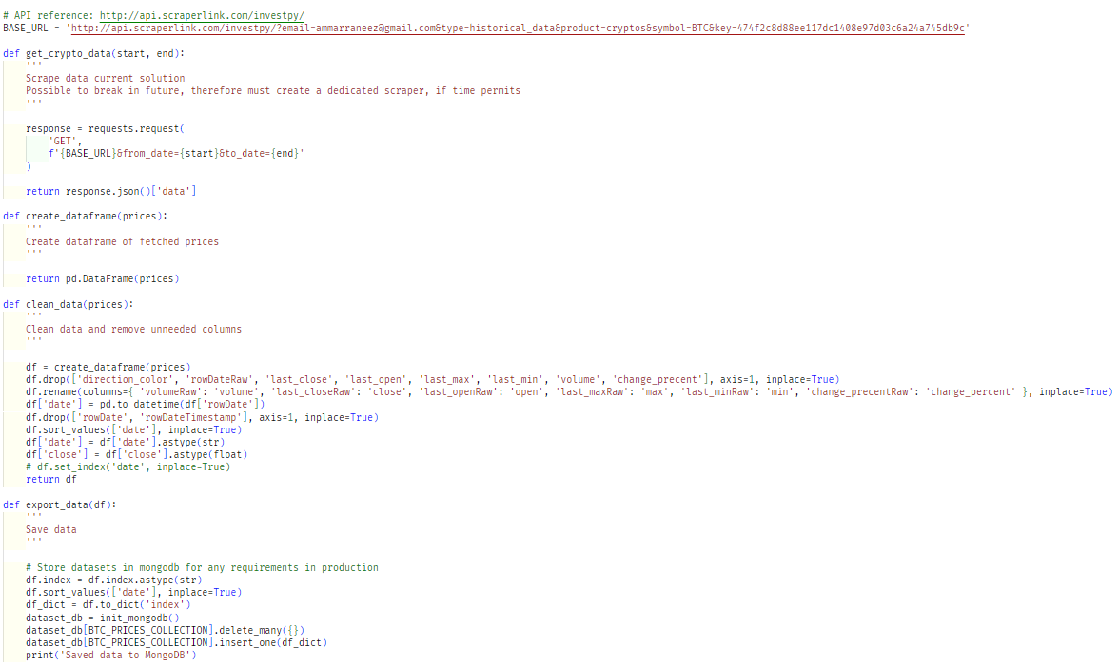

Figure 33: Fetch historical prices (*Self-Composed*)

The above script describes a couple of functions that can be used to fetch the latest BTC historical prices data and store it into a MongoDB collection, so that it can be later read from by the model. A third-party API was used to fetch the data, as existing APIs are all discontinued.

**Fetch Twitter volume, Google Trends & block reward size**

|  |  |
| --- | --- |
| Figure 34: Fetch Twitter volume (*Self-Composed*) | Figure 35: Fetch block reward size (*Self-Composed*) |
| Figure 36: Fetch google trends (*Self-Composed*) | |

The above scripts fetch the Twitter volume and block reward from a website that publicly exposes this data. Therefore, a simple website scraping tool can be used without authentication or authorization.

**Fetch tweet data**

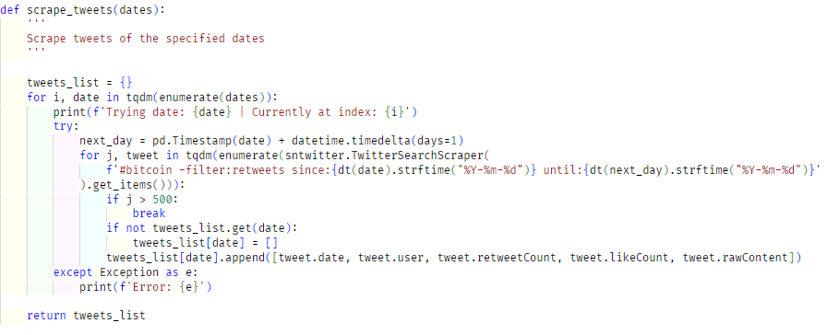

Figure 37: Scrape tweets (*Self-Composed*)

Obtaining the tweet data required a more tedious process as the Twitter API had been updated only to provide tweets for the past week; however, third-party libraries offer this functionality. Tweets fetched were limited to 500 for a single day due to time, performance, and storage constraints, and as the application is not the core contribution. Initially, tweets were fetched up to a specific time point; in the future, the above script could be run to scrape tweets of particular dates that are described to be from the days currently existing in the collection up to the day at which the script is run. There is a further limitation as only ‘#bitcoin’ is searched.

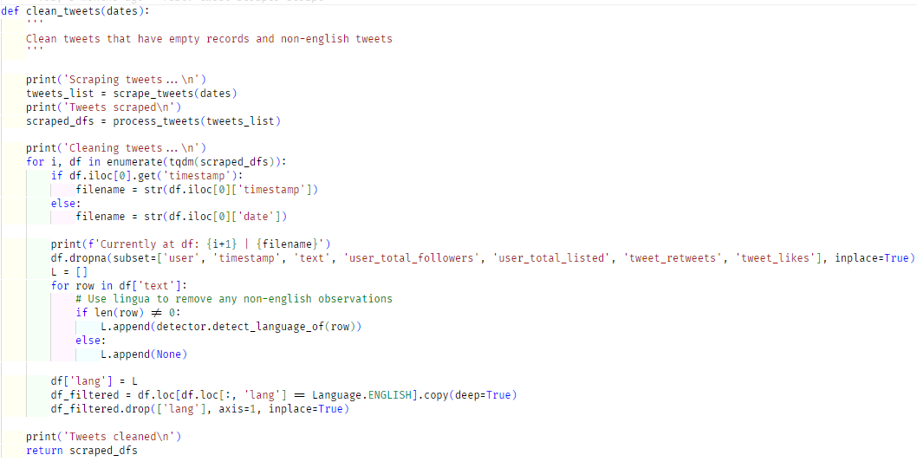

Figure 38: Clean tweets (*Self-Composed*)

As this research is currently limited to only English, the tweets are filtered, and non-English tweets are removed.

# **E.6. Preprocessing**

**Tweet sentiment analysis**

The main step of preprocessing is to perform sentiment analysis on the obtained tweet data. In this research, the VADER sentiment analyzer is used as determined in previous chapters.

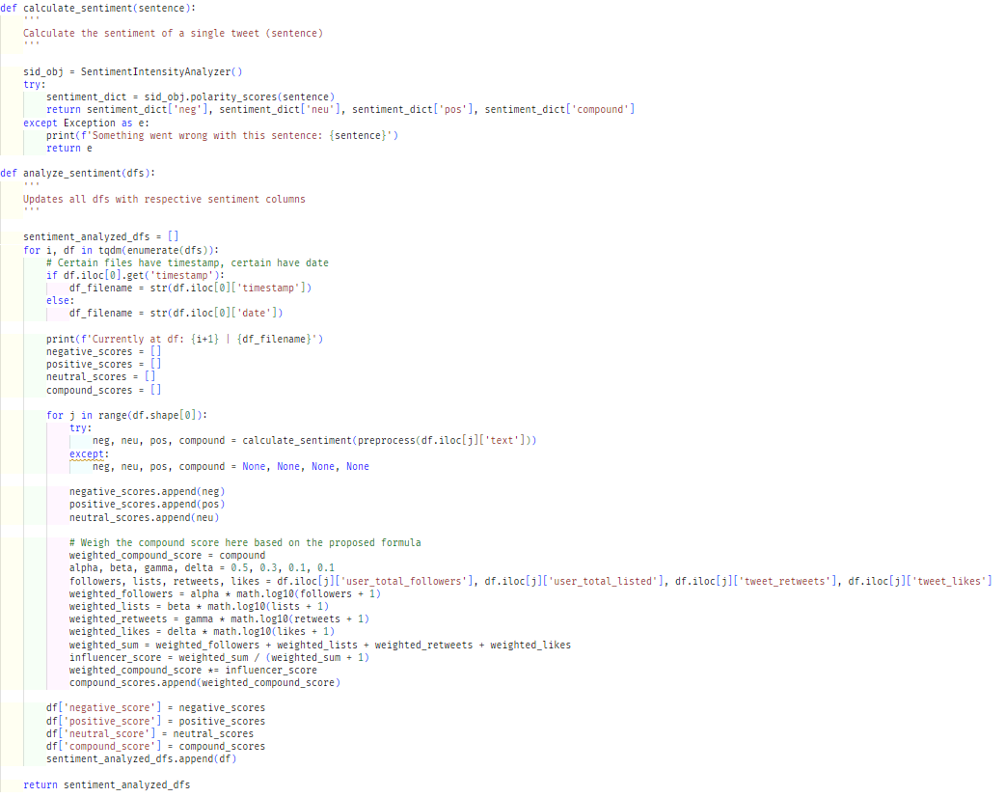

Figure 39: Analyze sentiments (*Self-Composed*)

The above script is used to perform sentiment analysis on the tweets and concatenates the negative, positive, neutral, and compound scores into the existing tweet dataset. The compound score is weighted beforehand by utilizing the proposed sentiment weighting formula in **Chapter 6**(as only the compound score is used on forth, there is no requirement to weight the negative, positive and neutral scores). They can then be condensed down to create an average score for a single day.

**Tweet dataset condensation**

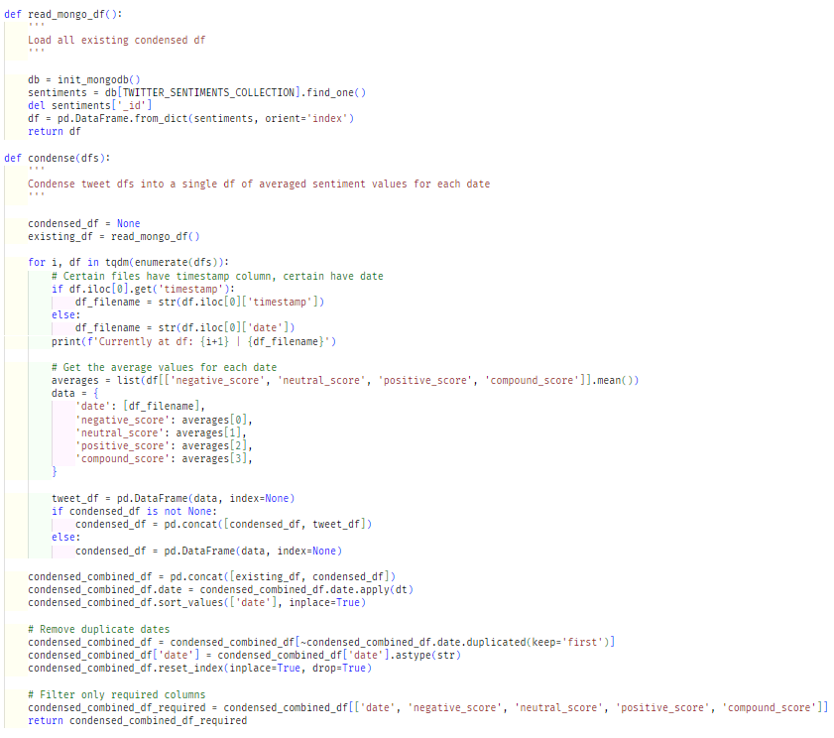

Figure 40: Combine and condense tweets (*Self-Composed*)

As the other data being used directly creates a single data frame with a row for each date, the condensation process is unnecessary. However, as the tweet data fetched consists of a separate dataframe file for each date, this data must be compressed to the same format as other datasets.

The above script condenses the tweet dataset into a single data frame by averaging the sentiment scores for each day.

**Final dataset creation**

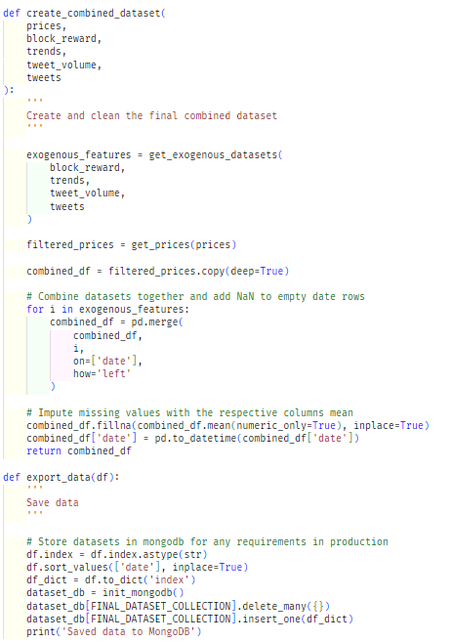

Figure 41: Combine all datasets (*Self-Composed*)

The above script is used to create the final dataset that the model uses. It fetches all the datasets and combines them into a single data frame. Initially, a helper function removes unneeded columns from the data, which were decided upon conducting correlation tests initially. The mean of their respective columns imputes missing values of each feature of specific dates, and the combined dataset is stored in a MongoDB collection so the model can finally utilize it.

# **E.7. User interface**

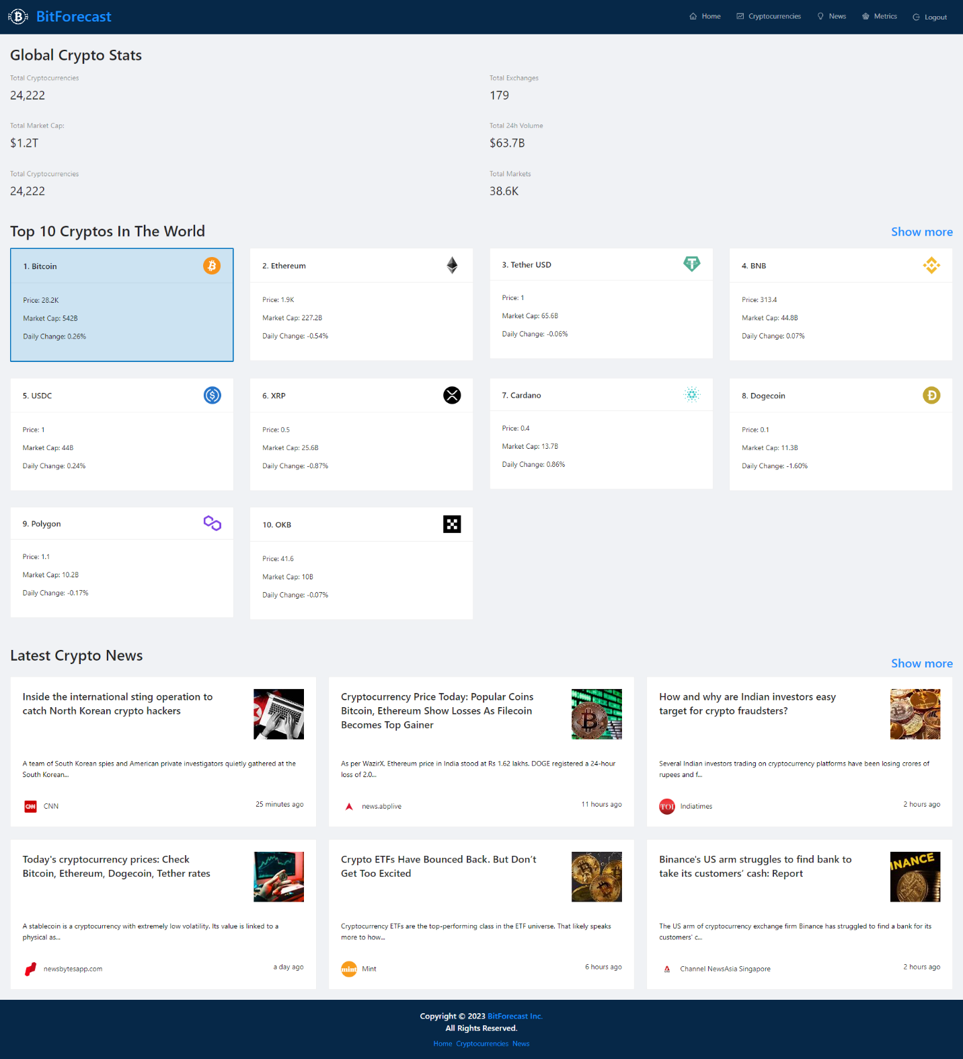

Figure 42: GUI - Home (*Self-Composed*)

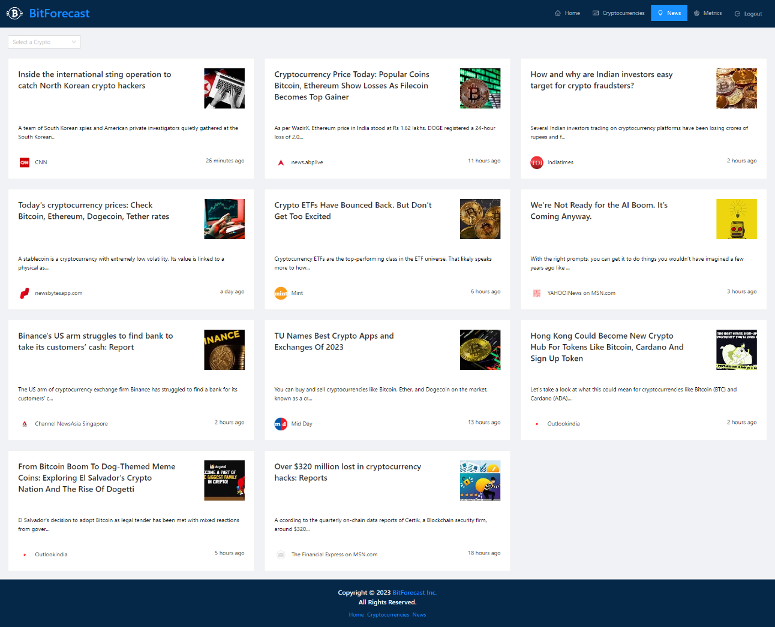

Figure 43: GUI - News (*Self-Composed*)

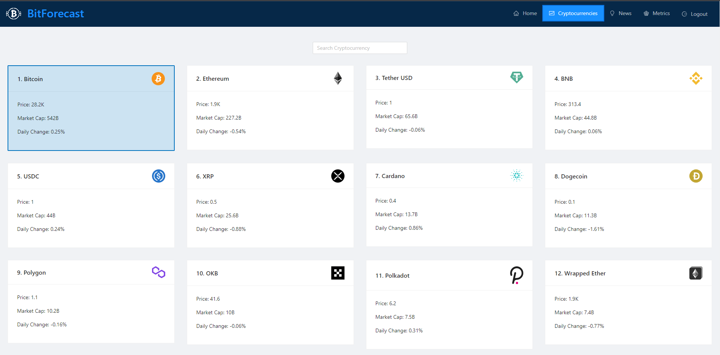

Figure 44: GUI - Cryptocurrencies (*Self-Composed*)

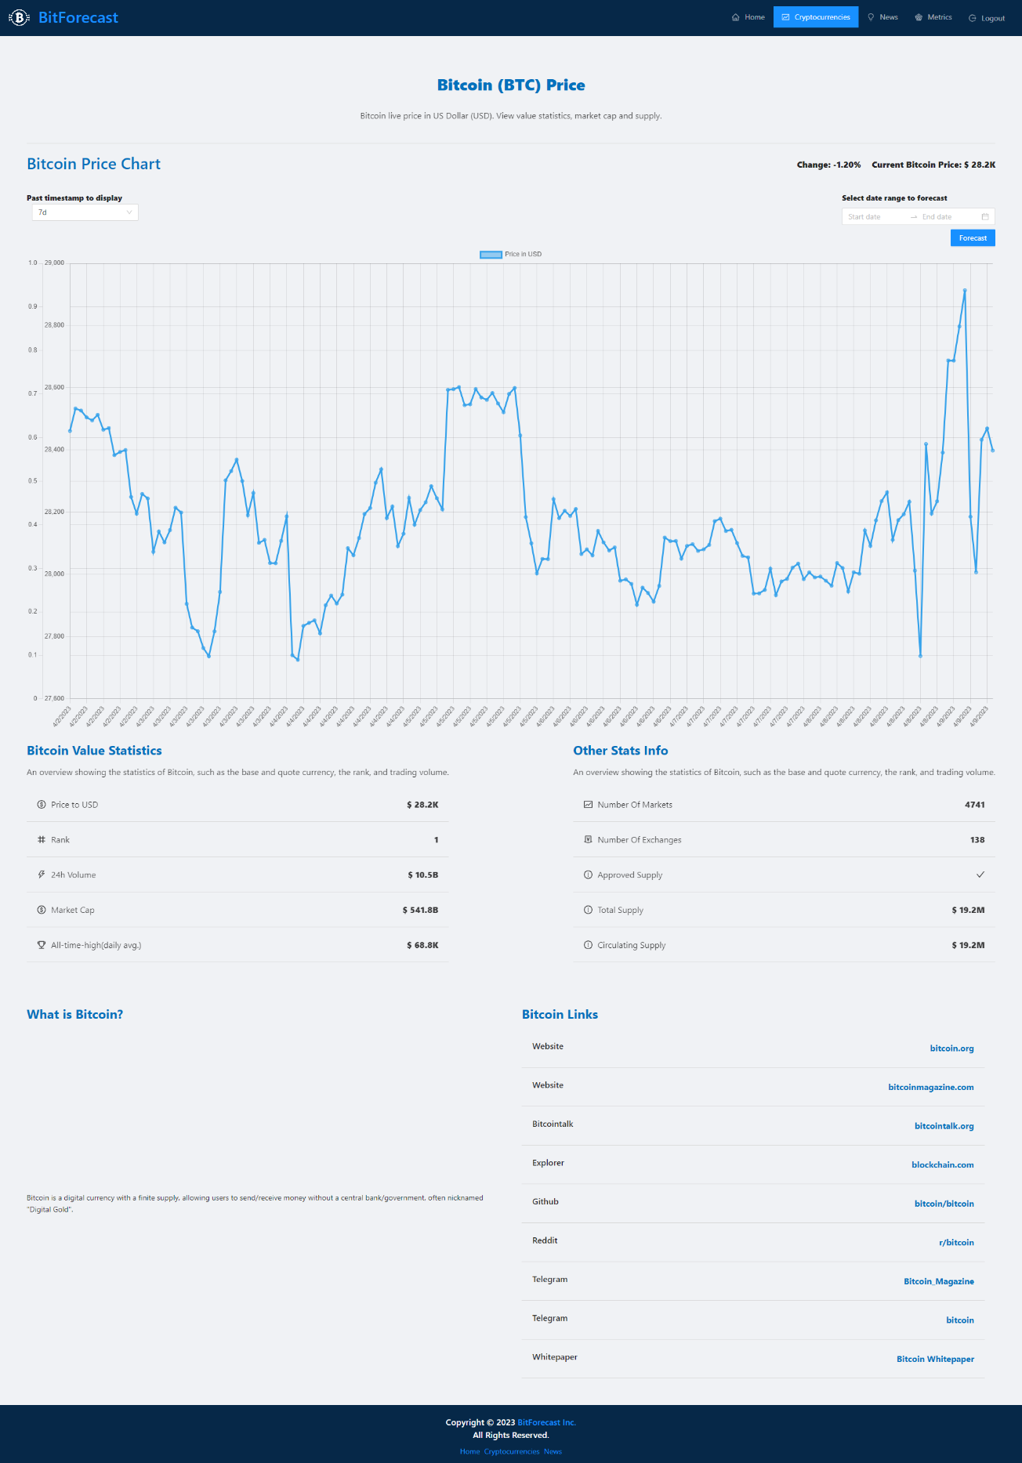

Figure 45: GUI - Cryptocurrency (*Self-Composed*)

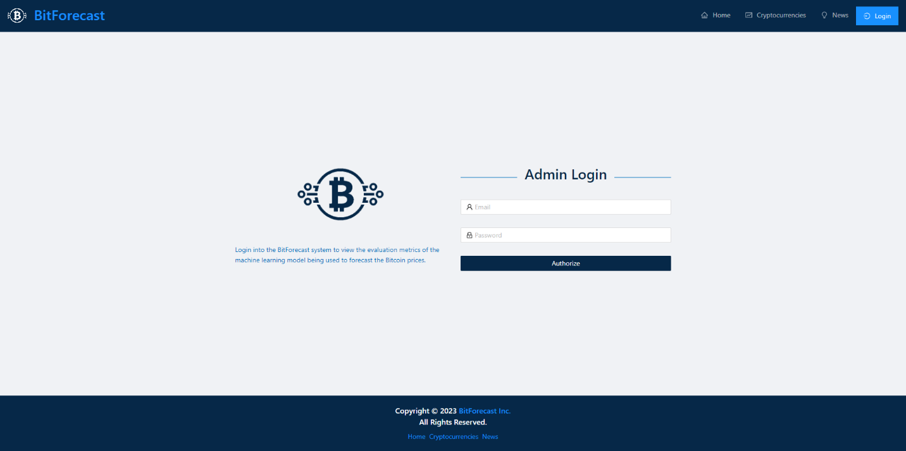

Figure 46: GUI - Admin login (*Self-Composed*)

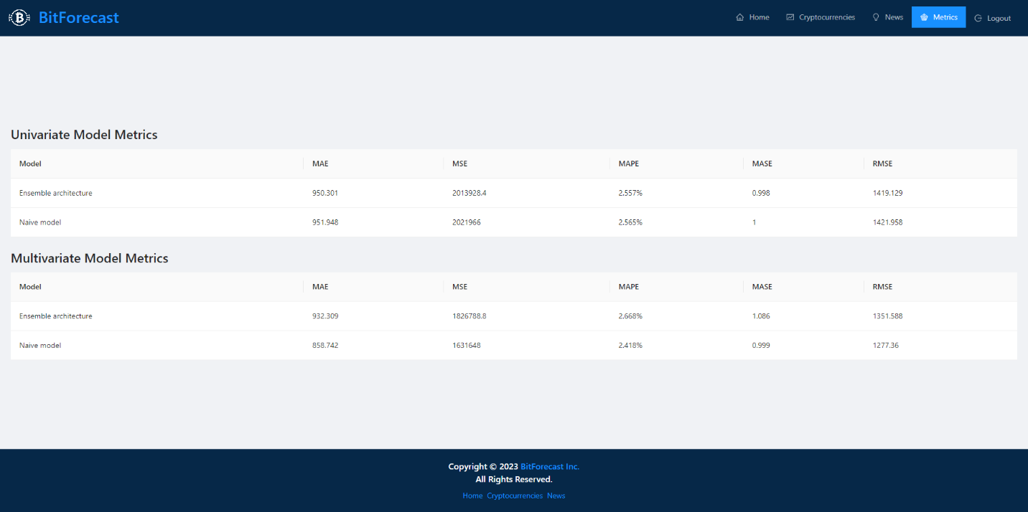

Figure 47: GUI - Admin metrics (*Self-Composed*)

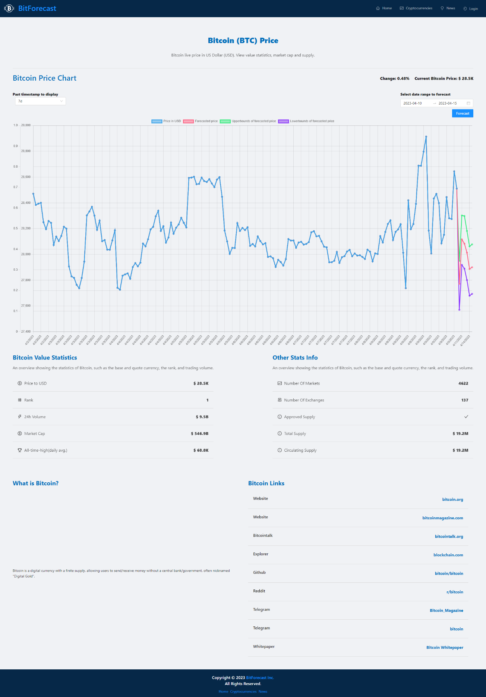

Figure 48: GUI - Forecast (*Self-Composed*)

# **APPENDIX F – TESTING**

# **F.1. Functional testing**

Table 46: Functional testing

|  |  |  |  |  |  |
| --- | --- | --- | --- | --- | --- |
| **Test case** | **ID** | **Action** | **Expected result** | **Actual result** | **Status** |
| **Research level** | | | | | |
| 1 | FR1 | - | The LTS follows recommended standards so that it can be scalable and built upon. | The architecture was built as a Keras layer so behind-the-scenes techniques that need to happen is handled by Keras. | Passed |
| 2 | FR2 | - | The LTS can be used as existing layers such as Conv1D and LSTM. | Building the LTS as a Keras layer provided this functionality. | Passed |
| **System level** | | | | | |
| 3 | FR3, FR4, FR5 | Users choose the future dates. | The user can view the prices of the chosen dates. | The deployed endpoint is triggered and the model’s response of the chosen dates are returned to the user. | Passed |
| 4 | FR3, FR8, FR9 | The user can view the price ranges of the chosen dates. | The deployed endpoint is triggered and the models’ responses of the chosen dates are returned to the user. | Passed |
| 5 | FR6, FR7 | Cron script is triggered periodically. | The latest data available is stored in the database. | The exogenous features are scraped/extracted, processed, condensed, combined, and saved into the database. | Passed |
| 6 | FR10 | Upon receiving the responses, the user views the updated graph. | The graph is updated with the predictions and plotted alongside the past prices. | The GUI is updated with more datapoints that are the future predictions. | Passed |
| 7 | FR11 | Sentiments extracted from scraped data. | Sentiments are weighted based on influencer score by the proposed formula. | The sentiments undergo a weighting stage where, based on certain metrics, the score is changed. | Passed |
| 8 | FR14 | Admins log into the system. | Technical information about the models is shown. | The evaluation metrics of the two models are displayed. | Passed |

# **F.2. Non-functional testing**

The author applied performance, GUI and maintainability testing, and a few test-cases to determine if the system meets the non-functional requirements and the design goals.

**Performance testing**

The author had deployed the API and model; therefore, there is no requirement of having a high GPU and CPU power. Docker, GitHub Actions and Heroku with basic Dynos were utilized for deployment purposes, which is capable of serving requests for small-scale applications. However, for large-scale purposes, it is recommended that the Dynos are scaled up, as the application would not be able to handle multiple requests concurrently. It is also worth mentioning that as the system is developed using TensorFlow, initial load times can take some time.

**GUI testing**

The requirement gathering phase determined that the need for developing a simple and effective GUI was important. The GUI was tested by Google Lighthouse to determine its performance and accessibility, the diagram below illustrates the obtained results.

|  |  |
| --- | --- |
| Figure 49: Lighthouse home page (*Self-Composed*) | Figure 50: Lighthouse login page (*Self-Composed*) |
| Figure 51: Lighthouse cryptocurrencies page (*Self-Composed*) | Figure 52: Lighthouse cryptocurrency page (*Self-Composed*) |
| Figure 53: Lighthouse news page (*Self-Composed*) | Figure 54: Lighthouse metrics page (*Self-Composed*) |

The results vary from page-to-page. This is likely since most pages utilize third party APIs to render information, hence demonstrating a subpar performance value.

**Maintainability testing**

Maintainability is important so that future research on the system and especially the developed algorithm can be conducted seamlessly. CodeFactor and CodeQL were used to ensure that the repositories are maintained and documented well and that there are no vulnerabilities.

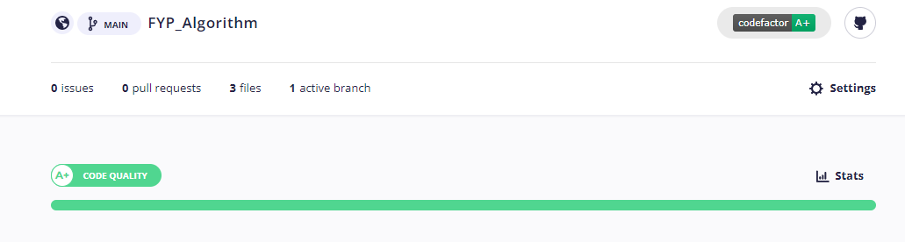

Figure 55: CodeFactor - Algorithm repository (*Self-Composed*)

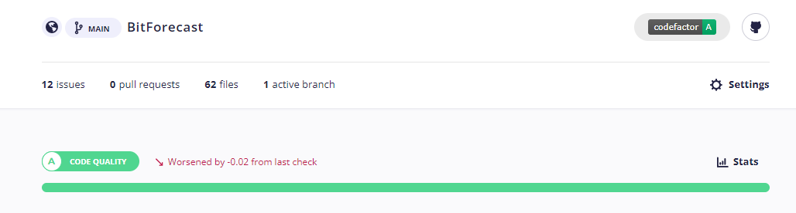

Figure 56: CodeFactor - Application repository (*Self-Composed*)

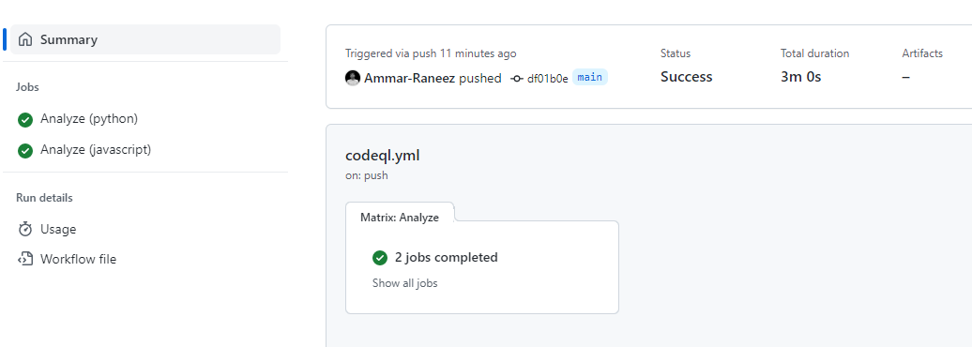

Figure 57: CodeQL - Algorithm repository (*Self-Composed*)

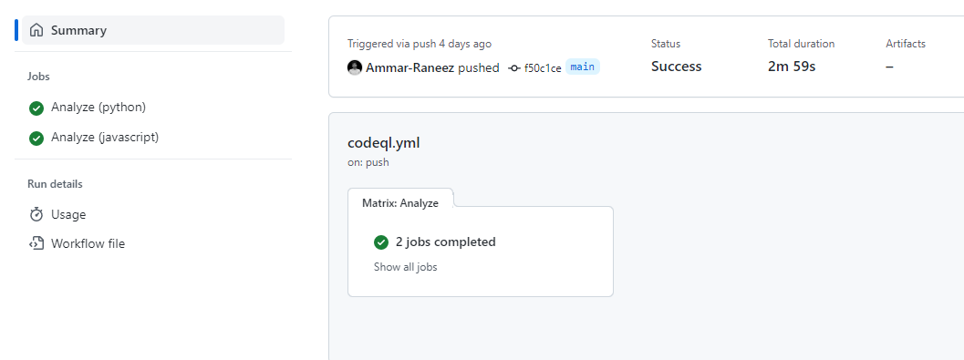

Figure 58: CodeQL - Application repository (*Self-Composed*)

**Test cases**

Table 47: Non-functional testing

|  |  |  |
| --- | --- | --- |
| **Non-functional requirements** | | |
| **Test case** | **ID** | **Result** |
| 1 | NFR1 | The system gives responses within 1-2 minutes. |
| 2 | NFR2 | Only the data for specific dates are scraped and updated whenever necessary. |
| 3 | NFR3 | The developed GUI is simple, easy to follow, and attractive. Additionally, no technical information is displayed to the users, except for admins who log in. |
| 4 | NFR4 | Docstrings were added for each method and comments wherever necessary. |
| 5 | NFR5 | The responses are plotted within the graph itself to show a growth/decline. |
| 6 | NFR6 | The system was deployed to Heroku by Docker and GitHub Actions, but will not scale as traffic increases: the utilized Dynos are the most basic version. |
| 7 | NFR7 | The model is stored in AWS S3 for backup and requests, the data is stored in MongoDB, and admin authentication is handled by Firebase. Therefore, security is integrated to some extent. |
| 8 | NFR8 | The application is responsive across a wide range of screen sizes. |
| **Design goals** | | |
| 9 | DG1 | The data are stored in MongoDB and fetched whenever necessary. For the case where the available data is not up-to-date, the script fetches data only for the missing dates and updates the database. |
| 10 | DG2 | The system is built to be as user-friendly as possible with zero information shown to users on what happens behind the scenes. |
| 11 | DG3 | The forecast is plotted alongside the existing price chart using a different color to differentiate between them. Two more lines are plotted to demonstrate the uncertainty estimations that display the range of prices. |
| 12 | DG4 | Docstrings were added for each method and comments wherever necessary. Analysis using CodeFactor produced a grade of A+ for the algorithm repository, which is the maximum grade possible. |

# **APPENDIX G – EVALUATION**

# **G.1. Expert evaluators**

Table 48: Selected expert evaluator details

|  |  |  |
| --- | --- | --- |
| **ID** | **Affiliation** | **Expertise related to the research** |
| **Research domain** | | |
| EV1 | Google Brain visiting researcher and Associate Professor at University of Toronto. | Neural ODEs and SDEs. |
| EV2 | Research scientist at Deepmind. | Neural ODEs and SDEs. |
| EV3 | Research scientist at Meta AI. | Probabilistic DL and differential equations. |
| EV4 | PhD candidate at University of Nottingham. | ML & DL. |
| **Problem domain** | | |
| EV5 | Prefer not to say | Blockchain and cryptocurrencies. |
| EV6 | Prefer not to say | Cryptocurrencies and crypto exchanges. |

# **G.2. Evaluation of functional requirements**

Table 49: Evaluation of the implementation of functional requirements

|  |  |  |  |  |
| --- | --- | --- | --- | --- |
| **ID** | **Description** | **Priority** | **Use Case** | **Evaluation** |
| **Research level** | | | |  |
| FR1 | A robust and scalable implementation of the novel algorithm must follow recommended standards. | M | **-** | Implemented |
| FR2 | The developed algorithm must be able to be used as existing layers and algorithms (ex: LSTM, CNN). | M | - | Implemented |
| **System level** | | | |  |
| FR3 | Users must be able to choose a future date. | M | UC:01 | Implemented |
| FR4 | Users must be able to view the point prediction price. | M | UC:03 | Implemented |
| FR5 | The system must generate the point prediction price based on the user’s choice of date. | M | UC:02 | Implemented |
| FR6 | The script must obtain the latest data available periodically. | M | UC:04 | Implemented |
| FR7 | The script must extract trends and sentiments from obtained data. | M | UC:05 | Implemented |
| FR8 | Users should be able to view a range of prices along with the single-point price. | S | UC:03 | Implemented |
| FR9 | The system should generate higher and lower bound uncertainty estimations. | S | UC:02 | Implemented |
| FR10 | The GUI should plot the forecast with the current prices in a single graph to show the growth/decline. | S | UC:03 | Implemented |
| FR11 | The script could weight sentiment based on any influential personnel’s tweet. | C | UC:06 | Implemented |
| FR12 | The system could display some insights to the user, such as a highly influential tweet that made it predict the price. | C | UC:03 | Not-considered |
| FR13 | Admins could authenticate and update the model with different parameters. | C | N/A | Not-considered |
| FR14 | Admins could get additional information about a prediction, such as the evaluation metric and accuracy. | C | N/A | Implemented |
| FR15 | The system will not produce forecasts for other cryptocurrencies. | W | N/A | Not-considered |
| FR16 | The system will not produce real-time forecasts (ex: hourly). | W | N/A | Not-considered |
| Functional requirement completion percentage = $\frac{12}{16}*100=75\%$ | | | | |

# **G.3. Evaluation of non-functional requirements**

Table 50: Evaluation of the implementation of non-functional requirements

|  |  |  |  |  |
| --- | --- | --- | --- | --- |
| **ID** | **Requirement** | **Description** | **Priority** | **Evaluation** |
| NFR1 | Performance | The system must take little time to generate a forecast, given that a couple of extra features are in use. | Important | Implemented |
| NFR2 | Performance | The system must not unnecessarily keep updating its data. | Important | Implemented |
| NFR3 | Usability | The user interface must be simple and effective and provide user-friendly errors if any occur. | Important | Implemented |
| NFR4 | Maintainability | The author must document the codebase well in case of future reference, mainly the algorithm development repository. | Important | Implemented |
| NFR5 | Quality | The output must be of good quality so that it provides vital insights. | Desirable | Implemented |
| NFR6 | Scalability | The system must be deployed to a cloud with no scaling issues and good resources for efficient and optimal performance, especially as there could be multiple concurrent active user requests. | Desirable | Implemented (~50%) |
| NFR7 | Security | The system must be resilient to attackers, specifically to prevent data manipulation. | Desirable | Implemented |
| NFR8 | Compatibility | To ensure compatibility, the developer must test the system on most browsers and mobile phones. | Desirable | Implemented |
| NFR9 | Availability | In critical failures, the primary operator must be available and solve issues as soon as possible. | Desirable | Not- implemented |
| Non-functional requirement completion percentage = $\frac{7.5}{9}*100=83.3\%$ | | | | |

Table 51: Evaluation of the achievement of design goals

|  |  |  |
| --- | --- | --- |
| **ID** | **Goal** | **Evaluation** |
| DG1 | Performance | Achieved |
| DG2 | Usability | Achieved |
| DG3 | Quality | Achieved |
| DG4 | Maintainability | Achieved |
| Design goals achievement percentage $$\frac{4}{4}*100=100\%$$ | | |

# **APPENDIX H – CONCLUSION**

# **H.1. Status of research objectives**

Table 52: Status of research objectives

|  |  |  |
| --- | --- | --- |
| **Objective** | **Description** | **Status** |
| Problem Identification | Understand and document the identified problem and provide reasoning on what makes it novel.  **R**O1: Conduct research on a domain of interest and identify a comprehensive enough issue that requires solving.  **R**O2: Delve deeper into the identified problem to obtain a general understanding on how to approach solving the problem.  **R**O3: Split the problem down into manageable subsections so it is easier to digest and to solve one section at a time.  **R**O4: Design a respective schedule, associated deliverables, and the Gantt chart. | Completed |
| Literature Review | Collate relevant information by reading, understanding, and evaluating previous work.  **R**O5: Conduct preliminary studies and investigations on existing TS forecasting systems and algorithms.  **R**O6: Analyze the requirement for specialized TS algorithms.  **R**O7: Conduct research on neural ODEs, LTCs & SDEs.  **R**O8: Obtain deep insights into the architecture behind the LTC.  **R**O9: Research and obtain insights on factors affecting the price of BTC.  **R**O10: Research on existing BTC forecasting and related open market systems.  **R**O11: Research on necessary ML techniques and evaluation approaches. | Completed |
| Requirement Elicitation | Collect and analyze project requirements using appropriate tools and techniques.  **R**O12: Analyze stakeholders and understand their viewpoints and concerns.  **R**O13: Gather the requirements and architectures of LTCs and SDEs.  **R**O14: Collate the most up-to-date details of BTC and obtain insights on the perspectives of the end users.  **R**O15: Design necessary diagrams to justify the product’s specification. | Completed |
| Design | Design the architecture and a corresponding system capable of effectively solving the identified problems.  **R**O16: Design necessary diagrams required to understand the algorithm  RO17: Design diagrams required to understand the supplementary system being developed.  **R**O18: Design the novel algorithm and analyze its complexities. | Completed |
| Implementation | Implement a system that is capable of addressing the research gaps.  **R**O19: Design, evaluate and pick necessary technologies best-suited for the implementation.  **R**O20: Develop an efficient LTC implementation.  **R**O21: Build on the LTC to implement the LTS.  **R**O22: Integrate the algorithm developed into a TS forecasting application.  **R**O23: Integrate the intelligent system into a client application to display forecasts.  **R**O24: Design and implement an automated flow to update the built network with the latest data.  **R**O25: Design and implement a pipeline for easy deployments.  **R**O26: Consider any legal, social, ethical & professional issues upon implementation. | Completed |
| Evaluation | Effectively test the algorithm implemented, the system, and the respective data science model using recommended techniques.  **R**O27: Evaluate the developed algorithm and the respective model against the evaluation metrics researched in the literature review.  **R**O28: Create a test plan & test cases and perform unit, performance, and integration testing. | Completed |
| Documentation | Document the progression of the research project and inform about any challenges faced.  **R**O29: Create a coherent report of new skills obtained, evaluations, contributions etc., and ensure that all the above-stated objectives are met. | Completed |

# **H.2. Achievement of learning outcomes**

Table 53: Achievement of learning outcomes

|  |  |
| --- | --- |
| **Description** | **Learning outcome(s)** |
| The project was broken down into two main subproblems: algorithm implementation and application development. They were then further broken down into digestible units to understand and implement one at a time by applying appropriate techniques recommended by analyzing literature and requirements. | LO1 |
| The units identified were placed into a project plan as milestones to achieve within a set timeframe and successfully complete the project within the given timescale. | LO2 |
| Project requirements were collected and analyzed from two parties: academic researchers and end users, to obtain insights into developing the LTS algorithm and prioritizing features that must be implemented in the BTC forecasting application. | LO3 |
| Literature was read and critiqued upon, both recent and some over a century old, to understand in detail certain mathematical concepts. | LO4 |
| Having obtained requirements, insights and knowledge. The author worked on implementing the two subproblems one unit at a time, whilst learning any new skills required. The author met with the supervisor regularly to make sure that they are on the right track by producing milestone deliverables. Any SLEP issues were also considered and documented. | LO5, LO6, LO7 |
| The research was documented and each individual chapter was presented with the supervisor as milestones. They were then updated based on feedback from the supervisor and the module leader. Before completion of this dissertation, two document artefacts were submitted: the project proposal and PSDP. Additionally, papers were presented in conferences to justify the authors solution. | LO8 |

# **APPENDIX I – CONCEPT MAP**

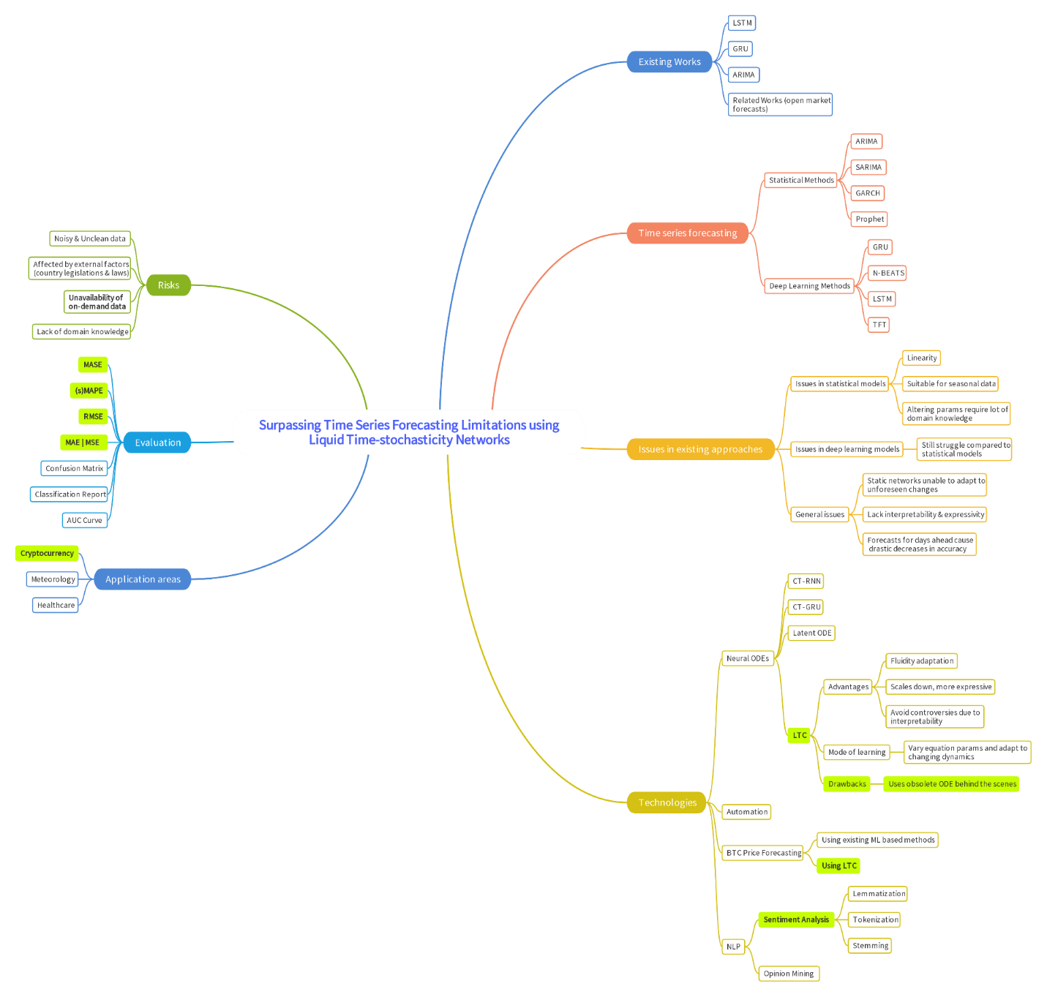

*A clearer version can be found* [*Here*](https://drive.google.com/file/d/1GwNYLEG649gszfBqYi9VXud5MPE70aPZ/view?usp=sharing)

# **APPENDIX J – EXTENDED REVIEW PAPER**

# **J.1. Acceptance notification**



# **J.2. Extended review paper**

